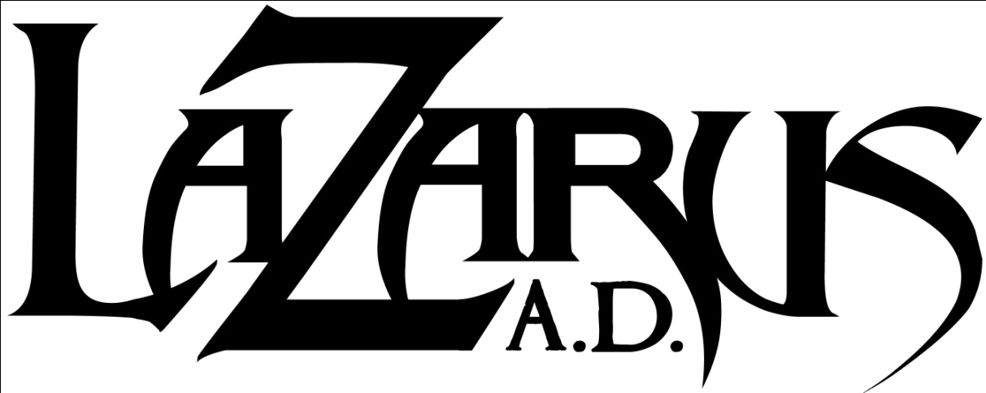
Black Rivers Flow

Jeff Paulick – Vocals/Bass
Dan Gapen – Guitars/Vocals
Alex Lackner – Guitars
Ryan Shutler – Drums

The dreaded sophomore album. How does a band like Lazarus A.D. approach what some see as a make-or-break album in a band's career? How do they handle song writing after the endless (and inevitable) comparisons to Testament, Metallica, Pantera, etc.? "You focus on writing better songs, plain and simple. We fully understood the "sophomore slump" notion, and tossed it to the side. We believe that bands that have achieved success and continue to maintain it naturally evolve their sound while keeping a strong core. That was the plan for us since the get go, and we believe we have achieved that thus far with our second effort." says vocalist and bassist, Jeff Paulick. It's simple to say, more difficult to achieve, but Lazarus A.D. has proven that they are up to the task again and again. They've played everywhere from the Loud Park Festival in Tokyo to tens-of-thousands to your run of the mill clubs in front of dozens – it doesn't matter – Lazarus A.D. brings the same show and intensity every time.

Black Rivers Flow is the band's latest slab of unadulterated, pure heavy metal. It was recorded near their hometown of Kenosha, WI at Belle City Sound with Chris Djuricic with James Murphy of Safehouse Productions handling mixing and mastering duties. The final product is a natural evolution of the band's sound and, quite literally, the sound of a more mature band. Much of The Onslaught was written while the band was still in high school, and by the time it was released by Metal Blade, the material was already several years old. You can imagine then how hungry and ready the band was to lay down new material.

The end result is a nine song beast full of pure heavy metal, free of any hindering genre tags and written for the sake of writing good music. The band claims any "filler" was left by the wayside and Paulick adds, "We are incredibly harsh when it comes to honesty in our songwriting, and if it doesn't scream "that's heavy as fuck" or "this sounds amazing", it's not making the record." Another aspect that the band honed in on was vocals. In the past, Paulick handled the vast majority of the vocal duties with some back-up lines from guitarist, Dan Gapen. This time through, there's much more synergy between the two. Paulick discusses further, "We used a mixture of singing and screaming, from both Gapen and myself. The way we interact is seamless throughout the record, and truly adds to the dynamic sound of the record." What you're hearing on Black Rivers Flow is a band that has truly found their groove. This album will prove to be one of the most undeniably heavy and catchy albums of 2011.

In April of 2009, the band embarked on their first ever full US tour. It would prove to be a big one: Swedish legends, Amon Amarth, with metal veterans Goatwhore and Skeletonwitch in tow. As if that wasn’t enough, Lazarus A.D. missed the last few dates of that tour to head back across the US to join up with San Francisco bay area thrash icons, Testament, for their full US tour. Also joining the party on that tour were label mates and metal/hardcore pioneers, Unearth. Following these two highly publicized and successful tours, Lazarus A.D. once again criss-crossed the US and Canada with label mates Bison b.c. and Woe Of Tyrants. To cap off an active 2009, Lazarus A.D. had the honor of being invited to play Japan’s Loud Park festival 2009, where they played alongside Slayer, Rob Zombie, Judas Priest, Megadeth, Hatebreed and more. To kick things off in 2011, Lazarus A.D. will be a part of Death Angel's North American Retribution Tour January-February 2011 with Early Man, Bonded By Blood and Hexen. This will be the first of many tours in support of Black Rivers Flow, so keep an eye on their tour schedule to see Lazarus A.D. near your!

