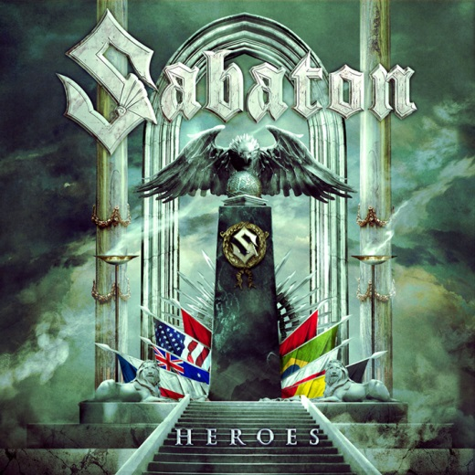
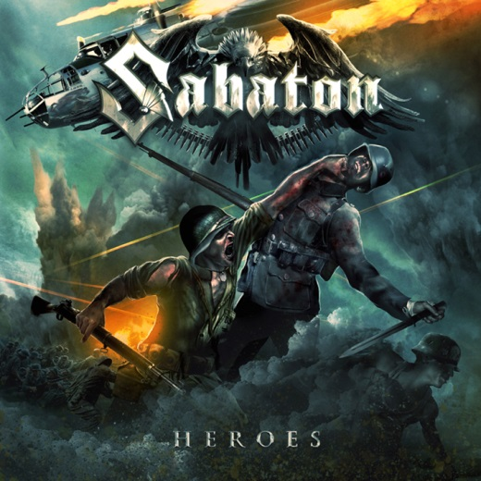

SABATON
»Heroes«

OUT: May 16, 2014
Line up: | Sabaton online:
Joakim Brodén | vocals  Pär Sundström | bass  Chris Rörland | guitars  Thobbe Englund | guitars  Hannes van Dahl | drums  Heroes are back with a vengeance! | www.sabaton.net  www.facebook.com/sabaton  www.nuclearblast.de/sabaton
"What can we do when our band's previous album is career-defining classic and one of our home country's most successful heavy metal albums ever?" This was the million dollar question that members of Sabaton - Swedish heavy metal heroes, who have dominated European the heavy metal circuit already for years and received prestigious awards including Metal Hammer UK's Golden Gods Award for "Best Breakthrough Artist" - had to ask themselves after successful world tour promoting their sixth and platinum selling album "Carolus Rex" (2012).

During this gigantic tour, heavy metal's most enthusiastic fan legions saw Sabaton playing huge stadiums with Iron Maiden - but also on their own as Sabaton performed their biggest show ever in Polish Przystanek Woodstock Festival in front of more than half a million fans and the show was - of course - filmed and later immortalized on massive "Swedish Empire Live" DVD/Blu-ray. After saying this, do we need to point out that Sabaton are nothing but superstars in Poland and the members of the band have been adopted as Polish honorary citizens?

Well, anyway, let's get back to that million dollar question.

After months of intense working (recording, producing and mixing) in famous Abyss-studios, the apparent answer is finally here and it is called "Heroes". Well, first of all: what could be more suitable title for Sabaton's seventh full-length studio recording? There probably isn't one.

Where "Carolus Rex" album took a sidestep and told famous story of Swedish Empire during 1561-1721, "Heroes" is once again a concept record based on different historical, 20th century wars and battles, telling fascinating stories about heroic men and women on their dangerous missions on battlefields and other belligerent locations, such as Auschwitz. Well, talking about real heroes - how could anyone be braver than Polish soldier Witold Pilecki aka Inmate 4859, who voluntarily entered concentration camp Auschwitz as he wanted to get evidence of the horrors and mass murders that were taking place inside the district of doom?

Music-wise, "Heroes", which will be released in May by world's most powerful heavy metal label Nuclear Blast Records, will strike metal scene like a fighter aircraft from the clear sky. After serving some ultra-catchy, more traditional Sabaton epics (f.e. "No Bullets Fly" and "Soldier Of 3 Armies"), this Falun-quintet dives into more unprecedented territory with songs such as powerful "The Ballad Of Bull", Western-movie themed "To Hell And Back" and guitar-driven "Resist And Bite" - the latter one being some of the most up-to-date performances on the endlessly vibrant album.

As a whole, "Heroes" serves compelling mixture of epic metal anthems, carried out by ultra-powerful guitar riffs, pounding drums, catchy choruses, "rough-meets-melody" kind of vocals and incomparable solos - not forgetting totally new level of intensity and bombastic sound quality, thanks to a world-famous producer and Sabaton's long-time guardian angel Peter Tägtgren. "Heroes" definitely introduces Sabaton more varied and dynamically wider than ever before, but at the same time, fresh-sounding new record still possess every imaginable element that you may expect from these heroic northmen.

After hearing "Heroes", it's definitely not exaggerating to inform that Sabaton has taken some mighty steps after the band's core musicians - vocalist/composer Joakim Brodén and bassist/manager Pär Sundström - were joined by totally new blood (guitarists Chris Rörland and Thobbe Englund and drummer Hannes van Dahl) after career-defining "Carolus Rex" was recorded during 2011/2012. If you ever had any doubts regarding new line-up's abilities, "Heroes" will blast your suspicions to outer space if not further.

There's not other way to say it: anno domini 2014, Sabaton sounds like a unstoppable, fearless and tireless war machine. So, please, please remember that you have been warned as this Swedish bulletproof machine will unquestionably reach all possible and impossible corners of the globe during their massive "Heroes World Tour 2014-2016".
During the upcoming tour, Sabaton will serve the fans with their usual magic tricks as they organize traditional 3-day festival Sabaton Open Air in Falun in August and after surviving that, they will sail away with their own 2000-capacity ferry, during the always sold out Sabatoncruise.

Now, what are you waiting for? Let's jump on board...

© Nuclear Blast

