**MEDIA wishing to attend and cover the event may register here for credentials – this is the one and only press submission form for this event:

www.altpress.com/apmas_media

For Immediate Release

June 23, 2014

Gibson Brands AP MUSIC AWARDS - Fueled by Monster Energy Drink - Announces More Special Appearances by PARAMORE, YELLOWCARD and More

Check Out Two Exclusive New Videos from AP Music Awards Host Mark Hoppus & Performers the Misfits

New Performers Machine Gun Kelly Announced – In Addition to Fall Out Boy, Joan Jett & The Blackhearts, the Misfits, A Day To Remember, All Time Low, Brendon Urie of Panic! At The Disco, Sleeping With Sirens, twenty one pilots + more to come!

JULY 21, 2014 @ the Rock And Roll Hall Of Fame and Museum in Cleveland, OH

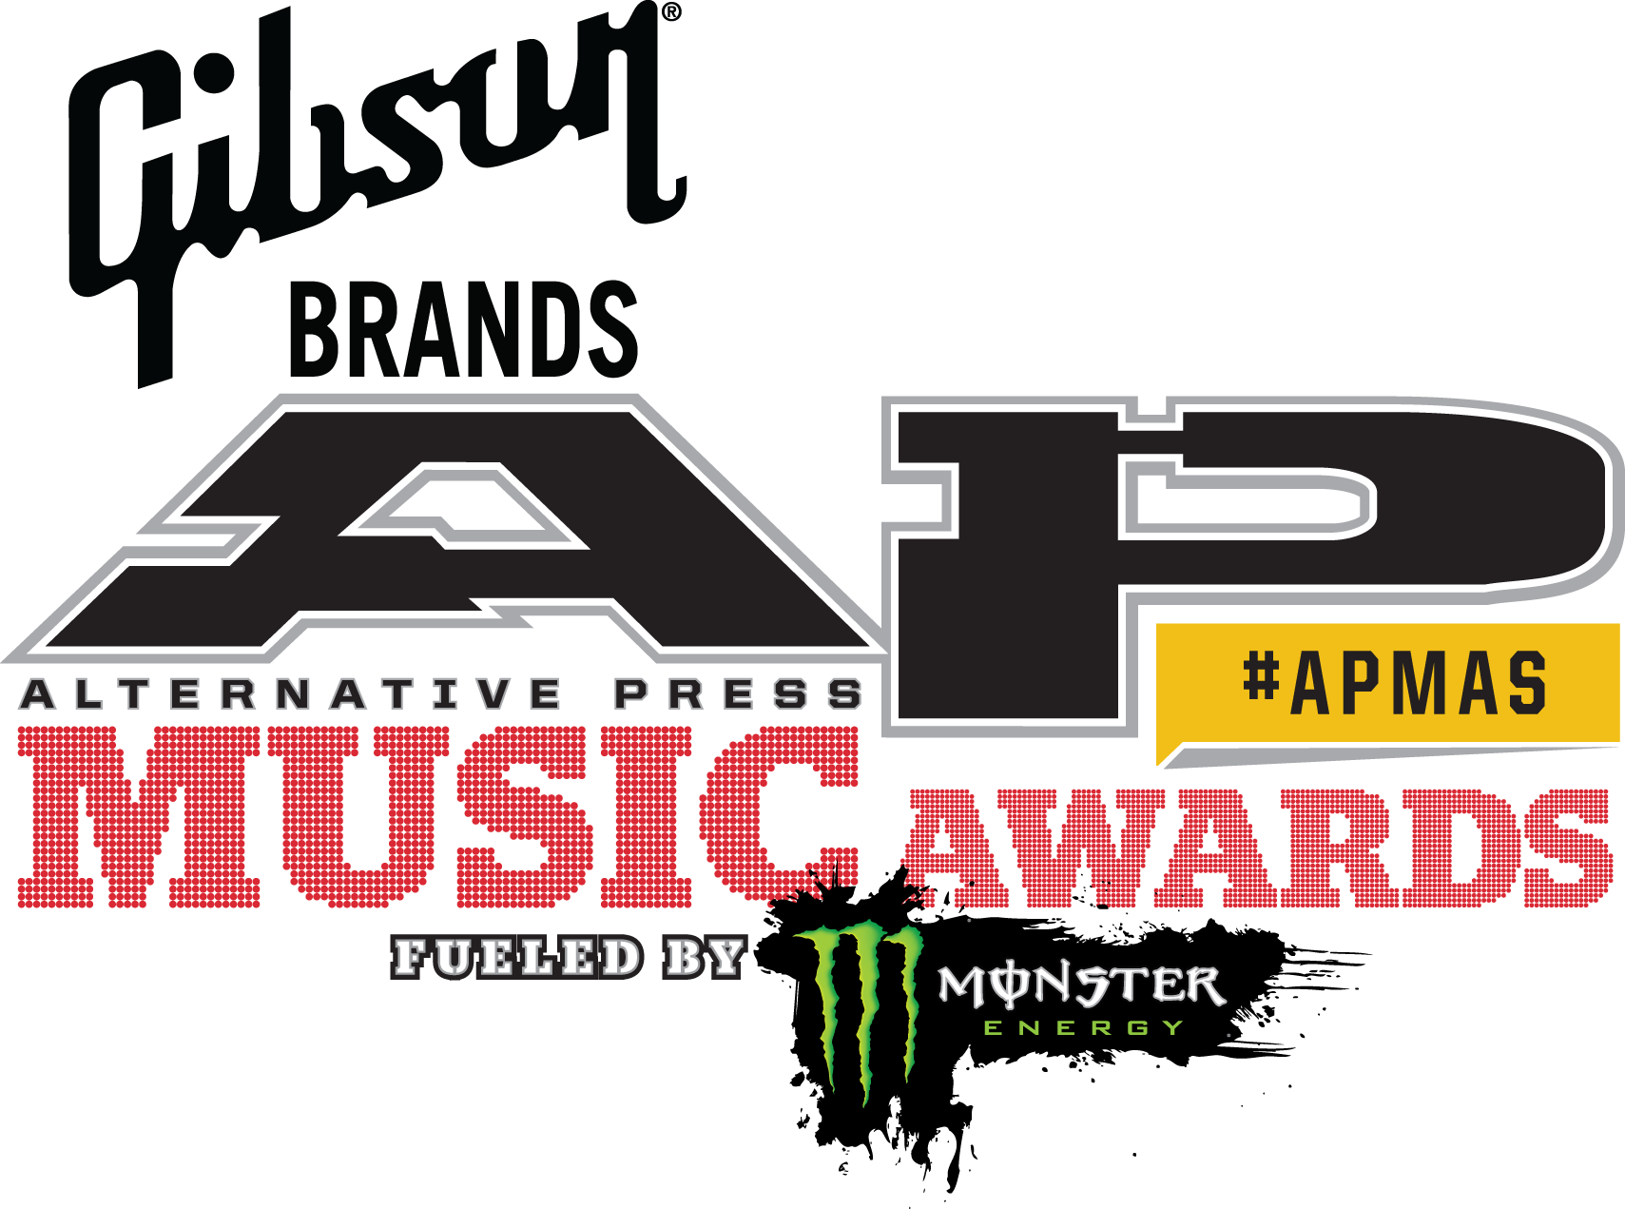

New Featured Appearances Also Include

Billy Corgan, We Came As Romans, Chiodos + More

Featuring Performances from Cleveland’s Very Own 115-Piece Contemporary Youth Orchestra

Tickets available now at www.altpress.com/apmas

Cleveland, OH — Organizers of the inaugural Gibson Brands AP Music Awards, fueled by Monster Energy Drink, have added yet another batch of top-shelf talent to its lineup. Joining the already star-studded list of special appearances are Paramore, Yellowcard, Billy Corgan, We Came As Romans, Chiodos, Miss May I and Issues. These world-renowned artists share an impressive combined 19 Alternative Press Magazine covers and more than 5 million-plus in U.S. album sales between them. Additionally, Machine Gun Kelly, previously announced as a special appearance, will now be performing live at the APMAs, making this an absolutely must-see event.

New this week – APMAs host Mark Hoppus of Blink-182 discusses his favorite memories and first recollections of many of this year’s performers, including Fall Out Boy, All Time Low and Joan Jett. Check out the video here: www.youtube.com/watch?v=8ud7dbRIr-8

BLOG EMBED: <iframe width="560" height="315" src="//www.youtube.com/embed/8ud7dbRIr-8" frameborder="0" allowfullscreen></iframe>

Also, the legendary Misfits have posted a new video, inviting you to vote and join them at the APMAs! Check out the video here: http://youtu.be/AEYs9YYa5nI

BLOG EMBED: <iframe width="640" height="480" src="//www.youtube.com/embed/AEYs9YYa5nI" frameborder="0" allowfullscreen></iframe>

APMAs digital media partner AXS TV, also recognized throughout the industry for their recent and innovative live coverage of music awards shows and events such as Coachella, Lollapalooza, Stagecoach, and New Orleans Jazz Fest, has announced the APMAs broadcast will begin at 8 p.m. ET/5 p.m. PT on July 21, and will not only feature the entirety of the APMAs, but will also include exciting highlights from the red carpet pre-show (co-hosted by Automatic Loveletter frontwoman/The Voice season two runner-up Juliet Simms plus a very special guest to be announced soon). This live broadcast will also feature footage from the VIP boat party during the day, and will feature exclusive performances from rising stars Issues, Ghost Town and Marmozets.

While there will be loads of action onscreen, AXS TV will also be taking the party online. Viewers can head to www.axs.tv/apmas/ to watch exclusive behind-the-scenes videos and view photos. Fans can also take part in live polls and get involved on social media. Plus, fans can enter to win awesome prizes, such as a one-year subscription to Alternative Press Magazine, Gibson Brands guitars and merchandise, and Monster Energy Drink swag.

This special one-night event on July 21, 2014, held at the Rock And Roll Hall Of Fame And Museum at North Coast Harbor in AP’s hometown of Cleveland, also coincides with the collision of two of the country’s premier touring rock festivals. This rock n’ roll crossroad brings several presenters and performers to the APMAs, such as Vans Warped Tour performers Motionless in White, Marmozets, Yellowcard, Issues, and other festival performers such as Asking Alexandria, Korn, Body Count feat. Ice T, Miss May I, and Frankie Palmeri of Emmure. More are set to be announced soon!

In its inaugural year, the APMAs will be hosted by six-time AP cover star Mark Hoppus (Blink-182) and will feature performances from A Day To Remember, All Time Low, Asking Alexandria, Fall Out Boy, Joan Jett & The Blackhearts, Machine Gun Kelly, the Misfits, Sleeping With Sirens, twenty one pilots and Brendon Urie of Panic! At The Disco, with more to be announced.

Other confirmed artists making appearances (some previously stated above) include Andy Biersack (Black Veil Brides), Billy Corgan, Chiodos, Laura Jane Grace (Against Me!), I See Stars, Ice-T & Coco, Issues, Korn, Memphis May Fire, Miss May I, Motionless In White, Frankie Palmeri (Emmure), Paramore, We Came As Romans and Yellowcard, with more to be announced. Cleveland’s 115-piece Contemporary Youth Orchestra will be performing throughout the APMAs, both independently and through unique artist collaborations.

Tickets are on sale now for $69.99 which includes a ticket to the Rock & Roll Hall of Fame And Museum to be used that same day and can be purchased online at www.altpress.com/apmas

Fourteen awards in total will be handed out, including Album Of The Year presented by Journeys, Artist Of The Year presented by Monster Energy Drink, Song of the Year presented by Epitaph Records, Best Guitarist presented by Gibson, Best Drummer presented by DW Drums, Best International Band presented by Zepeda Brothers Productions and Most Dedicated Fans presented by Fearless Records, along with an Icon Award presented by Blackstar Amps honoring Joan Jett and a Vanguard Award honoring Billy Corgan. Fans can cast their votes in 12 different categories at www.altpress.com/apmas. Voting ends July 15.

Fans that purchased VIP and Monster Energy Drink ticket packages will be invited to a pre-show boat party on the Goodtimes III, located right behind the Rock Hall. The boat sets sail at 1:30 p.m. and will include performances by Issues, Ghost Town and Marmozets, three bands recently featured in AP’s 100 Bands You Need To Know In 2014 special edition issue.

In addition to Gibson Brands and Monster Energy Drink, sponsors of the AP Music Awards include AKT, Blackstar Amps, DW Drums, Epitaph Records, Fearless Records, Fueled By Ramen, Hopeless Records, idobi Radio, Journeys, Onkyo, Roadrunner Records, Sumerian Records, Tascam, Victory Records and Zepeda Brothers Productions.

The AP Music Awards are produced by Kevin Lyman (founder & CEO of 4FINI) and Josh Bernstein (Golden Gods creator and producer). Executive producers are Mike Shea, Dawn Marshman and Joe Scarpelli.

AP MUSIC AWARDS NOMINEES

Artist Of The Year Presented by Monster Energy Drink

A Day To Remember
Avenged Sevenfold
Black Veil Brides
Bring Me The Horizon
Fall Out Boy
Of Mice & Men
Panic! At The Disco
Paramore
Pierce The Veil
Sleeping With Sirens

Album Of The Year presented by Journeys

A Day To Remember • Common Courtesy
Avenged Sevenfold • Hail To The King
Black Veil Brides • Wretched And Divine: The Story Of The Wild Ones
Bring Me The Horizon • Sempiternal
Fall Out Boy • Save Rock And Roll
Paramore • Paramore
Sleeping With Sirens • Feel
Touché Amoré • Is Survived By
twenty one pilots • Vessel
The Wonder Years • The Greatest Generation

Artist Philanthropic Award Presented by Sub City / Take Action

All Time Low — Skate4Cancer
Memphis May Fire— peta2
Modern Baseball — 1BlueString
Pierce The Veil — The Keep A Breast foundation
Rise Against — Shirts For A Cure
The Used — Living The Dream Foundation

Best Live Band

A Day To Remember
All Time Low
Asking Alexandria
Fall Out Boy
Pierce The Veil
twenty one pilots

Breakthrough Band

The Color Morale
Crown The Empire
Issues
letlive.
The Story So Far
twenty one pilots

Song of the Year Presented by Epitaph Records

All Time Low feat. Vic Fuentes • “A Love Like War”

Bring Me The Horizon • “Shadow Moses”
Fall Out Boy • “My Songs Know What You Did In The Dark (Light Em Up)”
Falling In Reverse • “Alone”
Paramore • “Still Into You”
Sleeping With Sirens feat. Machine Gun Kelly • “Alone”

Best International Band Presented by Zepeda Brothers Productions
Asking Alexandria (U.K.)
Bring Me The Horizon (U.K.)
Crossfaith (Japan)
Parkway Drive (Australia)
Silverstein (Canada)
Frank Turner (U.K.)

Most Dedicated Fans Presented by Fearless Records

All Time Low
Avenged Sevenfold
Black Veil Brides
Mayday Parade
My Chemical Romance
Pierce The Veil

Best Vocalist Presented by Victory Records
Andy Biersack (Black Veil Brides)
Vic Fuentes (Pierce The Veil)
Kellin Quinn (Sleeping With Sirens)
Oli Sykes (Bring Me The Horizon)
Brendon Urie (Panic! At The Disco)

Hayley Williams (Paramore)

Best Guitarist Presented by Gibson
JB Brubaker (August Burns Red)
Synyster Gates (Avenged Sevenfold)
Phil Manansala (Of Mice & Men)
Jack O’Shea (Bayside)
Chris Rubey (The Devil Wears Prada)
Jacky Vincent (Falling In Reverse)

Best Bassist
Jeremy Davis (Paramore)
Zack Merrick (All Time Low)
Ryan Neff (Miss May I)
Jaime Preciado (Pierce The Veil)
Devin “Ghost” Sola (Motionless In White)
Pete Wentz (Fall Out Boy)

Best Drummer Presented by DW Drums
Jess Bowen (The Summer Set)
Josh Dun (Twenty One Pilots)
Mike Fuentes (Pierce The Veil)
Matt Greiner (August Burns Red)
Luke Holland (The Word Alive)
Ryan Seaman (Falling In Reverse)

About Alternative Press:
Now in its 29th year, Alternative Press continues to be the definitive and most trusted source for discovering new artists, breaking news and reporting on the latest trends in the underground music scene and youth culture. With last year's redesign, the magazine has become an essential collectors' piece, providing a passionate fan base with in-depth content on their favorite contemporary artists. In addition to a successful print edition, AP has expanded its reach to incorporate multiple platforms including iPad and mobile apps, as well as Altpress.com. AP has promoted its brand through such avenues as the AP Tour and APTV (which offers exclusive nationwide reporting) and now the first AP Music Awards. No matter which platform, AP prides itself on offering fans insight to the hottest artists, interviews and trends first.

About Gibson Brands (Gibson.com)
Gibson Brands, one the fastest-growing companies in the music and sound industries, was founded in 1894 and is headquartered in Nashville, TN. Gibson Brands is a global leader in musical instruments, and consumer and professional audio, and is dedicated to bringing the finest experiences by offering exceptional products with world-recognized brands. Gibson has a portfolio of over 100 well-recognized brand names starting with the number one guitar brand, Gibson. Other brands include: Epiphone, Dobro, Valley Arts, Kramer, Steinberger, Tobias, Slingerland, Maestro, Baldwin, Hamilton, Chickering and Wurlitzer. Audio brands include: KRK Systems, TASCAM, Cakewalk, Cerwin-Vega!, Stanton, Onkyo, Integra, TEAC, TASCAM Professional Software, and Esoteric. All Gibson Brands are dedicated to innovation, prestige and improving the quality of life of our customers.

About Monster Energy Drink:
Most companies spend their money on ad agencies, TV commercials, radio spots and billboards to tell you how good their products are. At Monster Energy, we chose none of the above. Instead we support the scene, our bands, our athletes and our fans. We back athletes so they can make a career out of their passion. We promote concert tours, so our favorite bands can visit your hometown. We celebrate with our fans and riders by throwing parties and making the coolest events we can think of a reality. www.monsterenergy.com | www.facebook.com/monsterenergy

About AXS TV:
Launched in July 2012 by visionary entrepreneur Mark Cuban, AXS TV is dedicated to providing the best in music programming and festivals, comedy performances, current events and mixed martial arts promotions. AXS TV is a partnership between Mark Cuban, AEG, Ryan Seacrest Media, Creative Artists Agency (CAA) and CBS. The network is available in the United States via AT&T U-verse, Charter, Comcast/Xfinity, DIRECTV, DISH, Suddenlink, Verizon FiOS, and other cable, satellite and telco providers. The network is also distributed in Canada and the Caribbean. For more information, visit the website, www.axs.tv; go to the Facebook page here and follow the company on Twitter, @axstv; on Instagram; Tumblr and YouTube.
AXS TV’s companion network, HDNET Movies, is a linear TV channel and VOD service that delivers the ultimate film watching experience -- uncut and uninterrupted -- in high definition. Launched in 2003, HDNET Movies programs a diverse slate of box-offices hits spanning the 1950s to 2000s. The network is widely distributed by major cable, telco and satellite TV providers in the U.S. For further information, visit www.hdnetmovies.com.

About the Rock and Roll Hall of Fame and Museum:
The Rock and Roll Hall of Fame and Museum, Inc. is the nonprofit organization that exists to educate visitors, fans and scholars from around the world about the history and continuing significance of rock and roll music. It carries out this mission through its operation of a world-class museum that collects, preserves, exhibits and interprets this art form and through its library and archives as well as its educational activities. For more information, please visit www.rockhall.com.

For press inquiries and additional information, please contact Adrenaline PR and Maria Ferrero at 732-462-4262 or maria@adrenalinepr.com.

--
To unsubscribe from Adrenaline PR press releases, please send an email to unsubscribe@adrenalinepr.com with your email address as the subject.

Adrenaline PR is a boutique, independent public relations, marketing, lifestyle branding firm. Adrenaline PR collectively boasts five decades of experience launching thousands of brands and careers building scene giants. Adrenaline PR are known the world over for their credibility in the successful promotion of music, artists, labels, tours, events, musicians, film, books, and talent. Adrenaline PR are trusted to deliver campaigns beyond what is expected tapping into the entertainment, culture and niche lifestyle communities and crossing clients over into mainstream media. Adrenaline PR’s roster has included but is not limited to: 10 Years, 2010 American Idol winner Lee DeWyze, Alice Cooper, All That Remains, Anthrax, As I Lay Dying, Atreyu, Dethklok, Dimmu Borgir, Down, Every Time I Die, Ferret Music, Five Finger Death Punch, From Autumn to Ashes, Good Fight Entertainment, GWAR, Housecore Records, Killswitch Engage, KMFDM, Lamb of God, Live Nation, Machine Head, Motorhead, Mudvayne, Norma Jean, Operatica, Peter Murphy, Sevendust, Shadows Fall, Superjoint Ritual, Testament, Unearth, and tribute albums for the Smashing Pumpkins, Black Flag, and many more. Adrenaline PR boasts an impressive touring roster history, promoting MTV2 Headbangers Ball Tours, REPO! The Genetic Opera Road Tour, Rockstar Energy Drink Mayhem Festival 2010 – 2014, Sounds of the Underground, The Cool Tour, Thrash and Burn Tour, along with industry events such as the Alternative Press Magazine 20th Anniversary (My Chemical Romance, The Used and Say Anything). Adrenaline PR’s expertise coupled with their connections and relationships continue to build the firm into other areas of the arts, film, soundtracks and books, including Louder Than Hell; The Oral History Of Heavy Metal (book), The Merciless Book OF Metal Lists (book), The Punisher (soundtrack), REPO! The Genetic Opera (film), Precious Metal (book), Derek Hess (art book & calendar), Jeremy Saffer (photography, seminars & photography books) and Fine Art by Vincent Castiglia and Paul Booth - The King of Rock and Roll Tattoo.

For more information on Adrenaline PR and the roster, visit www.adrenalinepr.com, and follow us on Facebook and Twitter!

