For Immediate Release
September 10, 2014

Old Bridge, NJ Metal Band LORDS OF MERCY Announce Upcoming Tour Dates with ANVIL

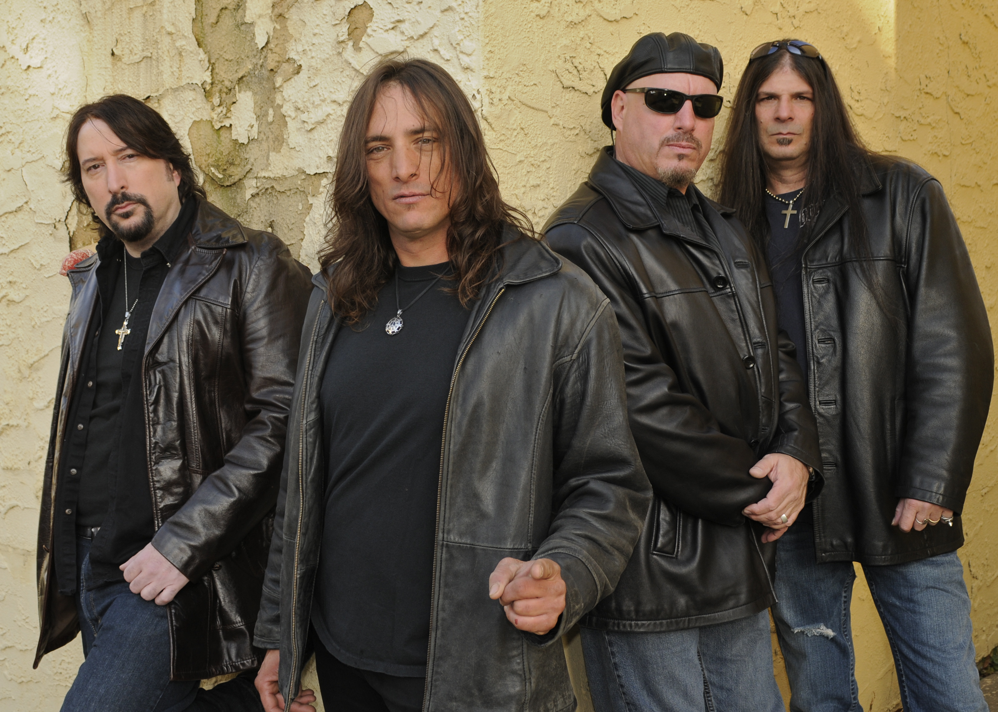

“Great vocal melodies, ripping guitar solos and grooves that hit my old school metal heart.”
– Ron “Bumblefoot” Thal describing LORDS OF MERCY

“LORDS OF MERCY are no nonsense hard rock and roll - full of melody with an emphasis on song writing.”
- Don Jamieson, co-host of VH1 Classic’s That Metal Show

“Great vocals, great album, great song writing LORDS OF MERCY kick ass!”
- Garrett Sweeny and Bob Pantella, Monster Magnet

“LORDS OF MERCY deliver old school power metal in fine tradition. They are a pleasure to listen to.”
- Lips, Anvil

Formed in 2011, Asbury Music Award-nominees LORDS OF MERCY hark back to the early days of thrash metal, hailing from the hub of the East Coast heavy music scene. In addition, LORDS OF MERCY are connected to the notable New Jersey musical grassroots organization Old Bridge Metal Militia, which paved the way for some of today’s top heavy metal acts such as Metallica, Slayer, Anthrax, Anvil, and more.

Lead guitarist Danny Anniello states, “LORDS OF MERCY are very excited to be doing more shows with Anvil. They are great guys and a great band that always goes full on and gives it all they’ve got. We are looking forward to playing in front of new audiences and kicking some new life into each stage that we rock. Like Anvil, Lords will be going full-on, so expect nothing less!”

Prevailing with a purpose to end the monotony of current trends and bring back the originality that put New Jersey on the heavy metal map, LORDS OF MERCY lead the fall touring season with a brief run of upcoming tour dates with Anvil. See below for a list of current tour dates, all within the tri-state area:

LORDS OF MERCY W/ ANVIL
10/15 - Patchogue, NY @ The Emporium
10/16 - Syracuse, NY @ Lost Horizon
10/17 - Long Branch, NJ @ The Brighton Bar

Do not confuse LORDS OF MERCY as a carbon copy of those bands of legends past, but rather a group of talented individuals breathing new life and innovation into a genre that is so easily repetitive and omitting passion and individuality. Listen for yourself by downloading the band’s full-length self-titled album released in December via Main Man Records, available here via iTunes: https://itunes.apple.com/us/album/lords-of-mercy/id780793785

Through their significant connections with some of history’s hottest musical talent, LORDS OF MERCY has garnered respect from local fans and musicians alike, commanding a packed crowd while remaining grateful for the support of those sharing the scene.

For more information on LORDS OF MERCY, please visit www.facebook.com/lordsofmercy or email lordsofmercy@aol.com.

LORDS OF MERCY is:
Danny Anniello – Guitar
Pete Perrina – Drums
Joe Stabile – Bass
Brandon Sweeny – Vocals

For press inquiries and additional information, please contact Adrenaline PR and Maria Ferrero at 732-462-4262 or maria@adrenalinepr.com.

--
To unsubscribe from Adrenaline PR press releases, please send an email to unsubscribe@adrenalinepr.com with your email address as the subject.

Adrenaline PR is a boutique independent public relations, marketing, lifestyle & branding firm. Adrenaline PR boasts a collective five decades of experience in launching thousands of brands and careers while building scene giants. Adrenaline PR is recognized internationally for their credibility and success in promotion of talented bands, artists (fine art, photography and tattoo), labels, tours, events, musicians, film and books. Adrenaline PR is trusted to deliver campaigns beyond what is expected by tapping into the entertainment, culture, and niche lifestyle communities while crossover marketing clients into mainstream media. Adrenaline PR’s roster includes (but is not limited to): 10 Years, 2010 American Idol winner - Lee DeWyze, All That Remains, Anthrax, As I Lay Dying, As The Palaces Burn (Lamb of God documentary), Atreyu, Black Flag (tribute album), Paul Booth - The King of Rock and Roll Tattoo. Vincent Castiglia (surrealist), Derek Hess (art book & calendar), Dethklok, The Devil’s Carnival (film), Dimmu Borgir, Down, Every Time I Die, Ferret Music, Five Finger Death Punch, Good Fight Entertainment, GWAR, Hank Williams III, HATEBREED, Hawthorne Heights, Hesher (film), Housecore Records, Jeremy Saffer (photography, seminars), KMFDM, Lamb of God, Louder Than Hell; The Oral History Of Heavy Metal (book), Machine Head, Miss May I, Motorhead, Mudvayne, Norma Jean, Peter Murphy, REPO! The Genetic Opera (film), Sevendust, Shadows Fall, Suicidal Tendencies, Super Duper Alice Cooper (film), Superjoint Ritual, Testament, The Aristocrats, The Merciless Book of Metal Lists (book), The Punisher (soundtrack), Top Chef, Ronnie James Dio: This Is Your Life (tribute compilation), Smashing Pumpkins (tribute album), Plus, Adrenaline PR has lead the charge on an impressive number of tours and events, such as Live Nation club events, MTV2 Headbanger’s Ball Tour I and II, REPO! The Genetic Opera Road Tour, Rockstar Energy Drink Mayhem Festival (2010 – 2014), Scott Ian’s Speaking Words, Sounds of the Underground, The Cool Tour, Thrash and Burn Tour, Gibson Brands AP MUSIC AWARDS (Fueled By Monster) and the Alternative Press Magazine 20th Anniversary (My Chemical Romance, The Used and Say Anything).

For more information on Adrenaline PR and the roster, visit www.adrenalinepr.com, and follow us on Facebook and Twitter!

