**MEDIA wishing to attend and cover the event may register here for credentials – this is the one and only press submission form for this event: www.altpress.com/press

For Immediate Release
January 8, 2015

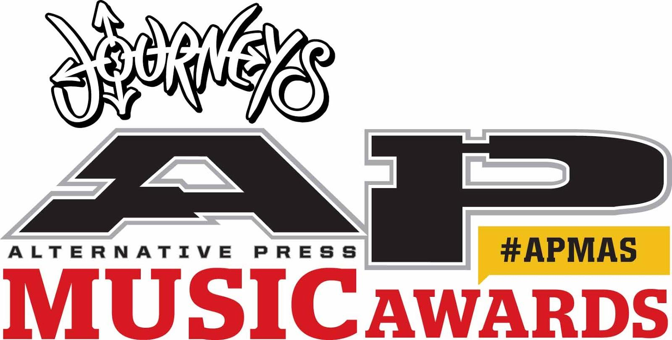

THE JOURNEYS ALTERNATIVE PRESS MUSIC AWARDS RETURNS WITH A VENGEANCE FOR 2015!

APMAS TO TAKE PLACE ON JULY 22, 2015 • CLEVELAND, OH
LIVE FROM THE QUICKEN LOANS ARENA
HOME OF LEBRON JAMES AND THE CLEVELAND CAVALIERS

INTRODUCING HOSTS
ALEX GASKARTH & JACK BARAKAT OF
BILLBOARD CHART-TOPPERS ALL TIME LOW

NOMINEES, PERFORMERS, VOTING, TICKETS, AND MORE AT
WWW.ALTPRESS.COM/APMAS

Last summer, rock music’s newest and most popular awards show – Alternative Press Magazine’s AP Music Awards – made a grand entrance with once-in-a-lifetime performances, a star-studded red carpet and unprecedented support from dedicated fans around the world. Now, the AP Music Awards are back and ready for more, and if last year’s show serves as any indication, 2015’s event is gearing up to be even bigger and better than its spectacular inaugural experience.

This year’s AP Music Awards, sponsored by Journeys, will take place on July 22, 2015, held again in Alternative Press Magazine’s hometown of Cleveland, Ohio, a city being touted as a top travel location for 2015 by key travel blogs and publications such as Fodor’s and the LA Times. Last year, the APMAs solidified Cleveland as an undeniably important spot on the musical map, adding to the list of outstanding events previously held at the esteemed Rock And Roll Hall Of Fame And Museum.

While hosting last year’s event at the Rock Hall was nothing short of incredible, this year’s awards event is being moved to a bigger venue based on anticipated growth reflected by the astounding success of last year’s event. This year, the AMPAs will be held at Quicken Loans Arena, home of LeBron James’ Cleveland Cavaliers! Once again, the Rock And Roll Hall Of Fame And Museum will host the official APMAs afterparty where all the winners, performers and industry insiders will celebrate together in this legendary landmark.

Greg Harris, CEO and President of the Rock And Roll Hall Of Fame And Museum says, “2015 is an incredible year for music and tourism in Cleveland. It’s the 20th Anniversary of the Museum, the Inductions are here in April and the APMAs return in July. These marquee events and our museum exhibits celebrate the power of rock and honor the creators and those who take rock in exciting new directions today. Last year’s APMAs were great, this year will be even bigger and better! We are proud to welcome all fans and artists to Cleveland and our Museum for the AP Music Awards!”

The 2014 APMAs were hosted by Mark Hoppus of Blink-182, who brought true class and comedy to the show. In 2015, Alternative Press has pulled from the new school of rock royalty, inviting hilarious hosts and heartthrobs Alex Gaskarth and Jack Barakat of Billboard-chart topping group and five-time AP cover stars All Time Low. “We couldn't be more honored and excited to be chosen to host the 2015 APMAs,” states Gaskarth. “We've got some big shoes to fill after last year’s amazing debut, but we're going to do our damnedest to make this an award show that truly pays homage to the punk / rock / alternative scenes we hail from. It's all about shaking things up and keeping the night weird and exciting. We can't wait!”

The juicy details fans are anxiously awaiting – including information on this year’s nominees, voting (beginning in March), tickets, performers, pre-show party, red carpet appearances, etc. – will be announced soon, so keep your eyes peeled for more information by visiting www.altpress.com/apmas over the coming weeks.

As mentioned above, the 2015 APMAs are thrilled to be supported by title sponsor, Journeys, a leader in the teen specialty retail scene focused on lifestyle-driven branded footwear and accessories in over 800 stores across all 50 states, Puerto Rico and Canada. “Journeys is committed to supporting the best in music and youth culture, and the APMAs captures both of these worlds,” says Journeys Group President & CEO Jim Estepa. “We're excited to be a part of it.”

In addition to Journeys, the APMAS are welcoming back official radio sponsor idobi along with several other top sponsors, including CreativeLive, Destination Cleveland, Disc Makers, DW Drums, Lace Pickups, and the Rock And Roll Hall Of Fame And Museum.

Alternative Press Magazine CEO Mike Shea states, “The APMAs are the place where the alternative music scene all come together on one night not only to celebrate and honor the best in music from the previous year but also to have one giant party. As a community, due to constant touring and our individual careers, it's difficult to get us all together in one place to celebrate and have some fun. We had an amazing show this past year during the inaugural event and we are looking to throw an even larger party this summer at The Q.”

Last year, the APMAs featured amazing appearances and performances from artists as diverse as Fall Out Boy, Paramore, Joan Jett & the Blackhearts, Ice-T and Body Count, Joe Perry of Aerosmith, the Misfits, Slash, Bring Me The Horizon, Jonathan Davis of Korn, Billy Corgan of Smashing Pumpkins, Coolio and many more. Watch all the highlights here.

Aside from the 6,500 plus attendees in 2014, millions of people were introduced to the APMAs on July 21, 2014 via AXS TV. In addition, to the award show trended No. 1 worldwide for 24-plus hours through Facebook and Twitter with an overall 2.5 billion combined impressions.

Don’t miss the 2015 AP Music Awards! Check back to www.altpress.com/apmas over the coming weeks for new announcements and information.

The APMAs are produced by Josh Bernstein, Mike Shea, Kevin Lyman, Dawn Marshman and Joe Scarpelli.

About Alternative Press:
Now in its 30th year, Alternative Press continues to be on the forefront of discovering new artists, breaking news and reporting on the latest trends in music and youth culture. Since its early days as a pasted-up fanzine in the mid-’80s, Alternative Press is one of the largest music magazines in the world. AP provides in-depth interviews and exclusive photos, making it an essential collectors piece for a passionate fan base, as well as digitally through various mobile and tablet formats. AP has expanded its digital reach via an enhanced mobile app and Altpress.com, one of the world’s fastest-growing websites. The site has become a necessary destination for up-to-the-minute breaking news, coverage from our national APtv correspondents, exclusive multimedia premieres and much more. Additionally, the brand has been successfully extended through live events, beginning with the launch of the AP Tour and the company's inaugural AP Music Award Show, which trended No. 1 worldwide on Twitter and Facebook. Independently owned and operated, AP continues to reach millions of fans, offering them insight to the hottest artists and cultural trends first.

About Journeys:
Journeys is a leader in the teen specialty retail scene, with more than 800 stores in all 50 states, Puerto Rico and Canada. Journeys uses fashion savvy and merchandising science to keep in step with the fast-paced footwear and accessories market for 13- to 22-year-old guys and girls. Journeys offers a wide variety of trendy, relevant brands that cater to teens who seek the hottest, new styles. The Journeys store is more than a retail environment; it’s an extension of the teen lifestyle. From the plasma TVs playing exclusive content and the latest music videos, to the visual merchandising strategy and promotions, to the employees whose image and style reflect the customers’ lifestyle and attitude. In addition, Journeys reaches its customers through www.journeys.com,a mobile website, catalog, national advertising, strategic cross-promotions, social media and grass-roots events like The Journeys Noise Tour. Journeys is, in every way, an attitude you can wear!

About the Rock and Roll Hall of Fame and Museum:
The Rock and Roll Hall of Fame and Museum’s mission is to engage, teach and inspire through the power of rock and roll. The institution carries out its mission by giving voice to the stories of the people, artifacts and events that shaped rock and roll — through Museum exhibits, materials in the Museum’s Library and Archives, traveling exhibitions, and a wide array of innovative educational programs and activities. The 150,000 square-foot Rock and Roll Hall of Fame and Museum, located in Cleveland’s rapidly developing North Coast Harbor, is home to major artifact collections, four state-of-the-art theaters, and year-round educational and concert programming.

The Museum is open seven days a week from 10 a.m. to 5:30 p.m. On Wednesdays (and Saturdays through Labor Day), the Museum is open until 9 p.m. Museum admission is $22 for adults, $18 for adult residents of Greater Cleveland, $17 for seniors (65+), $13 for youth (9-12), children under 8 are free. A 6% Admission Tax that goes to support Cleveland Metropolitan Schools is added to each ticket at purchase. Museum Members are always admitted free, for information or to join the membership program call 216.515.8425. For general inquiries, please call 216.781.ROCK (7625) or visit http://www.rockhall.com. The Ohio Arts Council supports the Rock and Roll Hall of Fame with state tax dollars to encourage economic growth, educational excellence and cultural enrichment for all Ohioans. The Museum is also generously funded by Cuyahoga County residents through Cuyahoga Arts and Culture.

For press inquiries and additional information, please contact Adrenaline PR and Maria Ferrero at 732-462-4262 or maria@adrenalinepr.com.

