**This album is available for review in digital format – serviced to pre-approved outlets on a rolling basis.
Please reply with requests for digital downlaods and any other press interest.

For Immediate Release
January 7, 2015

Guitar Maestro ULI JON ROTH to Release “Scorpions Revisited”
A Double-Disc Collection of Re-Imagined SCORPIONS Classics

Out March 10, 2015 (US) via UDR Music

…Feast your ears, heart and emotions on ULI JON ROTH’s unique return to his most famous musical legacy…

US Tour Dates Below - Jan/Feb 2015

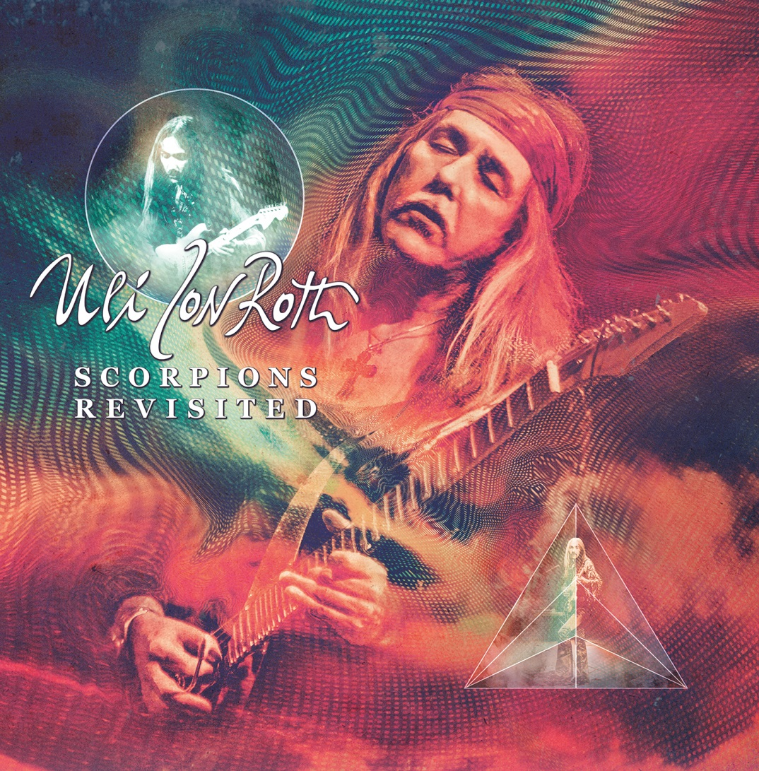

UDR, The Home Of Legends, is set to release guitar legend ULI JON ROTH’s brand new double album of 19 re-invented Scorpions tracks, entitled Scorpions Revisited, on March 10, 2015. Pre-orders for the album will be available soon.

For over four decades, ULI JON ROTH has forged new frontiers in the world of guitar, both in terms of approach and style. He even managed to invent the sky-guitar, a six octave lead instrument that remains unparalleled. But before he started to explore the creative worlds of music, philosophy and art, ULI JON ROTH was a member of European rock giants, the Scorpions, a band with which he helped create a new path in hard rock music. In 2013, venerated for his originality and dynamism at the time, Roth found himself intrigued by the memory of those early days which began 40 years ago, and specifically by the music he helped write, perform and occasionally sing on the albums Fly To The Rainbow, In Trance, Virgin Killer and Taken By Force. It lead to Roth deciding to spend a year re-visiting, exploring, performing and re-recording his favorite Scorpions songs.

The first results of this magical, mystical journey into his own past can be heard on ULI JON ROTH’s Scorpions Revisited, a double-disc CD recorded in Hanover, Germany which sees the maestro re-harness all the collective power and poise of those original Scorpions classics, and re-imagine them as he feels today. No one in their right mind would dare call these mere re-recordings, as it’s clear that ULI JON ROTH reinvents these songs from the soul up.

Track listing - CD1:
- The Sails Of Charon
- Longing For Fire
- Crying Days
- Virgin Killer
- In Trance
- Sun In My Hand
- Yellow Raven
- Polar Nights
- Dark Lady

Track listing - CD2:
- Catch Your Train
- Evening Wind
- All Night Long
- We’ll Burn In The Sky
- Pictured Life
- Hell Cat
- Life’s Like A River
- Drifting Sun
- Rainbow Dream Prelude
- Fly To The Rainbow

“The material for this double CD was recorded last year in the same hall in Hanover that we used for the Scorpions rehearsals 1973-1978,” explains Roth. “Together with an amazing bunch of very talented young musicians, I revisited my personal favourites from the early Scorpions period, some of which were written in that same hall. It was an emotional few days and I am very pleased with the results in more ways than one. The idea was to stay truthful to the original spirit of the music, while also putting a new slant on it whenever it felt like the right thing to do. I feel we really succeeded in this and I’m very excited about this project. It was a intense journey into the past and I think we really managed to bring the songs back to life with a vengeance.”

The band which performed with Roth for these historic shows was Nathan James (vocals), Jamie Little (drums), Ule W. Ritgen (bass), Niklas Turmann (guitar, vocals), Corvin Bahn (keyboards, vocals) and David Klosinski (guitar).

As noted, this is the first fruit from a re-engagement with his history that left ULI JON ROTH enjoying a surge of fresh creativity and approach to this classic material. Expect a further announcement for 2015. But for now, feast your ears, heart and emotions on ULI JON ROTH’s unique return to his most famous musical legacy.

2015 ULI JON ROTH US Tour Dates:
JANUARY
21.01.2015 – California – Ramona - Mainstage
22.01.2015 – California – Anaheim - House of Blues
23.01.2015 – California – Hollywood - House of Blues
24.01.2015 – Nevada – Las Vegas - Vamp’d
25.01.2015 – California – San Josè - Rock Star Bar
26.01.2015 – Oregon – Portland - Tonic
27.01.2015 – Washington – Seattle - Studio 7
29.01.2015 – Minnesota – Moorehead - The Garage
30.01.2015 – Minnesota – Spring Lake Park - POVS
31.01.2015 - Illinois – St. Charles – Arcada Theatre
FEBRUARY
01.02.2015 - Illinois – Chicago – Reggie’s (& Sky Academy)
02.02.2015 – Michigan – Detroit – Token Lounge
03.02.2015 – Toronto – Mod Club
04.02.2015 – Ohio – Cleveland – Agora Ballroom
05.02.2015 – Connecticut – Hartford – Infinity Hall
06.02.2015 – New Hampshire – Londonderry – Tupelo Music Hall
07.02.2015 – New York – Poughkeepsie – The Chance
08.02.2015 – New York – Manhattan – BB King’s
09.02.2015 – Virginia – Springfield – The Empire
2015 ULI JON ROTH International Tour Dates:
19.02.2015 – Japan – Nagoya – Bottom Line
20.02.2015 – Japan – Tokyo – Nakano Sun Plaza Hall
22.02.2015 – Japan Osaka - Quattro
11.04.2015 – Full Metal Cruise II –
to Mediterranian Sea –
16.04.2015 Plama de Mallorca/Barcelona/Ibiza
24.04.2015 – Germany – Lauda-Königshofen – Keep it True Festival
22.05.2015 – Germany – Bocholt – Alte Molkerei
23.05.2015 – Germany – Bocholt – Alte Molkerei
22.08.2015 – Germany – Balve - Balver Höhle
27.08.2015 - Full Metal Cruise III –
to North Sea -
31.08.2015 Kiel/Copenhaven/Gothenburg/Hamburg

For more information, please visit www.ulijonroth.com and www.udr-music.com.

For press inquiries and additional information, please contact Adrenaline PR and Maria Ferrero at 732-462-4262 or maria@adrenalinepr.com.

--
To unsubscribe from Adrenaline PR press releases, please send an email to unsubscribe@adrenalinepr.com with your email address as the subject.

Adrenaline PR is a boutique independent public relations, marketing, lifestyle & branding firm. Adrenaline PR boasts a collective five decades of experience in launching thousands of brands and careers while building scene giants. Adrenaline PR is recognized internationally for their credibility and success in promotion of talented bands, artists (fine art, photography and tattoo), labels, tours, events, musicians, film and books. Adrenaline PR is trusted to deliver campaigns beyond what is expected by tapping into the entertainment, culture, and niche lifestyle communities while crossover marketing clients into mainstream media. Adrenaline PR’s roster includes (but is not limited to): 10 Years, 2010 American Idol winner - Lee DeWyze, All That Remains, Anthrax, As I Lay Dying, As The Palaces Burn (Lamb of God documentary), Atreyu, Black Flag (tribute album), Paul Booth - The King of Rock and Roll Tattoo. Vincent Castiglia (surrealist), Derek Hess (art book & calendar), Dethklok, The Devil’s Carnival (film), Dimmu Borgir, Down, Every Time I Die, Ferret Music, Five Finger Death Punch, Good Fight Entertainment, GWAR, Hank Williams III, HATEBREED, Hawthorne Heights, Hesher (film), Housecore Records, Jeremy Saffer (photography, seminars), KMFDM, Lamb of God, Louder Than Hell; The Oral History Of Heavy Metal (book), Machine Head, Miss May I, Motorhead, Mudvayne, Norma Jean, Peter Murphy, REPO! The Genetic Opera (film), Sevendust, Shadows Fall, Suicidal Tendencies, Super Duper Alice Cooper (film), Superjoint Ritual, Testament, The Aristocrats, The Merciless Book of Metal Lists (book), The Punisher (soundtrack), Top Chef, Ronnie James Dio: This Is Your Life (tribute compilation), Smashing Pumpkins (tribute album), Plus, Adrenaline PR has lead the charge on an impressive number of tours and events, such as Live Nation club events, MTV2 Headbanger’s Ball Tour I and II, REPO! The Genetic Opera Road Tour, Rockstar Energy Drink Mayhem Festival (2010 – 2014), Scott Ian’s Speaking Words, Sounds of the Underground, The Cool Tour, Thrash and Burn Tour, Gibson Brands AP MUSIC AWARDS (Fueled By Monster) and the Alternative Press Magazine 20th Anniversary (My Chemical Romance, The Used and Say Anything).

For more information on Adrenaline PR and the roster, visit www.adrenalinepr.com, and follow us on Facebook and Twitter!

