These fellas are persistent… after a “SPEC DEAL” in 2003 with producer John Blanche (mastering engineer- The Eagles, Hotel California, Bee Gees), and many shows at venues such as Hard Rock Live, Freebird Live, etc… radio play, the almost 2 years in the studio took its toll and as a result ways were parted as a band in 2005.

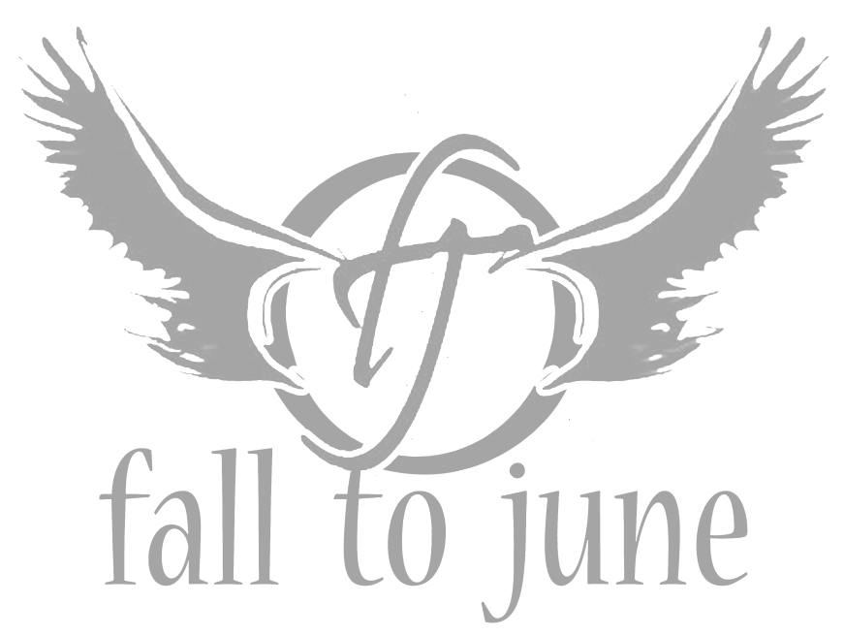Fast forward to 2011… Nate had just exited a long time gig with NerVer (Casey Daniel, Seven Mary Three) and felt left with a huge void. Playing several acoustic gigs around the southeast was just not cutting it. He knew where the magic was and that was in the music of Fall To June. Through a friend of the band (Nolan Neal) Nate was introduced to Brad Stewart (Fuel, Shinedown, Ballistic Audio). Nate and Brad got together on doing a new Fall to June EP with an all star production cast including Stan Martell, Josh Like and Alex Gibson. Jeremy Marshall of Cold signed on to handle bass tracks and so it began. Nate got the boys back together and within a couple of months they were back in the studio.

The recording session at Martell Studios yielded far more than imagined. The EP got the attention of Brad Stewart at Ballistic Audio and a production deal was signed for The EP and a Video for the single Delta Breakdown. Ballistic Audio then stepped in and negotiated directly with Megaforce Records and Sony Red Distribution and secured the band a 3 year deal to get this EP out to the masses.

Ballistic Audio assembled an All Star production team to do the video for the EP’s title track and single “Delta Breakdown”. Produced by Meagan Gibson (The Voice) and directed by Student Academy Award winner Heather Burky , the video is poised to drive the single as it heads to Radio.
The band is gearing up for the release of the EP worldwide as well as a Regional tour to promote the single. A more rigorous National tour is being planned as well as a full length LP for early 2015.

These fellas sure are persistent and focused to bring real Rock music played by real Musicians on real instruments to the world.

