For Immediate Release
February 17, 2015

American Metal Legends TESTAMENT Announce “Dark Roots of Thrash II” Tour, Coming April 2015

TESTAMENT to Perform an Exclusive New Set List, Including The Legacy and The New Order in Their Entirety + Select Practice What You Preach Album Cuts

Re-Introducing Bassist STEVE DIGIORGIO

Support from Thrash Leaders EXODUS + Texas Metal Assailants SHATTERED SUN

TESTAMENT and EXODUS Combined VIP Meet & Greet Experience Available via www.SLOTIX.com

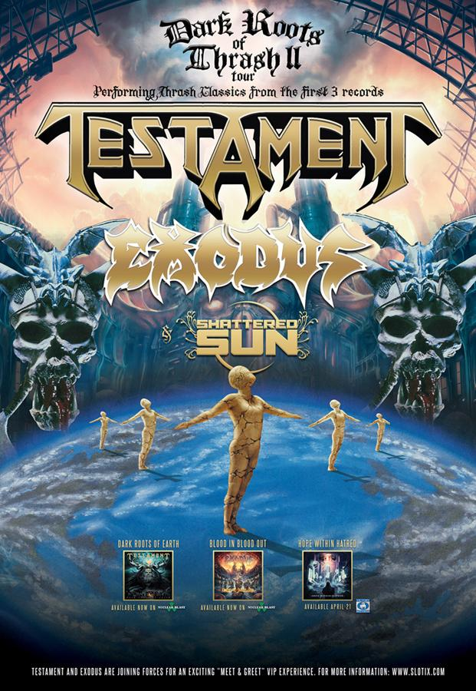

Leaders of the classic American metal scene, TESTAMENT, are announcing what will undoubtedly be the most crushing heavy metal tour to hit North America this spring – the Dark Roots of Thrash II tour! The Dark Roots of Thrash II tour will conquer North America for five weeks, beginning April 1st in San Francisco, and will include select TESTAMENT and EXODUS festival performances. Select cities are on sale now, and more dates will be announced soon.

Adding to TESTAMENT’s live onslaught, fans will receive a guaranteed pummelling from the Dark Roots of Thrash II tour’s revered support: fellow Bay Area-thrashers EXODUS and Texas melodic metal assailants SHATTERED SUN.

TESTAMENT, EXODUS and SHATTERED SUN “Dark Roots of Thrash II” Dates:
04/01/15 Regency Ballroom – San Francisco, CA
04/02/15 House Of Blues – Hollywood, CA
04/03/15 Livewire – Scottsdale, AZ
04/04/15 Sunshine Theater – Albuquerque, NM
04/06/15 Aztec Theater – San Antonio, TX
04/07/15 House Of Blues – Houston, TX
04/08/15 House Of Blues – Dallas, TX
04/10/15 Pop’s – Sauget, IL
04/11/15 Mojoes – Joliet, IL
04/12/15 Harpo’s – Detroit, MI
04/13/15 The Intersection – Grand Rapids, MI
04/15/15 Phoenix Concert Theatre – Toronto, ON – CANADA
04/16/15 Rapids Theatre – Niagara Falls, NY
04/17/15 Starland Ballroom – Sayreville, NJ
04/18/15 The Palladium – Worcester, MA, New England Metal & Hardcore Festival
04/19/15 The Paramount – Huntington, NY
04/21/15 Mercury Ballroom – Louisville, KY
04/22/15 Cannery Ballroom – Nashville, TN
04/23/15 Masquerade – Atlanta, GA

Additional TESTAMENT & EXODUS Festival Dates (No SHATTERED SUN):
04/25/15 – Metropolitan Park – Jacksonville, FL, Welcome To Rockville Festival
05/01/15 – Farm Bureau Live – Virginia Beach, VA, Lunatic Luau 15
05/03/15 – Charlotte Motor Speedway – Concord, NC, Carolina Rebellion 2015

Additional dates will be announced soon.

In addition to its monumental line-up, the Dark Roots of Thrash II tour sees TESTAMENT serving up another surprise for die-hard fans of their early tenure. Each night, TESTAMENT will perform an epic headlining set that digs deep into the early discography that launched their worldwide career spanning two-and-a-half decades. TESTAMENT’s exclusive set will feature full-album performances of 1987’s classic body of work The Legacy and 1988’s unrelenting The New Order, in addition to select tracks from 1989’s mainstream crossover Practice What You Preach.

The Dark Roots of Thrash II tour marks the live re-introduction of TESTAMENT bassist Steve DiGiorgio. This isn’t DiGiorgio’s first time playing with TESTAMENT, as he is credited for recording bass on 1999’s The Gathering and 2001’s First Strike Still Deadly. Additionally, the tour will mark the live debut of Alex Skolnick’s anticipated brand new signature ESP guitars and Budda amps. Learn more about the guitars and amps at these links.

Brothers and sisters in metal – meet TESTAMENT and EXODUS via a combined VIP Meet & Greet Experience package – available for the first time during this tour via www.slotix.com. The combined VIP experience includes:

· One Premium Reserved ticket or One General Admission ticket
· A Meet & Greet with select members of TESTAMENT and EXODUS
· Individual & Group Photo opportunities with select members of TESTAMENT and EXODUS
· Exclusive TESTAMENT/EXODUS poster
· Collectible TESTAMENT/EXODUS commemorative laminate
· On-site check-in staff

TESTAMENT vocalist Chuck Billy states, “The stars have finally aligned. After almost 30 years of touring, TESTAMENT and EXODUS get to share our individual styles of thrash metal across the U.S. and Canada. The Day of Reckoning is here and coming to a town near you. Good times with good friends – heavy metal forever!”

EXODUS guitarist Gary Holt adds, “EXODUS are very excited in the most violent of fashion to announce our part in the Dark Roots of Thrash II tour with our old friends and label mates TESTAMENT, as well as soon to be new friends SHATTERED SUN! This is gonna be a thrash metal tour de force and we cannot wait to deliver a Bay Area beating to everyone, everywhere, in every way! We shall see everyone out there!”

“We are ecstatic to announce this tour with TESTAMENT and EXODUS,” offers SHATTERED SUN frontman Marcos Leal. “This will be our first national tour and we couldn't be more ready to represent and show the world what we are all about! We have been anticipating getting out there and playing this album to the fans, so the moment we have been fighting for has finally arrived! Thank you to TESTAMENT for having us out, this is a huge honor for us and our family and we look forward to wreaking havoc with our brothers in metal EXODUS.”

The Dark Roots of Thrash II tour embodies the true lineage of American thrash metal.

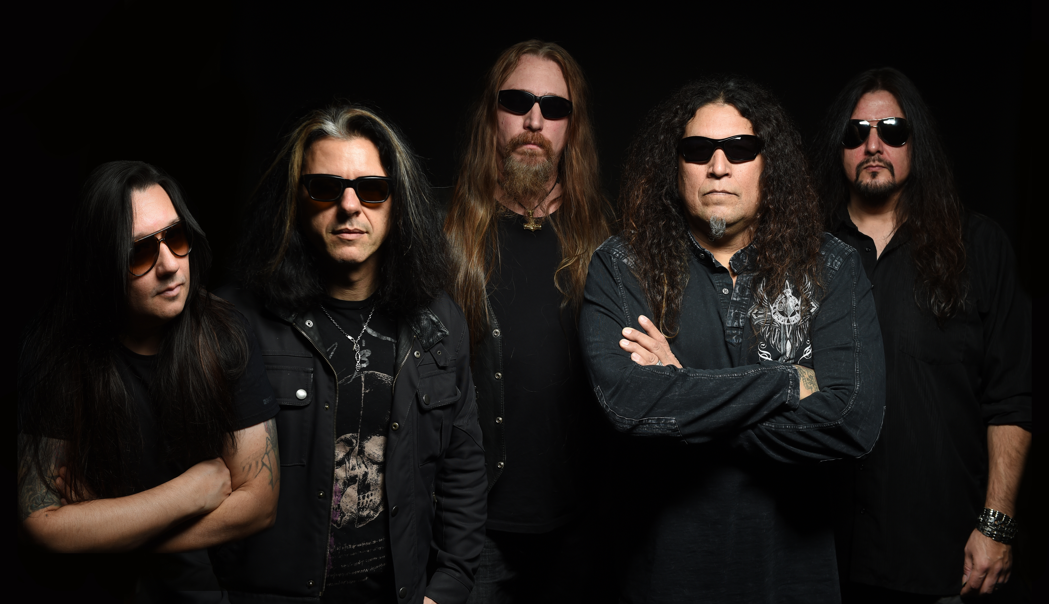

ABOUT TESTAMENT:
In 2012, TESTAMENT’s Dark Roots Of Earth debuted at #12 on the Billboard Top 200 Albums chart, #1 on the Independent Albums chart, and #1 on the Top Hard Music Albums chart with the band’s highest first week sales since the inception of Soundscan. The album roared into the #9 position on the World Sales chart - a huge accomplishment for a metal band on a chart that included pop artists such as ADELE, JUSTIN BIEBER, LINKIN PARK, JENNIFER LOPEZ and MAROON 5. In 2013, TESTAMENT released their Dark Roots Of Thrash live DVD/CD, recorded via multi-camera angles at their sold-out headlining performance at the Paramount in Huntington, New York. Order both titles from the Nuclear Blast USA Webshop.
“Native Blood” is TESTAMENT’s award-winning video.

View TESTAMENT’s official live video of “Rise Up” on the Nuclear Blast YouTube channel.

Visit TESTAMENT online at www.TESTAMENTLEGIONS.com.
Like: www.facebook.com/TESTAMENTLEGIONS
Twitter: twitter.com/TESTAMENT
Watch: www.youtube.com/TESTAMENTOFFICIAL

ABOUT EXODUS:
This year, thrash architects EXODUS celebrate 30 years since the release of their first album, thrash metal’s classic blueprint Bonded By Blood. Keeping with that tradition, EXODUS was joined by their original guitarist, Metallica’s Kirk Hammett, on their most recent release Blood In, Blood Out (2014). In its first week, Blood In, Blood Out doubled the first week sales of their most previous full-length release, in addition to securing their highest charting position ever – #38 on the Billboard Top 200 Albums chart, as well as #2 on the Hard Rock/Metal chart and #6 on the Independent Albums chart. Blood In, Blood Out gained a strong foothold in European countries by topping several first-week international charts, as well as landing at #6 on Canada’s Hard Music chart. Order the dual-disc Blood In, Blood Out digi-pak from http://smarturl.it/EXODUS-Blood. EXODUS recently finished up a highly-successful tour with heavy music titans Slayer and Suicidal Tendencies.

“Blood In, Blood Out” is the latest video by EXODUS.

Visit EXODUS online at www.EXODUSATTACK.com.
Like: www.facebook.com/EXODUSATTACK
Follow: twitter.com/EXODUSATTACK
Watch: www.YouTube.com/EXODUS

ABOUT SHATTERED SUN:
Victory Records’ SHATTERED SUN are poised to dominate the metal scene. The six-piece is a remarkable example of hard work and determination, coming a long way from their industrious origins. SHATTERED SUN reflect the roots of their influences amidst their vigorous Southern backdrop, slamming together into a sound that is Hope Within Hatred, their debut album to be released April 21, 2015 via Victory Records. What sets SHATTERED SUN apart from the crowd is their lyrical content in a time where it seems most heavy music is about negativity and angst. SHATTERED SUN empower with their message of hope and positivity.

“Hope Within Hatred” lyric video by SHATTERED SUN.

Visit SHATTERED SUN online at www.victoryrecords.com/shatteredsun.
Like: https://www.facebook.com/ShatteredSunBand
Follow: https://twitter.com/shatteredsun

For press inquiries and additional information, please contact Adrenaline PR and Maria Ferrero at 732-462-4262 or maria@adrenalinepr.com.

--
To unsubscribe from Adrenaline PR press releases, please send an email to unsubscribe@adrenalinepr.com with your email address as the subject.

Adrenaline PR is a boutique independent public relations, marketing, lifestyle & branding firm. Adrenaline PR boasts a collective five decades of experience in launching thousands of brands and careers while building scene giants. Adrenaline PR is recognized internationally for their credibility and success in promotion of talented bands, artists (fine art, photography and tattoo), labels, tours, events, musicians, film and books. Adrenaline PR is trusted to deliver campaigns beyond what is expected by tapping into the entertainment, culture, and niche lifestyle communities while crossover marketing clients into mainstream media. Adrenaline PR’s roster includes (but is not limited to): 10 Years, 2010 American Idol winner - Lee DeWyze, All That Remains, Anthrax, As I Lay Dying, As The Palaces Burn (Lamb of God documentary), Atreyu, Black Flag (tribute album), Paul Booth - The King of Rock and Roll Tattoo. Vincent Castiglia (surrealist), Derek Hess (art book & calendar), Dethklok, The Devil’s Carnival (film), Dimmu Borgir, Down, Every Time I Die, Ferret Music, Five Finger Death Punch, Good Fight Entertainment, GWAR, Hank Williams III, HATEBREED, Hawthorne Heights, Hesher (film), Housecore Records, Jeremy Saffer (photography, seminars), KMFDM, Lamb of God, Louder Than Hell; The Oral History Of Heavy Metal (book), Machine Head, Miss May I, Motorhead, Mudvayne, Norma Jean, Peter Murphy, REPO! The Genetic Opera (film), Sevendust, Shadows Fall, Suicidal Tendencies, Super Duper Alice Cooper (film), Superjoint Ritual, Testament, The Aristocrats, The Merciless Book of Metal Lists (book), The Punisher (soundtrack), Top Chef, Ronnie James Dio: This Is Your Life (tribute compilation), Smashing Pumpkins (tribute album), Plus, Adrenaline PR has lead the charge on an impressive number of tours and events, such as Live Nation club events, MTV2 Headbanger’s Ball Tour I and II, REPO! The Genetic Opera Road Tour, Rockstar Energy Drink Mayhem Festival (2010 – 2014), Scott Ian’s Speaking Words, Sounds of the Underground, The Cool Tour, Thrash and Burn Tour, Gibson Brands AP MUSIC AWARDS (Fueled By Monster) and the Alternative Press Magazine 20th Anniversary (My Chemical Romance, The Used and Say Anything).

For more information on Adrenaline PR and the roster, visit www.adrenalinepr.com, and follow us on Facebook and Twitter!

