For Immediate Release
June 11, 2015

Announcing the First Annual FOOD TRUCK & ROCK CARNIVAL
September 18-20, 2015 @ Oak Ridge Park in Clark, NJ

GODSMACK, SLASH, STONE TEMPLE PILOTS & More to Perform
Live Concert Tickets Starting at $29.99 (Single Day) and $54.99 (Weekend Pass)
See Below for FULL Price Breakdown + VIP & Cabana Pricing

An Action-Packed Weekend Including FREE Events Such As:
Full Classic Carnival with Amusement Rides
40+ Food Truck Competition
Craft Beer Village
Pro-Wrestling
Hypnotist, Illusionist
& More

www.TheRockCarnival.com

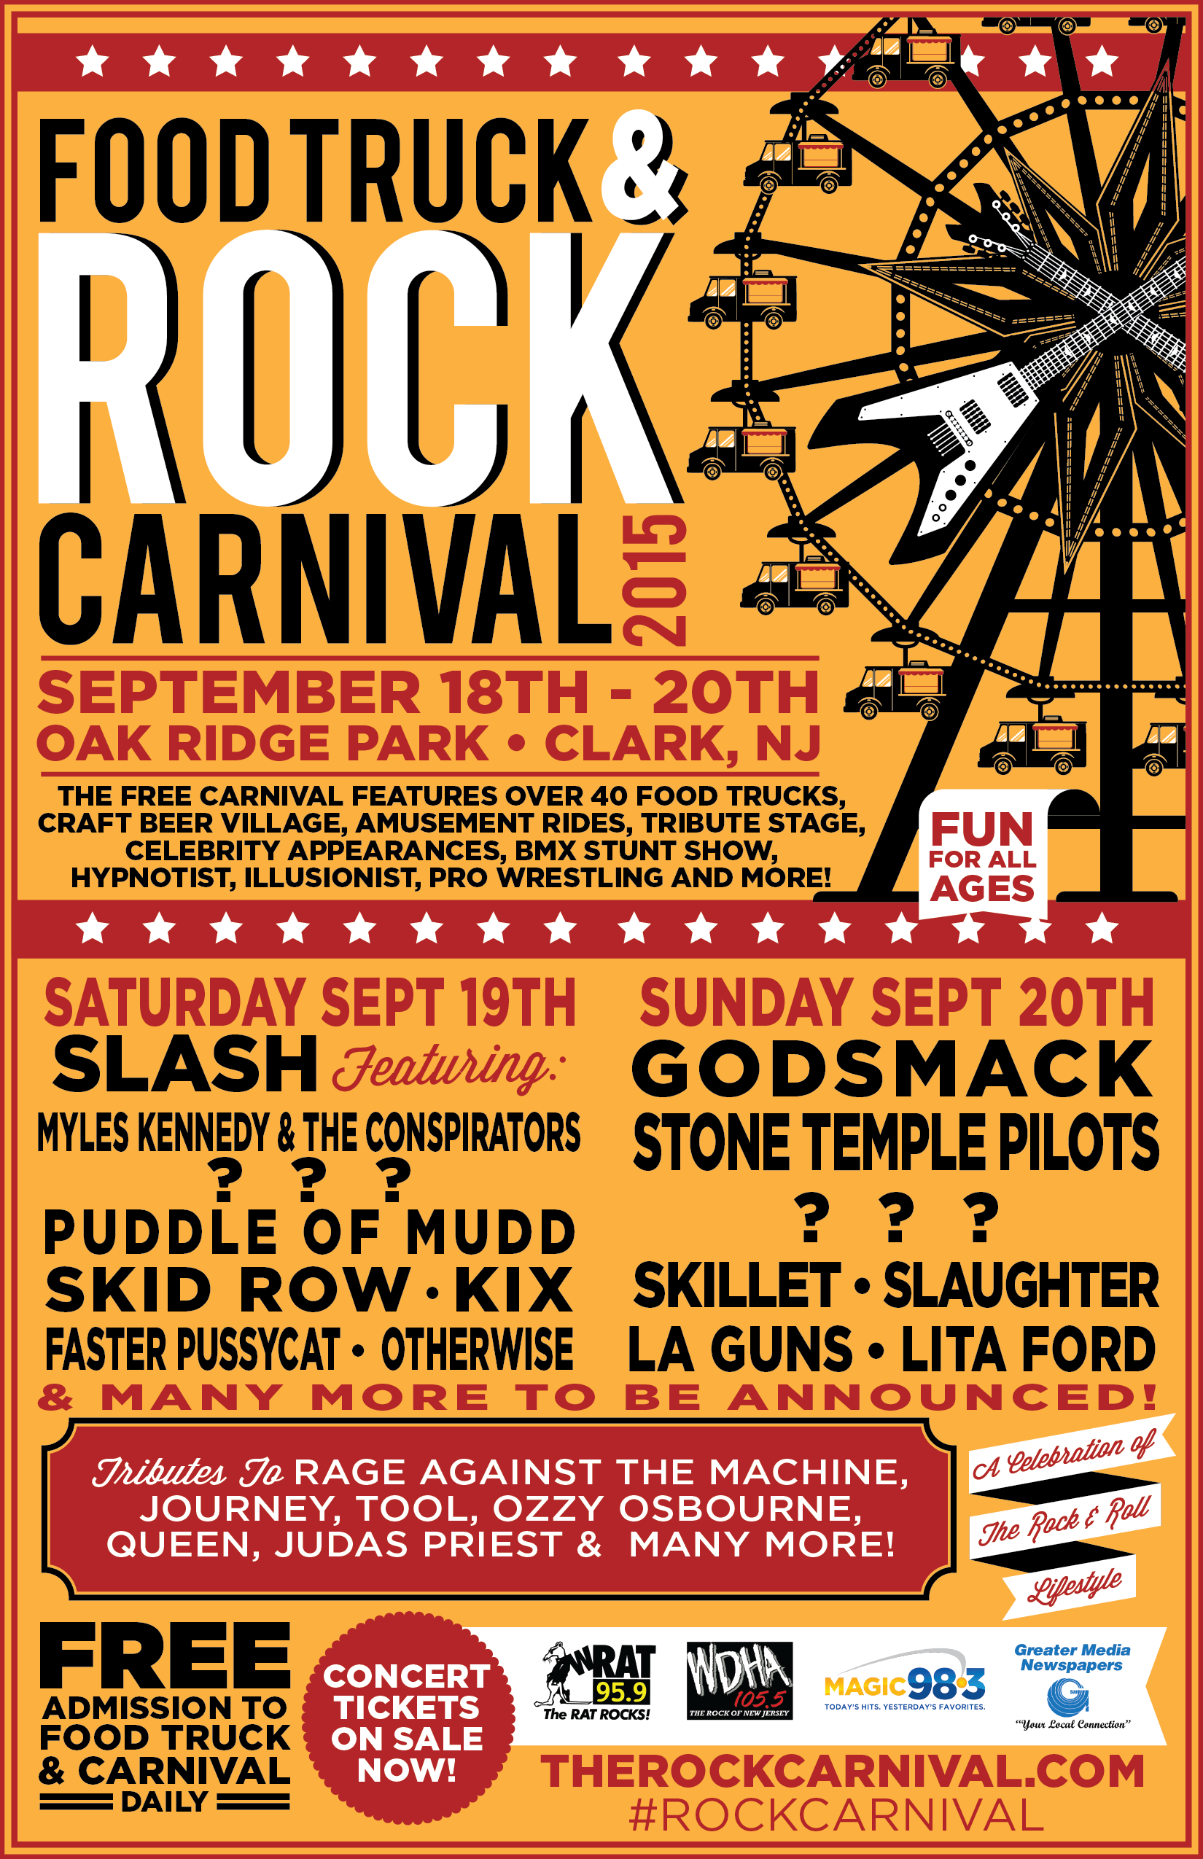

In the “age of the festival” – whether it be for food trucks, music festivals, beer festivals, etc. – several things are often left desired. Event-goers want fun for all ages, including entertainment that the entire family can enjoy, with activities, music, and refreshments available throughout the event. What if you could experience all of those things, with a classic carnival experience, FREE food truck competition featuring 40+ trucks, four stages of continuous live music from chart-topping, Grammy-winning artists, beer gardens, pro-wrestling, and more, all in one weekend?

This September 18th, 19th and 20th, the first annual FOOD TRUCK & ROCK CARNIVAL comes to Oak Ridge Park in Clark, NJ – and believe it or not – features all of the above and more! In addition to celebrating the rock n’ roll lifestyle, the FOOD TRUCK & ROCK CARNIVAL includes fun for all ages and walks of life.

Several FOOD TRUCK & ROCK CARNIVAL activities will offer FREE admission to all, with daily events including live music, GCW pro-wrestling, food truck competitions, karaoke and discount, high-energy amusement rides. The event will also include a special vendor village.

See below for all currently confirmed information, and stay tuned for more coming soon!

CARNIVAL FUN - FREE ENTRY!
As mentioned above, the FOOD TRUCK & ROCK CARNIVAL will bring you daily action-packed, high energy rides. Rides and amusements will require tickets or wristbands, and will include everything from classic ferris wheels to thrill-inducing rides. Discount Ride Programs will be hosted on Friday, September 18th with unlimited ride wristbands available for purchase.

A Tribute Bands Music Stage in the free carnival area will include performances by renowned Tool cover band Schism, Rage Against the Machine cover band RATM2, Queen cover band Almost Queen, Ozzy Osbourne cover band Ozzmosis, Judas Priest female cover group Judas Priestess, Journey cover band Voyage, and more to be announced. A special battle of the bands competition will also take place with The Break Contest (nationally and in NJ), in conjunction with the Union County Performing Arts Center.

LIVE CONCERTS - PRICING BELOW!
Live music entertainment will come from many of today’s hottest rock music groups, including Godsmack, Slash feat. Myles Kennedy and The Conspirators, Stone Temple Pilots, Skid Row, Skillet, Puddle of Mudd, Otherwise, Slaughter, Faster Pussycat, LA Guns, Lita Ford, Kix and more to be announced.

Live music tickets are on sale now - starting affordably low:
Single Day Passes - $29.99
(Under 16 $19.99, Under 10 FREE - intro prices valid until July 6th)

Full Weekend Passes - $54.99
(Under 16 $39.99, Under 10 FREE - intro prices valid until July 6th)

Single Day VIP Passes - $129.99
Weekend VIP Passes - $249.99
*VIP Includes Access to VIP Lounge Area, Private Entrance, Side of Stage Privileges, Access to private Restrooms with Attendants, Lamite/Lanyard, unlimited ride wristband, 21+ or accompanied by an adult 21+.

Ringmaster Cabana - $3,499
*Limited Quantity Available. This package is for 6 event tickets in total for the weekend. The Ringmaster Cabana includes the VIP ticket package plus a private six person tent (10x10 high peak tent), furniture and a cocktail table, Food Truck and Rock Carnival cooler with a microbrew six-pack, personal parking with shuttle service, a private restroom per cabana, and waitress/waiter service available! 21+.

Rockstar Cabana - $4,499
*Limited Quantity Available. This package is for 6 event tickets in total for the weekend. The Rockstar Cabana includes a 30 minute meet and greet in your cabana + photos and autographs with Slaughter, Faster Pussycat, Kix, Lita Ford, and more, the VIP ticket package, a private six person tent (10x10 high peak tent), furniture and a cocktail table, Food Truck and Rock Carnival cooler with a microbrew six-pack, personal parking with shuttle service, a private restroom per cabana, and waitress/waiter service available! 21+.

Act now – ticket prices will rise as the FOOD TRUCK & ROCK CARNIVAL nears!

In addition, the FOOD TRUCK & ROCK CARNIVAL Concert Field will feature the Birch Hill Stage, featuring performances from some of the legendary acts who called the New Jersey music scene home. The Birch Hill was an iconic rock nightclub open in New Jersey until the early 2000s. The Birch Hill launched the careers of some of today's biggest names in rock and roll... from Linkin Park, System Of A Down, Blink 182, Kid Rock, and Korn. Chart toppers from the 80s and 90s along with some special guests will deliver an action packed experience for all those fans who want just one more weekend to relive all those memories. The actual Public Address system from the original Birch Hill will be used for this event. The stage layout and set up with be that of the venue’s historic layout. A fun way to pay homage to a premier venue that introduced some of our generation’s greatest talent!

FOOD TRUCKS - FREE ENTRY!
The 40+ food truck competition element of the weekend is running in conjunction with the New Jersey Food Truck Association, and will include many popular food trucks vying for the 1st place spot, scheduled to be hosted and judged by a celebrity chef (to be announced). On Friday night, each guest will receive a ballot to cast their vote for their favorite truck. The trucks will be serving their most popular items and our layout should help prevent any long lines from hindering your experience. The competition aspect of the food truck event is very unique to the FOOD TRUCK & ROCK CARNIVAL!

Confirmed, delicious food trucks include Aroy-D the Thai Elephant, The French Quarter, Luke’s Lobster, Pizza Vita, Dark Side of the Moo, The Cow and the Curd, Amanda Bananas, Falafull Gourmet, Jersey Johnnies, Oink n Moo, The Original Soupman, The Outslider, Cupcake Carnivale, Fork in the Road, Prime Kutz, Waffles de Lys, Rockland Roots. More trucks are being added daily. Save room, the event will have some incredible desserts and fair favorites available!

BEER GARDENS - FREE ENTRY!
The FOOD TRUCK & ROCK CARNIVAL has partnered with micro-breweries, offering some of the finest craft beers from around the country. Craft beer will be available exclusively in the carnival and within the Concert Field Beer Gardens. In the next few weeks, the FOOD TRUCK & ROCK CARNIVAL will be unveiling their line-up of brewers and the amazing selections that will be on tap and available for their guests 21 and up. Proper ID will be required to enter the Craft and Beer Gardens.

*Please note that the event will offer picnic areas for families, friends and guests to relax, enjoy the above food and drink refreshments. Tables will be on a first come, first serve basis. Restroom facilities, baby changing stations will be available in the picnic areas. Tent and seating will be limited and not guaranteed.

LIVE ACTION WRESTLING - FREE ENTRY!
The FOOD TRUCK & ROCK CARNIVAL has partnered with GCW Pro Wrestling to bring you the best ring action. The GameLoud Arena will feature WWE Legends along with some of the best in the pro wrestling circuit battling for the ultimate Rock Carnival Championship Title. With three shows daily, this is an event not to be missed.

GAMING - FREE ENTRY!
For this event specifically, GameLoud will present a special video gaming tournament. Open to all gamers, GameLoud will host various competitions and gaming activities all weekend long in a tent, featuring individual and team play. Slots are on a first come, first serve basis. Rules, Game play schedules and more will be posted in the next few weeks...Stay Tuned and bring your best! The GameLoud Mobile Tent will be open daily from 1pm to 7pm. Gaming is free and open to all. Free play sessions and competition schedules will be released. Be patient, it takes time to plan perfection. Download the FREE GameLoud App to stay connected with The FOOD TRUCK & ROCK CARNIVAL. Win prizes playing on our artist to fan mobile platform.

Detailed information outlined by date is coming soon!
For constantly updated information and tickets + VIP packages, please visit www.TheRockCarnival.com.

Learn More:
WEBSITE: www.therockcarnival.com
MOBILE APP: Gameloud On IOS & ANDROID
FACEBOOK: www.facebook.com/therockcarnival
TWITTER: @therockcarnival
INSTAGRAM: @therockcarnival

ABOUT THE FOOD TRUCK AND ROCK CARNIVAL:
The FOOD TRUCK & ROCK CARNIVAL is a multi-day celebration of the Rock And Roll lifestyle to include food truck competitions, concerts, amusement rides, music themed inter-actives and exciting performances geared for music fans of all ages. The Rock Carnival is the creative partnership of John D'Esposito of GameChanger, Larry Fishman of Top Wave Entertainment and Stan Levinstone of SLP Concerts, all New Jersey based firms who handle talent buying for top area venues along with Six Flag Theme Parks, Skate And Surf Festival, Electric Adventure Festival and The Bamboozle Festival. The event includes a free food truck and carnival for all to enjoy with tickets required for admission to concert field.

For press inquiries and additional information, please contact Adrenaline PR and Maria Ferrero at 732-462-4262 or maria@adrenalinepr.com.

