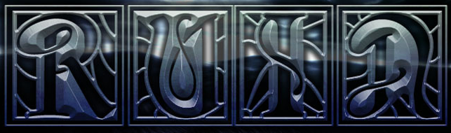

RUIN’s highly anticipated release Rite of Passage hit the shelves last October, setting fire to the metal scene. Their distinguished no holds barred style crashes full speed ahead, taking no prisoners. The thunderous four piece displays an unabashed, unrelenting sound. From their reflective and compelling lyrical content to their devastating musical precision, RUIN is a force of nature. They deviate from current convention by producing a bold stripped down American metal that cuts across styles and stands alone. Hailing from their hometown, Portland Maine, the band was founded by brothers Rich and Craig Carey, and completed by Kevin Whitman and Todd Bidwell. Created a decade ago, Ruin has released three full length albums independently: Hands of Enmity in 2007, Human Moral Deception in 2009, and Rite of Passage.

