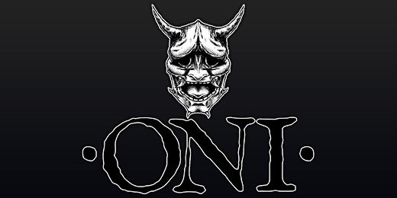

'Ironshore' - available November 25th, 2016

In Japanese folklore, the Oni is a malevolent shape-shifting demon, able to take on many guises as it spreads pain and misery. The constantly shifting, ever-evolving sound of Ontario, Canada's Oni is no less elusive, though unlike their namesake, amidst the brutality and violence, they weave great beauty, and a breadth of heartfelt emotion. "We want the songs that we write to not only move us but move our fans, and stand the test of time" states vocalist Jake Oni. "And though our music is very technical, songwriting is so important to everything we do. The songs need to rock, regardless of how well anyone plays their instrument, and we want to write songs that people can bang their heads to, and have fun with."

Formed in 2014, the initial vision was "to be the band I never got to see", explains Jake Oni. With their influences rooted in progressive metal, Oni's sound can be compared to the genre's heavy hitters - The Human Abstract, Protest The Hero and Between The Buried And Me - yet they remain truly unique. With Jake Oni handling vocal duties, Martin Andres and Brandon White on guitar, Chase Bryant on bass and Joe Greulich on drums, they are also perhaps the first metal band to feature a Xylo-synth player, in the form of Johnny D, which adds an intriguing dynamic to the nine tracks found on their full-length debut, Ironshore.

Emphasizing Oni's many strengths, Ironshore takes listeners on an absorbing ride that provides ample opportunity for head-banging, singing along, and deep introspection. With first single, "Eternal Recurrence", the band snaps and snarls through a barrage of savage yet controlled violence, counterpointed by passages of unfettered grace, and shredding that is as complex as it is melodic. In 4 minutes and 54 seconds, they demonstrate the breadth of their musical mastery and songwriting abilities, which runs through the course of the album. Lyrically, Jake Oni also refuses to limit himself to a specific theme. "There is no one concept because every song is different. Some songs are about other people, some songs are about me. Some songs are about scenarios or themes that my band and I created. It's about how the song makes someone feel more than anything."

Presiding over the sessions was producer Josh Wilbur (Lamb Of God, Gojira), who immediately understood what Oni was trying to achieve. "He brings out the best in our music," Jake Oni enthuses. "He pushes me vocally to get the best performance, and he knows what I'm trying to say, musically, so we get great results together. He's a top-notch producer, he knows the metal genre, and has an ear that is amazing for the stuff that Oni does." Through this connection, the band was able to reach out to Lamb Of God vocalist Randy Blythe, who contributes his inimitable style to "The Only Cure" - one of Ironshore's heaviest moments, as well as naming the record.

With their debut under their collective belt and ready for release via Blacklight Media/Metal Blade Records on November 25th, 2016, the band has now set their sights on conquering the music world, one show at a time. "Energy and inspiration is what we're all about," asserts Jake Oni. "Every day is a new beginning if we make it, so we give our best at every show, for every fan. We live for music, and our fans make our music possible. They give it life, energy and inspiration."

Ironshore track-listing
1. Barn Burner
2. Eternal Recurrence
3. The Only Cure
4. The Science
5. Spawn and Feed
6. Chasing Ecstasy
7. Kanvas
8. Thrive
9. Coast to Coast

Oni line-up:
Jake Oni - vocals
Martin Andres - guitar (not on album)
Brandon White - guitar
Chase Bryant - bass
Joe Greulich - drums
Johnny D - Xylo-synth

Oni online:
http://www.theoniband.com/
https://www.facebook.com/TheOniBand
https://www.instagram.com/theoniband/
https://twitter.com/theoniband
https://www.youtube.com/channel/UCx_eQ00tDlwXZZoGqVvVbcw

