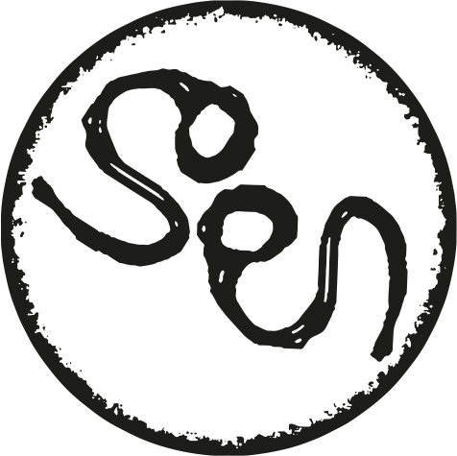

SOEN’S NEW ALBUM LYKAIA TO BE RELEASED FEBRUARY 1ST 2017

Soen:
Joel Ekelöf, vocals
Martin Lopez, drums and percussion
Stefan Stenberg, bass
Lars Åhlund, organ and rhodes
Marcus Jidell, guitars
In Ancient Greece the Lykaia (Greek: Λυκαία) was an archaic festival with a secret ritual on the slopes of the tallest peak in rustic Arcadia; Mount Lykaion, Wolf Mountain. The rituals and myths of this primitive rite of passage centered upon an ancient threat of cannibalism and the possibility of a werewolf transformation for the participating epheboi (adolescent males).

I should care to let you fly
A chance to retrieve what was left behind
To experience life
Soen; Jinn

Since the dawn of civilization, mankind’s instinct has been to go on long explorative journeys. Often such journeys are treacherous, fraught with deviations, twists and turns that take people in directions they could never have imagined. Tribes fight, people seek the support of Gods where they once didn’t care and humanity writhes around in varying states of ecstasy and agony as it continues its journey through nature, at the same time pitting itself against the very elements it can never properly control.

Deeper journey
For those who have followed Soen’s career thus far, the concepts of journey and exploration are not new. 2012’s Cognitive beat a firmly heavy, progressive metal path. 2014’s Tellurian with its Pink Floyd explorative spirit and Opeth-like forceful power, saw Soen start to stride freely into their own power and unique visions. Their third offering, Lykaia, is a journey into earthier places, their most cohesive, powerful and congruent creative quest yet.

In Lykaia Soen remains fascinated with the shadows and the darker edges of our world, with a particular focus on the various thoughts and concepts behind religion and ritualistic, belief-based behaviour in society.

– There’s a lot of edges in religion which are fascinating, says co-founder and vocalist Joel Ekelöf. It contains darkness as well as light, and of course, those dark sides are intriguing. Some of us were raised in Catholic households, so we’re not afraid of religion at all, but it is something which consistently offers intriguing views on life. We come from perhaps the most atheistic country in the world, Sweden, and one thing I always found rather bizarre was how if you say you believe in God or Satan or any sort of higher power, you’re seen as a bit simple and a feeble-minded person. I always found that strange. Because given the attention these belief systems continue to inspire, there must be something to investigate, right?

– This has never been about genres, it’s always been about the journey we need to take both musically and personally, says founder and drummer Martin Lopez. What we´re working on right now is another adventure, another journey which in some ways is quite different again but also builds upon the experiences we’ve had over the last few years.

Analog and organic
Recorded at Ghost Ward, StudioGröndal and Deep Well in Stockholm, Sweden, with production duties handled by guitarist Marcus Jidell and the mix made by Stefan Boman, Soen kept things as far away from the digital age as possible, embracing warmth and organic recordings as the drive behind the technical working process.

– Wherever we could the music was analog, all the sounds you hear were pure and not samples or keyboard generated. When we needed a Mellotron, we got a real one. With my vocals as well, we intentionally left out the endless possibilities of post editing and instead focused on pure vocal work, says Joel Ekelöf.

If the first two albums were harder, more technical, angular and perhaps cerebral pieces which demanded sharp focus, Lykaia presents a warmer, rounder, flesh and blood on the bones approach that allows listeners a dual entry to the eight tracks presented. The journey is no less dynamic, continuing the underscore of complex melodies with crushing power and no fear of walking proudly into more ambient spaces to explore the temperature. With Lykaia, however, it is clear that Soen have never felt more congruent or sure of themselves. From the haunting urgency of ‘Sectarian’ to the epic power-segues of darkness and light in ‘Jinn’, Soen have rounded into a frighteningly powerful and cohesive unit.

Inspiring bonds
– This line-up has played a lot of shows together, says Joel Ekelöf. From that of course comes a comfort and knowledge of each other that can only make Soen stronger. You learn the details of musical space that you share which obviously opens up for even stronger songwriting. Maybe what you can say now is that there are a couple of different paths ‘in’ to Soen music. For the hardcore fans there will always be degrees of complexity and layers to the music, but the song structure is the most important thing. We didn’t want to make the music complicated just for the sake of complexity. We wanted to make these songs perhaps less angular, maybe more flesh and blood as opposed to just skin and bone, a whole body with all the various elements that suggests.

If you still need a final gauge as to what Lykaia sounds like, even smells like, then enjoy the excellent artwork which at once evokes ancient woodcut folk art and the beautiful savagery of the wolves depicted.

– The wolf has always fascinated mankind and occurs in most cultures around the world. The predatory instinct that lies deep within us. The wolf-pack is something that humans can interact and relate to, how the mob behaves, how the mob chooses a pack-leader and how we easily give in to herd mentality. There is beauty to be found too of course, nothing is black and white in these situations…but they are certainly creatures which symbolize ‘feral spirit’ very, very clearly, Joel Ekelöf concludes.

Lykaia is released on February 1st, 2017. It is a feast you will gorge yourself on forever.

