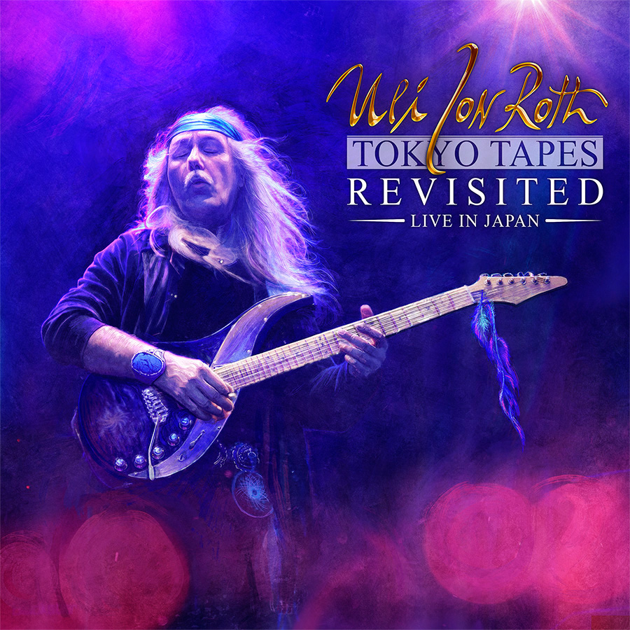

ULI JON ROTH TEAMS UP WITH UDR MUSIC TO RELEASE
TOKYO TAPES REVISTED - LIVE IN JAPAN

One of rock ‘n’ roll’s most venerated guitar Gods, Uli Jon Roth, will be releasing a very special live performance from the Nakano Sun Plaza Hall in Tokyo, Japan on December 16th 2016 through UDR Music, titled Tokyo Tapes Revisited - Live In Japan. The performance is a celebration of Roth’s classic work with The Scorpions, and was recorded on February 20th 2015 at the same venue as the band’s classic 1978 live album Tokyo Tapes. Roth was a founding member of The Scorpions in 1973 before leaving to pursue a solo career in 1978 with his own Electric Sun. As the recognized creative heartbeat of The Scorpions, Roth achieved worldwide fame for his unique guitar and song-writing talents, in turn causing him to influence a plethora of modern guitar giants such as Kirk Hammett of Metallica, Billy Corgan of The Smashing Pumpkins and Steve Vai.

Tokyo Tapes Revisited - Live In Japan will be released in four different formats.

Product 1 - BluRay Digipak:
Video & audio recording of Roth’s Tokyo concert in a BluRay digipak containing one BluRay video disc and two audio CDs.

Product 2 - DVD Digipak:
The same as Product 1 only in a DVD digipak.

Product 3 – Digital Download:
A digital audio copy of the Tokyo concert.

Product 4 - Super-Deluxe Boxset, limited to 800 copies:
It will be a proper, lid-off shell box containing 4 heavyweight vinyl LPs of Roth’s 2015 Scorpions Revisited release which has never been released on vinyl. There will also be an 80-page, gatefold, hardcover 12” book which will house 8 discs - 1 BluRay concert main-feature, 1 bonus BluRay disc (which will contain the original footage from the first Japanese Scorpions Tour 1978, shot personally by Uli on his Super 8 Camera), 2 audio CDs of the main Tokyo concert and 4 bonus audio CDs of Roth’s Osaka and Nagoya dates on the same Japanese tour. The set will also include an Uli Jon Roth replica guitar key-ring, and a signed certificate of authenticity, numbered and signed by Uli himself.

For further details, please contact: info@udr-music.com

