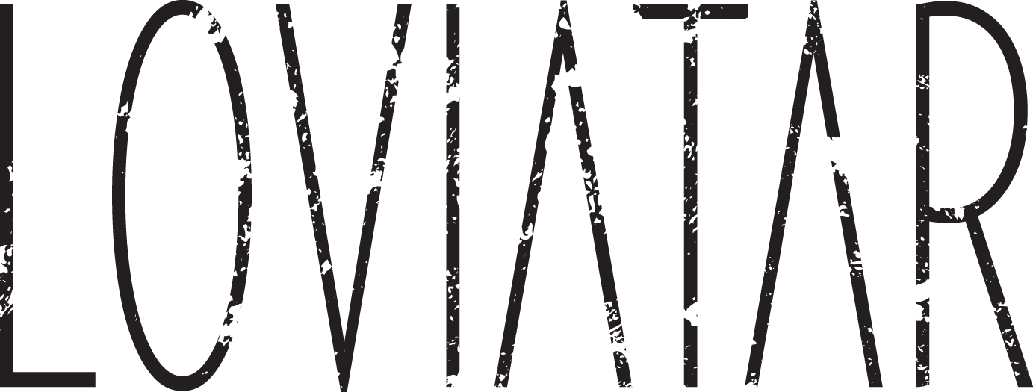

LOVIATAR (pronounced low-vye-ah-tar) are a metal band from Canada whose sound borrows equally from the hazy gloom of My Bloody Valentine and the crushing riffs of Isis. Clearly sung vocals, equal parts sombre and soaring, set them apart from others in the genre. Thunderous elements of doom and post-metal contrast with hypnotic moments of atmospheric introspection. Their art is inspired by the mysteries of ancient mythology: the band takes its name from an ancient Scandinavian death goddess and frequently evokes themes of epic fantasy in their imagery and lyrics.

Formed in 2010, Loviatar has independently released a series of singles and EPs, and have been tapped to support such acts as Red Fang, Skeletonwitch, and Blood Ceremony. In 2014, they shifted production to their newly built studio deep in the forested hills outside the nation’s capital and have now completed their first full length LP.

Recorded at the Wolf Lake Studios by bassist, Mike Bond, their self-titled full length debut album will see a worldwide release date Juy 27th 2017 and features two monolithic tracks available on all digital platforms, digipack CD and a limited edition gold and black swirl LP.

TRACKLISTING
1. Nascent (Stygian Wyrm Part I) - 6:11
2. Discordant (Stygian Wyrm Part II) - 3:39
3. Ascendant (Stygian Wyrm Part III) - 8:07
4. Blind Goddess of the Nine Plagues - 19:03

LOVIATAR ARE:
JD: Vocal, Rhythm Guitar
JP Sadek: Drums, Backing Vocal
Shane Whitbread: Lead Guitar
Mike Bond: Bass

DISCOGRAPHY
- Eternal Sons (Single) 2011
- Widows Flame (EP) 2012
- Druid’s Curse (EP) 2013
- Diva’s Hymn (Single) 2014
- Loviatar (LP) 2017

