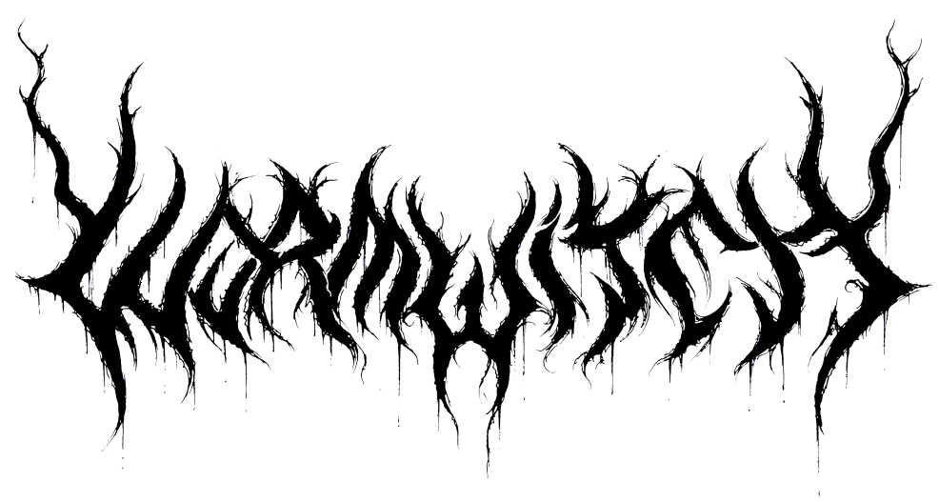

Hailing from Vancouver, Canada, an early incarnation of the group was more of a hardcore/punk band but as the band’s influence of Celtic Frost, Darkthrone and Disfear started showing up more in their music, they chose to rebrand themselves as Wormwitch. In October of 2015, they released their first EP, The Long Defeat. In early 2016, No Clean Signing premiered a new track, Coffin Birth, describing it as a “high-octane rush of deep, grinding riffs, piston-driven drumming, and thundering bass, with a heavy-as-hell production.” It was then that they caught the attention of Prosthetic Records and soon a worldwide deal was struck. A few short months later, they entered Rain City Recorders with producer Curtis Buckoll (Archspire) to begin work on their debut album, Strike Mortal Soil. The band comments on the recording:
“As far as the making of the album goes, this is our first full length release, and it's got our fingerprints all over it. If something was possible to do ourselves, we did it, down to mixing and artwork. To go from recording a demo over a couple days in a sweaty jam space, to putting out an LP on Prosthetic within a year and a half...it's just not something we could have realistically expected.”
Integrating equal parts black metal savagery and rock n' roll defiance, Strike Mortal Soil, stands like a monolith commemorating those that came before while dispersing a beacon of hope to the future. Available digitally, on CD and limited edition LP in lightning bolt blue w/ black specks on May 12.
Regarding the album’s concept and theme, they elaborated with this:
“Thematically, the album has a lot to do with being alive. We live in a society both obsessed with, and terrified of death. We exist in a world constantly seeking immortality through fame or gods. Strike Mortal Soil is a phrase that came about during the writing that has come to mean: living with a furious passion, to go to one’s grave like lightning, in rejection of eternity. Total annihilation... Beyond that there's a message that life has worth and it doesn't come from your nationality, your land, your god, or your flesh, but what you do with yourself. We aren't born into strength, strength is earned. And that's essentially it; we'll wave the flag for that message everywhere we go.”
STIRKE MORTAL SOIL TRACKLISTING
1. As Above
2. Howling From the Grave
3. Weregild
4. Even the Sun Will Die (WATCH)
5. Relentless Death
6. Cerulean Abyss
7. Everlasting Lie (WATCH)
8. ...And Smote His Ruin Upon the Mountainside
9. Mantle of Ignorance
10. So Below

Don't forget to mark your calendars to catch WORMWITCH's captivating live performance when they hit the road across the U.S. and Canada later this summer in support of black metal outfit, Numenorean. Dates are as follows:

6/26 Vancouver, BC - Cobalt #
6/27 Grant’s Pass, OR - The Sound Lounge #
6/28 Boise, ID - The Shredder #
6/29 Salt Lake City, UT - Metro Music Hall #
6/30 Denver, CO - Streets of London #
7/1 Albuquerque, NM - Burt’s Tiki Lounge #
7/2 Phoenix, AZ - Yucca Tap Room #
7/3 San Diego, CA - Brick By Brick #
7/4 Los Angeles, CA - Complex #
7/5 Las Vegas, NV - The Beauty Bar #
7/6 Oakland, CA - Golden Bull #
7/7 Santa Cruz, CA - Blue Lagoon #
7/8 San Francisco, CA - Thee Parkside #
7/9 Sacramento, CA - Starlite #
7/10 Portland, OR - High Water Mark #
7/11 Seattle, WA - Funhouse #
# with Numenorean

Wormwitch is
Colby Hink - guitar
Robin Harris - vocals
Cam Saunders - drums

https://wormwitch.bandcamp.com
https://www.facebook.com/wormwitch
https://twitter.com/wormwitchmetal

