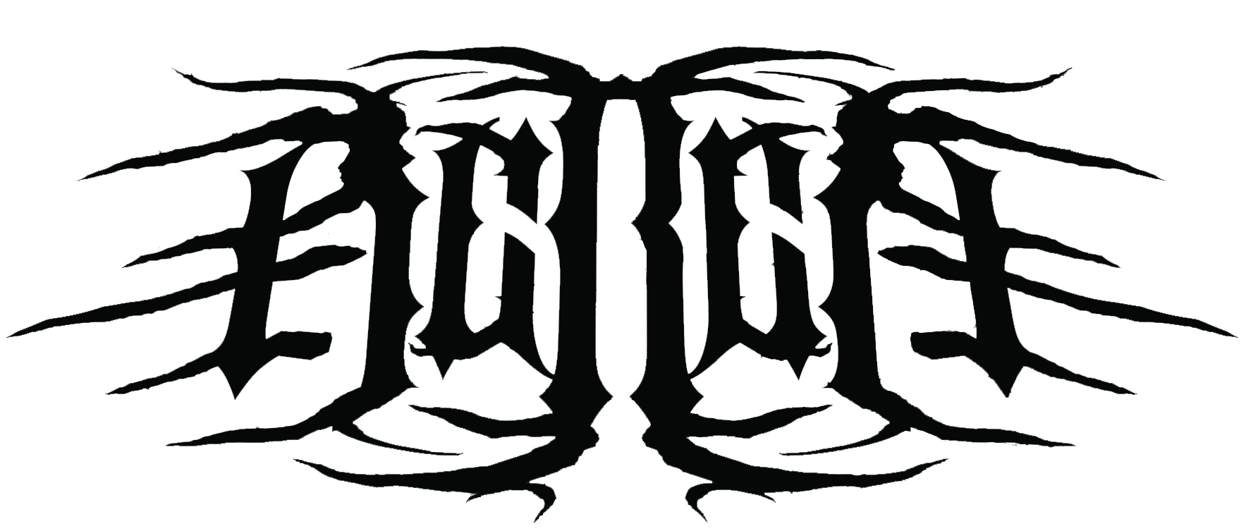

What began as a steadfast expression of the human condition, moves forward with momentum for Madison, WI’s atmospheric doom metal band, Bereft. Founded by Zach Johnson and Alex Linden in 2011, the band is rounded out by Cade Gentry on bass and Jerry McDougal on drums. Bereft weave elements of doom and black metal into exhaustive, dynamic songs. Lyrically, they draw from their views on religion, politics and social injustice. It is in this spirit that they create their own style of powerful metal, unbound to any genre and fully conscious of the impression.

After a successful year of touring in support of their EP, Lost Ages (War Crime Recordings, Silent Pendulum Records), Madison, WI based Bereft took some time off from playing shows to focus on completing their Prosthetic Records debut. Expanding musically from Lost Ages, but keeping with their blackened doom sound, Lands brings Bereft’s vision to life.Writing for Lands began in earnest during the winter of 2015. However, with studio time booked and the departure of their drummer, the pressure mounted. Alex, Zach and Cade focused on what mattered most; finishing the album.

Without a complete lineup and only a few short months to prepare, Michael Kadnar (Downfall of Gaia, Black Table, The Number 12 Looks Like You) stepped in to play drums on the record. “It was a breath of fresh air when Michael agreed to help out” says Linden “We had no doubt he would take these songs to the next level.”

“Writing this record was a monumental task for us” says Gentry. “We got together two to three times every week for months, just hammering on these songs.” The band would record riffs and structure songs, then send them to Michael in New York, where he would program drums and send them back.

“The guys would send me guitar demos and I would program my drum ideas with Ableton Live and Superior Drummer. I then wrote out charts and notes for each song to take into the studio.”

In May of 2016, the band departed for Rockaway, New Jersey, where, after just one practice session with Kadnar, they set into nine days of tracking with Kevin Antreassian (Dillinger Escape Plan) at Backroom Studios.

“I've been a big Dillinger Escape Plan fan for years, so it was pretty surreal to work with Kevin.” Kadner added. “He's a phenomenal engineer, and also the most down to earth, funny, and welcoming dude you'll meet. The recording sessions couldn't have gone smoother.”

With the album finished, the drummer search began. It didn’t last long, however, when long time friend and gear-head Jerry McDougal joined. “We’ve known Jerry for a few years.” says Johnson. “He has been nothing but stunning behind the kit. His work as alter ego Satyrnine Amplification has been increasingly helpful for our sound as a band and we're ecstatic about his presence and talent in our collective.”

McDougal adds “I first met the guys at a rehearsal complex we shared. They caught wind of my gear-headed nature, which struck up some great conversations. One thing lead to another and here we are. I feel extremely honored and grateful to be part of Bereft, and can’t wait to see what crazy adventures await us on the road.”

Now, with the album ready to go and a new drummer on board, the band feels invigorated. The release of this record is a big milestone, having overcome a lot of obstacles along the way. They’re better because of it though, the band says. “This album has brought us together in ways we never thought possible as a band.”

LANDS will be available on March 31st 2017 on CD, limited edition blood red LP and all digital platforms.

Artwork was drawn by Sam Alvarez (Bongripper)

BEREFT IS:
Zach Johnson - Guitar/Vocals
Alex Linden - Guitar/Vocals
Cade Gentry - Bass
Michael Kadner – Drums (studio)
Jerry McDougal – Drums (live)

BEREFT TOUR DATES:
01/20 Rock Island, IL - QC Jantopia
02/11 Madison, WI - Red Zone Madison

facebook.com/bereftwi
bereftwi.bandcamp.com

