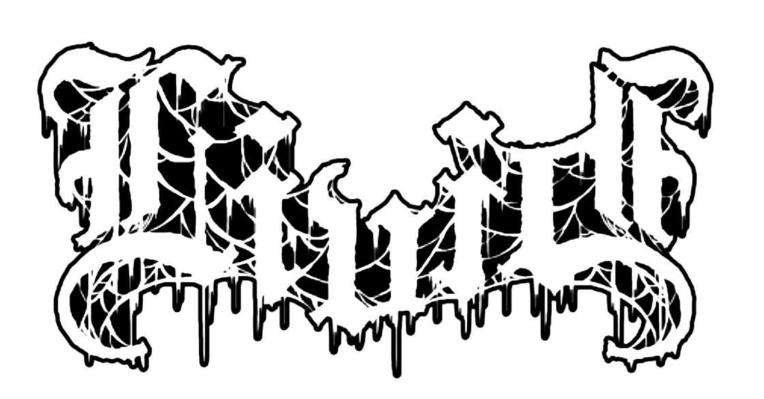

Minneapolis dwellers Cole Benson, Chad Padelford and Tim Leick first got together in 2013 playing instrumental post rock. It wasn’t long after that the three’s influences of Eyehategod and the Melvins, Boris and Tool & Evoken and Mournful Congratulation began to manifest naturally through their music creating a more sonically cathartic endeavor. Livid was born after that.

By 2015 the trio had been evolving their riffs enough to feel confident to lay them down to tape and teamed up with producer, Ali Jaafar at Ecstattic Studio to record their first demo. The two part, 22 minute opus, Sint, was released on Bandcamp in the Summer of that year and was met with wide acclaim in the metal underground. Doomed & Stoned, The Burning Beard, as well as Seattle radio station, KEXP, all jumped on board as early flag waivers for the band.

Sint was powerful, both in riff and vocals. Benson’s vocal style was often compared to Gregorian Monks chants. They are haunting and perfectly complimented the eerie, dreary riffs he played combined with the thunderous backend of drummer Leick and bassist Padelford.

With shows booked, they felt it was best to add local metalhead, Swen, to second guitar, making the live sound more powerful. Throughout the remainder of the year, Livid shared the stage with bands such as Theories, Bell Witch, Cobalt, Mantar, Immortal Bird, False, and Wrekmeister Harmonies.

The following year, they embarked on their first tour playing with Forn, Yellow Eyes, Plebeian Grandstand, and Pyrrhon, to name a few. It was on this run that they met up with Prosthetic Records and shortly after that, signed a deal with the label. Padelford comments:

“Being approached by Prosthetic Records was very surreal and caught us completely off guard. Prosthetic has put out some amazing records that get heavy rotation at my house, especially a lot of the more recent releases. It felt as they were on a major upswing and we are very excited to be a part of it.”

By Fall of 2016, the went back to Jaafar’s studio and began work on their debut album, Beneath This Shroud, The Earth Erodes. The political climate of that time, combined with various struggles each member had, helped create and extremely dark, extremely moody and heavy and angry sounding album. Padelford remarks, “while each of us dealt with personal strife and success we found solace coming together to spill out what we had bottled up.”

Benson further elaborates on how the country’s state of affairs effected and changed the lyrical them of the album, “we rewrote most of the lyrics in the studio the day after the 2016 presidential election. The lyrics paint a bleak image of the future. The track The Fire underwent the most changes and addresses this issue most directly. We hope to open the listener’s eyes, and we hope for for a better future."

Beneath This Shroud, The Earth Erodes will see a July 14th release date and will be available on all digital platforms, digipack CD and transparent purple vinyl.

Beneath This Shroud, The Earth Erodes
Official tracklisting:
- Descend
- Nothing
- Sins of God
- The Fire
- Into Nothing

Livid is:
- Cole Benson - Guitar/Vox
- Tim Leick – Drums
- Chad Padelford- Bass
- Swen - Guitar

https://www.facebook.com/lividirate

