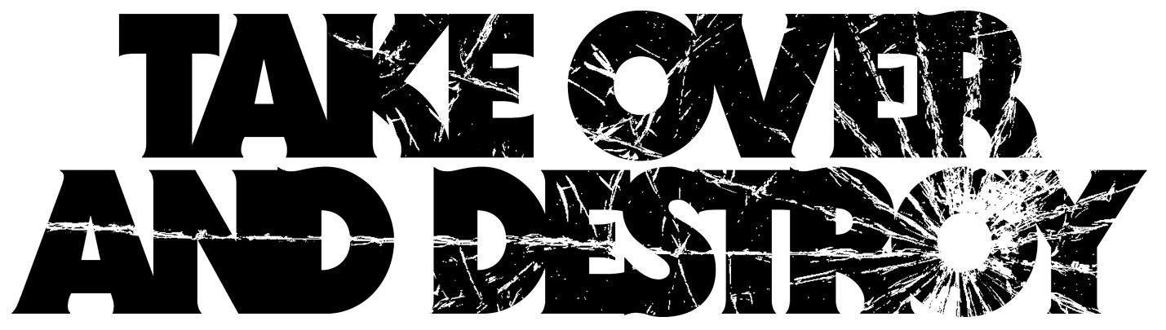

Alex Bank Rollins: guitar Nate Garrett: guitar Andrew Leemont: vocals/keys
Pete Porter: bass Jason Tomaszewski: drums

Since 2008, Take Over And Destroy has been relentlessly pushing the boundaries of heavy music. With an amalgamation of eclectic tastes: death metal, classic rock, doom, death rock, black metal and horror scores, TOAD has established itself as a truly unique entity, both sonically and aesthetically. The five members’ collective obsession with cinema results in their incorporation of the moody undertones of classic film scores into the raw power and energy of heavy metal and rock and roll. Stereogum did their best to describe this sound as “vintage horror-movie/swinging black-mass ambience.”

The band has toured extensively, booking countless DIY tours, as well as being selected as direct support for Agrimonia on their recent US tour as well as Year of No Light on their only US tour to date.

The group has an arsenal of releases that it has independently circulated, including a split with sludge act Drone Throne in 2009, 2011’s “Rotten Tide” EP, a split with black metal legends VON in 2012, 2013’s critically-acclaimed “Endless Night,” and 2014’s list-topping “Vacant Face.” The band’s releases have garnered praise from a multitude of publications, including Noisey, Pitchfork, Invisible Oranges, The Needle Drop, Stereogum, New Noise, Metal Sucks, and Metal Injection, among many others.

The band entered Flying Blanket Studios in their home state of Arizona with producer Bob Haug (The Bled, Hour of the Wolf) and recorded 10 tracks that will make up their third full length album. Self-titled and released on October 7th, 2016, the album continues TOAD’s tradition of pushing boundaries and crafting something unique. Post punk elements weave their way into rock and roll, providing haunting ambiance in the background to stadium anthems.
Take Over and Destroy isn’t just the band name, it’s a mission. The band’s aim is to take over any preconceived notions in the mind of the audience and destroy the prejudices and expectations the listener might have in order to inspire progression and inspiration in the realm of heavy music.

takeoveranddestroy.com
facebook.com/TakeOverAndDestroy

