For Immediate Release
August 24, 2018

Technical Death Metal Leaders GOROD to Release Tenth Full-Length Album, “Aethra”, on October 19, 2018

Watch a New Album Teaser and Read the First Exclusive “Aethra” Interview via Metal Injection

Pre-Orders Available Now via Amazon | iTunes | Google Play

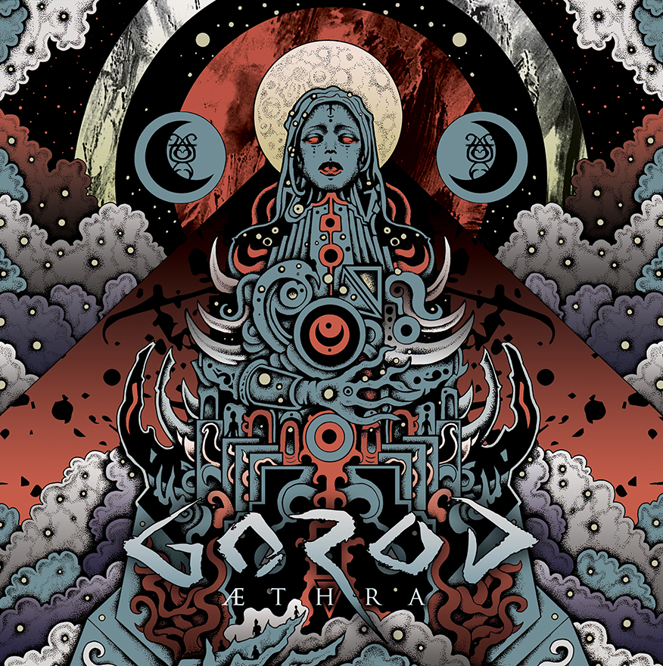
Art by Jeff Grimal

Following up on their critically-acclaimed album A Maze of Recycled Creeds and the incredible thrashy EP, Kiss The Freak, technical metal icons GOROD are set to release their upcoming 10-track album, Aethra, on October 19, 2018 via their new international label, Overpowered Records. Aethra marks the 10th release from GOROD. The album is available to pre-order digitally via Amazon, iTunes and Google Play, and in several physical formats via Overpowered Records’ merchandise site.

Produced and recorded by GOROD guitarist/mastermind Mathieu Pascal in his own Bud Studio, mixed at Dugout Studio by the outstanding Daniel Bergstrand (Meshuggah, Behemoth, Decapitated, In
Flames) and mastered by Lawrence Mackrory at Obey Mastering (Decapitated, Nightrage), Aethra is poised for Album of the Year status.

Watch a brand new album teaser video and the exclusive first Aethra interview now via Metal Injection: http://www.metalinjection.net/interviews/gorod-talk-new-album-aethra-and-tech-metal-wizardry-in-exclusive-interview

In comparison to GOROD’s previous albums, the band sees Aethra as a profound progression in terms of production, songwriting and arrangements. Guitarist/producer Mathieu Pascal says, “We decided that I would be in charge only for the recording in my studio, and chose Daniel Bergstrand for the mixing and mastering, as we love his work for decades. It puts some pressure on me, firstly because I'm used to working alone with the production of GOROD albums. The tracks should be clear and perfect enough to be easily understood and included into the mix the way I imagined. But also, because I still feel like a newbie compared to Bergstrand and I just didn't want to look like an amateur job! Bergstrand and McCrory did an awesome job on this album, the sound is powerful but still natural and balanced.”

Aethra track listing:
1) Wolfsmond
2) Bekhten’s Curse
3) Aethra
4) The Sentry
5) Hina
6) And the Moon Turned Black
7) Chandra and the Maiden
8) Goddess of Dirt
9) Inexorable
10) A Light Unseen

With Aethra, GOROD transports the listener to a tragic and melancholic universe – a completely new level of darkness – while preserving what GOROD considers their tried and true core sound: incomparable groove, remarkable dexterity, and relentless technicality. But all the while, the band never sacrifices earworm hooks and unforgettable riffage.

Vocalist Julien Deyres explains the concept behind Aethra, “The moon: a star, an allegory, a universal symbol that concerns all peoples and eras... this is the central theme of the lyrical concept of this album which is divided into ten texts that follow a form of parity in terms of genres: four titles are devoted to female lunar deities, four to male deities. The remaining two are respectively dealing with the universal symbolism of the owl and the star itself.

The concept is basically a study of different cults associated with the moon through the ages and peoples. Some themes are treated in a purely narrative way, some others in a more philosophical or poetic way, but generally it remains a personal reading of each myth, which aims to awaken critical thought as much as evasion.”

Mathieu Pascal adds, “The writing process was exceptionally short, only six weeks. I wanted more spontaneous and song-oriented music with clear and efficient structures. For the first time I tried to write the music always thinking stage-wise, always anticipating how every riff or lead would be perceived live, and of course how it could be performed.”

As a live band through and through, GOROD plan to bring their trademark power and precision to North America on a full tour in support of Aethra. Before coming to the states, GOROD will tour in Europe and the UK with headliners Beyond Creation, as well as fellow support artists Entheos and Brought By Pain. See below for all confirmed tour dates:

02.11 Hamburg (D) Headcrash
03.11 Hannover (D) Faust
04.11 Berlin (D) Musik & Frieden
05.11 Prague (CZ) Nova Chmelnice
06.11 Vienna (A) Viper Room
07.11 München (D) Feirwerk
08.11 Ljubljana (SLO) Orto Bar
09.11 Retorbido (I) Dagda Club
10.11 Venice (I) Revolver
11.11 Aarau (CH) Kiff
12.11 Grenoble (F) L'Amperage
13.11 Barcelona (E) Upload Club
14.11 Madrid (E) Caracol
15.11 Porto (PO) Hard Club
16.11 Donosti (E) C.C. Larratxo
17.11 Angoulême (F) La Nef
18.11 Paris (F) Petit Bain
19.11 Manchester (UK) Satan's Hollow
20.11 Glasgow (UK) Audio
21.11 Dublin (IRE) Voodoo Lounge
22.11 London (UK) Underworld
23.11 Birmingham (UK) Asylum2
24.11 Netherlands Oss Groene Engel
25.11 Oberhausen (D) Kulttempel

Stay tuned for more information on Aethra, with more tracks and videos coming soon!

GOROD online:
www.facebook.com/gorodofficial
www.twitter.com/gorod_dm
www.instagram.com/gorod_official

GOROD is:
Julien "Nutz" Deyres: Vocals
Mathieu Pascal: Guitars
Ben "Barby" Claus: Bass
Nicolas Alberny: Guitars
Karol Diers: Drums

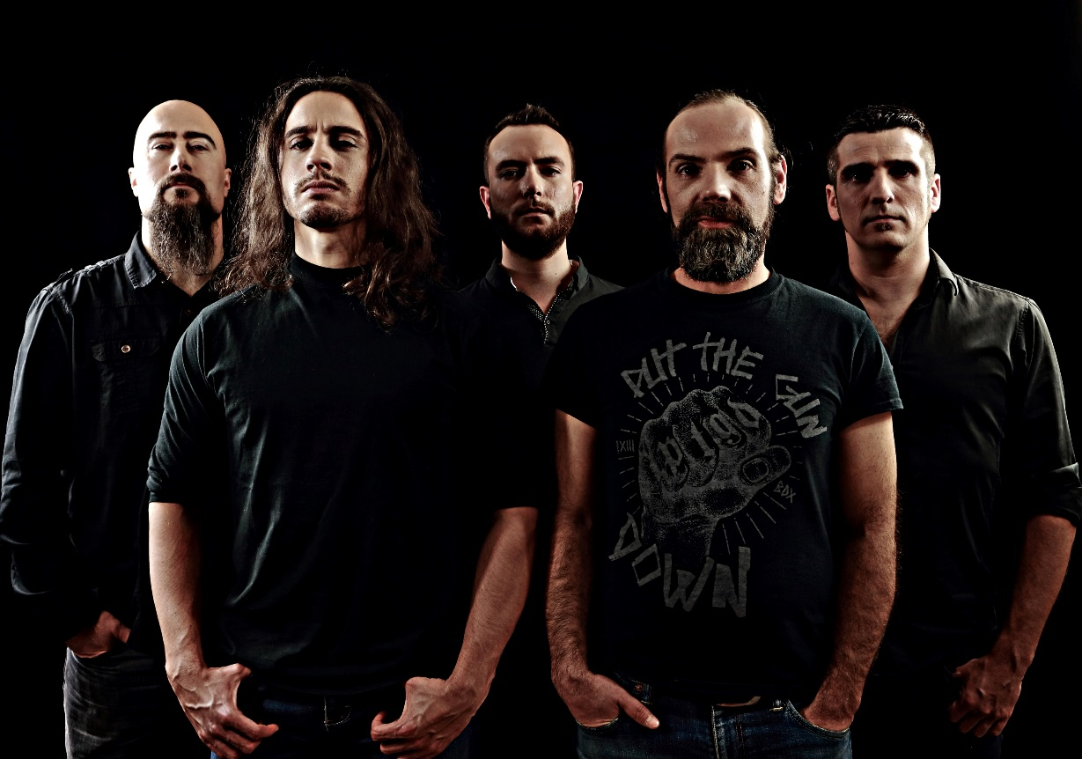
GOROD Press Photo

