**For Immediate Release**

**August 22, 2018**

**BROKEN HOPE’s Jeremy Wagner to Release New Horror Novel, “Rabid Heart”**

***Rabid Heart* out October 3, 2018 via Riverdale Avenue Books**

**Pre-Order** [**Here**](http://riverdaleavebooks.com/books/5380/rabid-heart) **or at the Digital Retailer Links Below!**

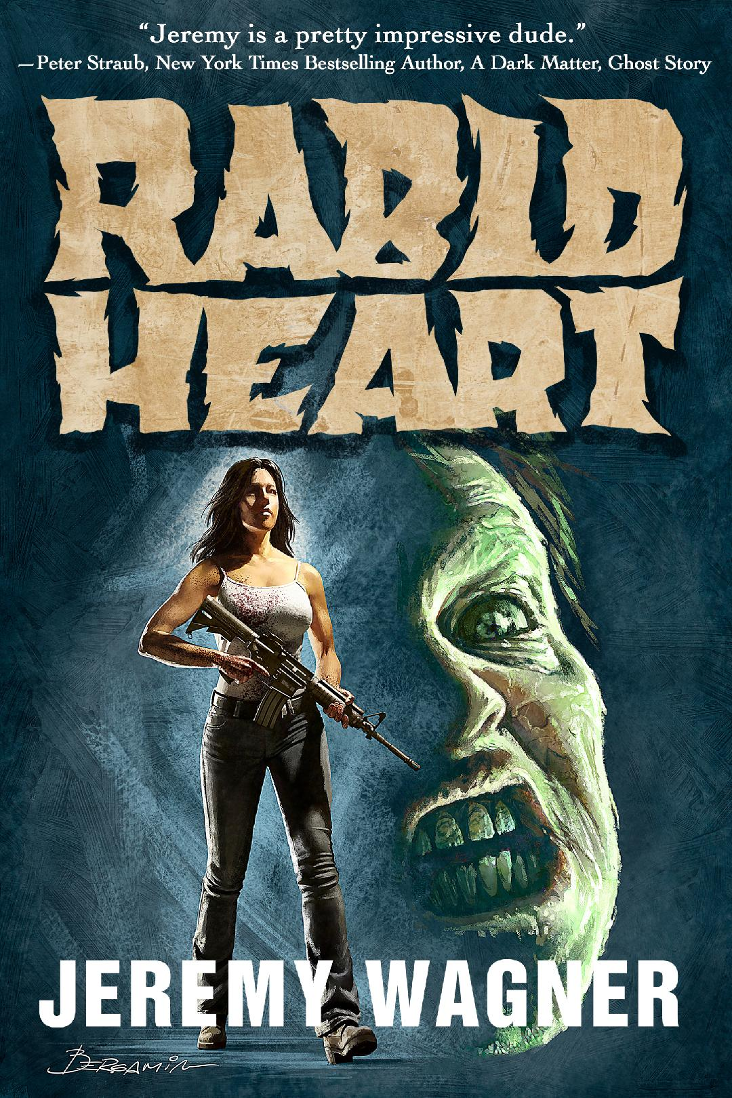

**\*RABID HEART cover design by CLAUDIO BERGAMIN (Judas Priest, Nocturnal Rites, Rata Blanca)**

Founding father and current member of renowned death metal band **BROKEN HOPE** and author of Barnes & Noble Top 10 Paperback Bestseller ***THE ARMAGEDDON CHORD****,* **Jeremy Wagner**, will release his new horror novel, ***RABID HEART*** – a novel about the depth of undying love in the midst of a zombie apocalypse – available internationally in Hardcover, Trade Paperback, Digital, and Audio formats on October 3, 2018 via the **AFRAID** Horror Imprint of **Riverdale Avenue Books**.

**SYNOPSIS:**

***How far would you go for love when all you love is DEAD?***

Six months after the Necro Rabies pandemic turned the world into hordes of rabid undead known as “Cujos," 21-year-old Rhonda Driscoll discovers her zombified fiancé, Brad, in her old hometown. Fearing that her Marine Colonel father will kill undead Brad, Rhonda flees, taking a road-trip with Brad in tow in hopes of starting a new life in a frightening and uncertain world complicated by numerous perils, pure horror, and unconditional love.

***RABID HEART***author Jeremy Wagner says, "*I had a solid draft of****RABID HEART****cooling for a while as I worked on some other projects for a couple years. Once I came back to revise and polish****RABID HEART****, I fell hard for it all over again and knew I had something special. I love f-ed up stories... I write f-ed up things. My style of fiction and my personal tastes in what I read all leans towards really dark fiction and usually has protagonists who go through hell – there’s a lot of that in****RABID HEART****. The things that my main character Rhonda Driscoll goes through might fit in nicely with say, McCarthy’s The Road pairing with 28 Days Later or Romero’s Day of the Dead. I hope you all enjoy the ride.*

*Thanks to Lori Perkins and* ***Afraid/Riverdale Avenue Books*** *for really getting behind this novel and making me an offer I couldn’t refuse. Watch for* ***Afraid/Riverdale Avenue Books*** *to also re-release my first novel,* ***THE ARMAGEDDON CHORD****, in December. Thanks for reading! Support horror fiction!”*

Pre-order ***RABID HEART*** now:

Paperback – [Amazon](https://www.amazon.com/dp/1626014647/ref=cm_sw_r_cp_api_eY8CBbM20417S) | [Barnes and Noble](https://m.barnesandnoble.com/w/rabid-heart-jeremy-wagner/1129126502?ean=9781626014640)

Hardcover – [Amazon](https://www.amazon.com/dp/1626014655/ref=cm_sw_r_cp_api_J28CBbTEXVGWV) | [Barnes and Noble](https://m.barnesandnoble.com/w/rabid-heart-jeremy-wagner/1129126502?ean=9781626014657)

Digital – [Amazon](https://www.amazon.com/dp/B07FQG5Y9V?ref_=pe_3052080_276849420) | [Kobo](https://www.kobo.com/us/en/search?query=Rabid%20Heart%20(Jeremy%20Wagner)&ac=1&acp=rabid%20heart&ac.title=Rabid%20Heart&ac.author=Jeremy%20Wagner) | [Barnes & Noble](https://www.barnesandnoble.com/w/rabid-heart-jeremy-wagner/1129126502?ean=2940161669525) | [iTunes](https://itunes.apple.com/us/book/rabid-heart/id1414727791?ls=1&mt=11) | [Google Play](https://play.google.com/store/books/details/Jeremy_Wagner_Rabid_Heart?id=UpdlDwAAQBAJ) | [Smashwords](https://www.smashwords.com/books/view/880444) | [Riverdale Avenue Books](http://riverdaleavebooks.com/books/5380/rabid-heart)

**About Author Jeremy Wagner:**

Wagner has written lyrics to hundreds of songs spanning several albums with his internationally-renowned death metal band, **BROKEN HOPE**. Music aside, Wagner writes dark fiction and short works full time.

His published works include the best-selling debut novel, ***THE ARMAGEDDON CHORD***, the story **"Romance Ain’t Dead”** for the anthology, *Hungry For Your Love* (St. Martin’s Press), the story **"The Creatures From Craigslist”** in the anthology *Fangbangers:* *An Erotic Anthology of Fangs, Claws, Sex and Love* (Ravenous Romance), the seasonal bio tale, ***When I Scared Myself Out of Halloween***(Shock Totem Books), his horror writing essay-exercise in the **Now Write! Edition of Science Fiction, Fantasy, and Horror** (Bantam Books), and most recently, his short story **“Pit Stop”** in the *A Tribute Anthology to Deadworld*(Riverdale Avenue Books).

Wagner's novel, ***The Armageddon Chord***, peaked at #4 on Barnes & Noble’s Top 10 paperback Bestseller List and peaked at #9 on Barnes & Noble’s Top 100 overall Bestseller List in the first week of release. The novel also earned a Hiram Award, a first-round ballot Stoker Award Nomination, and received critical acclaim in Publisher's Weekly and Rolling Stone, among many other worldwide media outlets.

The **Afraid** imprint of **Riverdale Avenue Books** will re-release a revised edition of ***THE ARMAGEDDON CHORD***in December 2018 with new cover artwork and more.

New York Times Bestselling Author, **Peter Straub** (A Dark Matter, Ghost Story, and The Talisman— with Stephen King) says, *“Jeremy is a pretty impressive dude.”*

**Praise for *RABID HEART*:**

*“Zombies and the end of days don't stand a chance against true love. Jeremy Wagner's****RABID HEART****is good, clean apocalyptic fun.”*

**— Alma Katsu, author of *The Hunger***

*“Just when you think you've heard every love story, along comes****RABID HEART****. My man Jeremy Wagner proves once again he's as much of a wild man with words as he is with his guitar. This book is sick and sweet, and I say that with respect!”*

**— Peter Blauner, NY Times bestselling author of *The Intruder* and *Sunrise Highway***

**Praise for *THE ARMAGEDDON CHORD*:**

*“Wagner debuts* ***THE ARMAGEDDON CHORD*** *with a highly entertaining blend of breakneck pacing, a cast of over-the-top characters and memorable lines...”*

**—Publishers Weekly**

*“An evil Egyptologist. A scheming billionaire. A guitar maestro. They're all there in Jeremy Wagner's,* ***THE ARMAGEDDON CHORD****. This is pulp fiction at its breeziest best.”*

**—Rolling Stone**

*“Wagner strikes a winning heavy-metal chord in this stunning story that foretells an End of Time beyond imagination. The author’s use of music as a backdrop and his development of fascinating characters make for interesting reading in this enthralling tale.”*

**—RT Book Reviews**

*“****THE ARMAGEDDON CHORD*** *is a kickass novel!”*

**—Jonathan Maberrry, New York Times Bestselling Author, Patient Zero and the Joe Ledger series**

*“****THE ARMAGEDDON CHORD*** *is a quick, enjoyable read full of action, violence, hell-spawned (and human) monsters and original variations of scenarios common to end-time thrillers."*

**—Decibel Magazine**



**Jeremy Wagner (Author photo by Gene Ambo)**