For Immediate Release
September 28, 2018

ANGEL VIVALDI & NITA STRAUSS Announce “The Guitar Collective 2018” Co-Headline Tour

Kicking Off November 19 in New Bedford, MA

Tickets On Sale Now:
www.angelvivaldi.com/tour

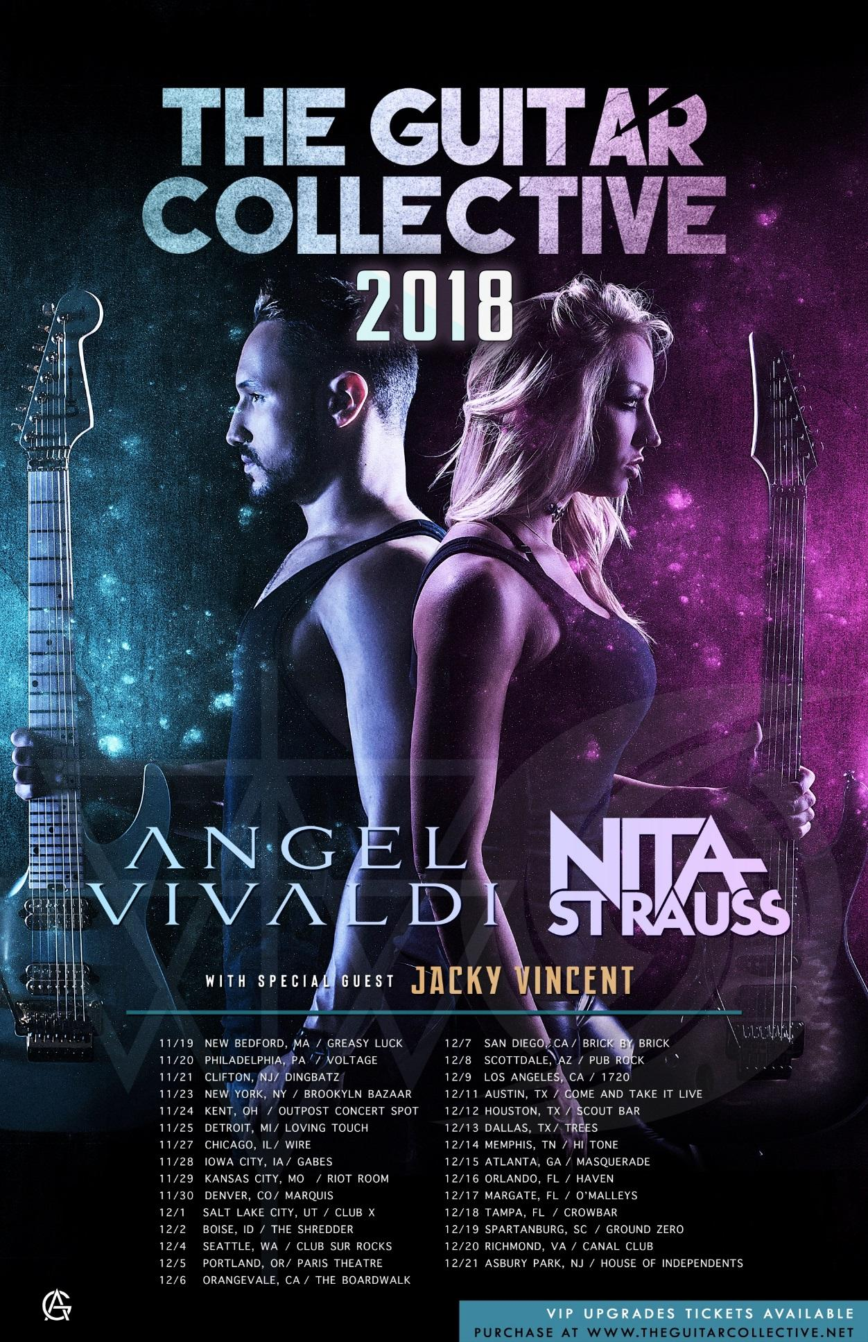

Two of the most revolutionary guitar virtuosos of our generation -- renowned soloist ANGEL VIVALDI and Alice Cooper axemaiden NITA STRAUSS -- are pleased to announce the 2018 edition of The Guitar Collective, a United States tour kicking off on November 19 in New Bedford, MA. The tour will visit several major cities, ending in Asbury Park, NJ on December 21. ANGEL VIVALDI and NITA STRAUSS will co-headline each date of the tour with support from special guest Jacky Vincent (ex-Falling in Reverse). The Guitar Collective 2018 will mark NITA STRAUSS’s live solo debut.

VIP and general admission tickets are available now via www.angelvivaldi.com/tour. VIP Meet and Greets with ANGEL VIVALDI and NITA STRAUSS will include a Q&A session, a signed tour poster, and an HD photo with Angel and Nita.

The main goal of The Guitar Collective tour, now in its second year, is to give fans of instrumental guitar music a chance to discover new artists, and for those artists to branch out to new fans. The Guitar Collective founder ANGEL VIVALDI sees the tour as a place where people can come year after year to discover new virtuosos in an exciting live setting, not just behind their computers and phones.

ANGEL VIVALDI says, “The past four years have given us some of today's most incredible guitarists. After last year's Guitar Collective, which included Scale the Summit and Andy James, I knew I had to make this "modern G3" an annual outing. This year, not only do we have NITA STRAUSS's live solo debut, we've also got Jacky Vincent, who both will continue to carry the torch of instrumental guitar music for generations to come. I can't wait to get on stage night after night to jam with my friends.

NITA STRAUSS adds, “These will be my first shows ever as a solo artist, and I couldn't have hoped for a better fitting tour. I've been a huge fan of Angel's since I first discovered his music and became an even bigger fan when I saw his incredible live performance. Angel and Jacky are two of the most innovative and exciting solo guitarists out there in the scene today, and I am beyond honored to share the stage with them on this tour!”

THE GUITAR COLLECTIVE 2018 TOUR DATES:
11/19 New Bedford, MA @ Greasy Luck
11/20 Philadelphia, PA @ Voltage Lounge
11/21 Clifton, NJ @ Dingbatz
11/23 Brooklyn, NY @ Brooklyn Baazar
11/24 Kent, OH @ Outpost Concert Spot
11/25 Detroit, MI @ The Loving Touch
11/27 Berwyn, IL @ Wire
11/28 Iowa City, IA @ Gabe’s
11/29 Kansas City, MO @ The Riot Room
11/30 Denver, CO @ Marquis Theater
12/1 Salt Lake City, UT @ Club X
12/2 Boise, ID @ The Shredder
12/4 Seattle, WA @ Club Sur Rocks
12/5 Portland, OR @ Paris Theatre
12/6 Orangevale, CA @ The Boardwalk
12/7 San Diego, CA @ Brick by Brick
12/8 Scottsdale, AZ @ Pub Rock
12/9 Los Angeles, CA @ 1720
12/11 Austin, TX @ Come and Take It Live
12/12 Houston, TX @ Scout Bar
12/13 Dallas, TX @ Trees
12/14 Memphis, TN @ Hi-Tone
12/15 Atlanta, GA @ Masquerade
12/16 Orlando, FL @ The Haven
12/17 Margate, FL @ O’Malley's
12/18 Tampa, FL @ Crowbar
12/19 Spartanburg, SC @ Ground Zero
12/20 Richmond, VA @ Canal Club
12/21 Asbury Park, NJ @ House of Independents

About ANGEL VIVALDI:
As made evident throughout his five solo releases, ANGEL VIVALDI’s blend of spell-binding guitar anthems and tasteful yet virtuosic playing have reached and inspired millions. Beginning his solo career in 2003, Vivaldi joined forces with the newly reformed 40 Below Summer in 2008. He continued to release multiple solo albums including the critically acclaimed Universal Language in 2010, which has become a must-hear staple in today’s instrumental album catalog. In 2012, Vivaldi joined supergroup Vext featuring Tommy Vext (Bad Wolves, Divine Heresy) as well as members from Mutiny Within. After the loss of his best friend to ALS in 2014, not long after the crowd-funded release of Away With Words Part 1, Angel realized that the only thing worse than living with regret would be to die with it. So in 2015, putting his confidence and trust in his audience, Vivaldi quit his day job, committing himself full-time to his career in music.

His latest full-length album, Synapse, is a conceptual opus that joyously matches musical wits with a number of his talented contemporaries. Vivaldi continues to captivate the masses with stunning video releases unlike any seen in the instrumental world such as “A Martian Winter,” “.. _ _ _ “ (Two), and most recently “Serotonin” which features not only NITA STRAUSS but also acclaimed dance crew The Wannabes.

Since beginning to tour in 2015, he has shared the stage with icons such as Yngwie Malmsteen, NITA STRAUSS, Gus G and Devin Townsend. In 2017, he launched his annual The Guitar Collective tour, which has featured artists such as NITA STRAUSS, Scale the Summit, Andy James, Yvette Young and more.

ANGEL VIVALDI online:
www.angelvivaldiofficial.com
www.facebook.com/angelvivaldi
www.twitter.com/angelvivaldi
www.instagram.com/angelvivaldiofficial
www.youtube.com/angelvivaldi

About NITA STRAUSS:
Los Angeles born guitarist NITA STRAUSS has become a force to be reckoned with in the music world, dazzling audiences across the US, UK, Europe, Asia and Africa, and sharing the stage with a diverse range of artists including legendary R&B star Jermaine Jackson, deathcore heavy hitters As Blood Runs Black, early MTV darlings Femme Fatale, video game supergroup Critical Hit and popular tribute band The Iron Maidens. Her skill, exuberant stage presence and love for all things about her instrument have earned her a stellar reputation and endorsements from many top companies. Nita has been featured in many worldwide print ads and on dozens of albums, trailers, and soundtracks, most recently Heroes Of The Storm (Blizzard) and Grammy-nominated Metal Gear Rising: Revengeance (Konami/ Platinum Games), and is the author of the Premier Guitar column "Drop Dead Shred". She was ranked #1 of Guitar World's "10 Female Guitar Players You Should Know", and has been featured in Revolver Magazine's annual "Hottest Chicks in Hard Rock" issue and calendar for the last 2 years. She is currently on tour with Alice Cooper.

NITA STRAUSS online:
www.facebook.com/nitastrauss
www.twitter.com/hurricanenita
www.instagram.com/hurricanenita

