For Immediate Release
November 19, 2018

Melodic Metal Outfit THE CROWN REMNANT to Release New Album, “The Wicked King: Part II”, on January 18, 2019

Stream Blazing New Track “Inferno” via YouTube or Spotify

Available for Pre-Order via iTunes, Google Play, Bandcamp & Pre-Save via Spotify

Tour Dates Coming Soon!

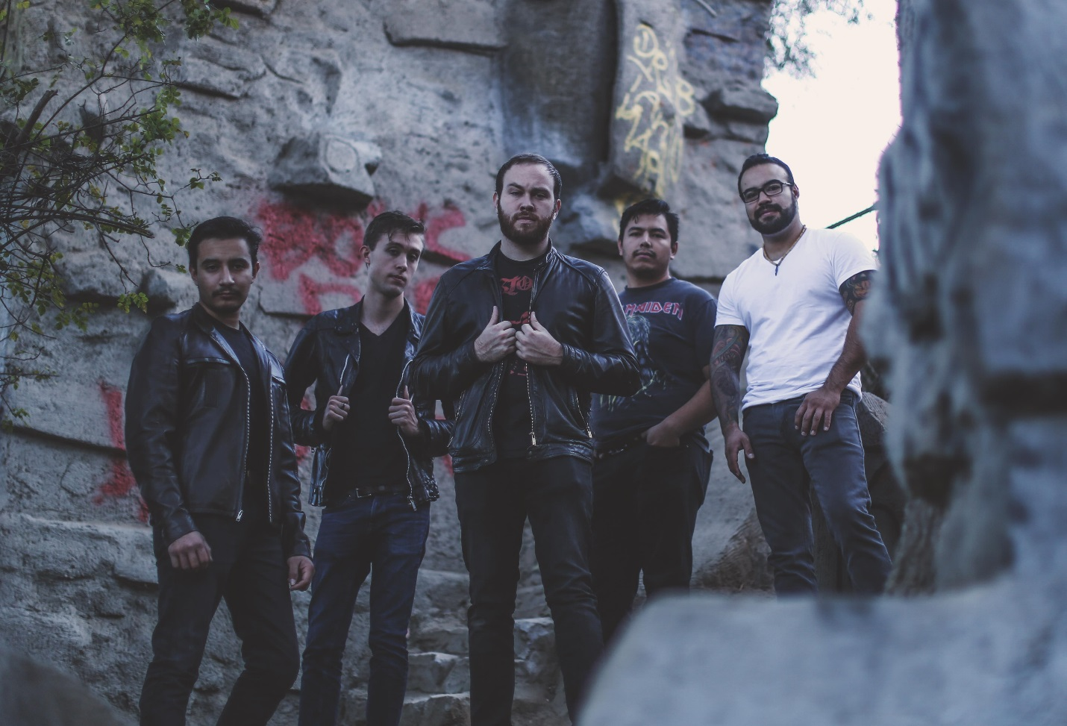

Los Angeles-based five-piece THE CROWN REMNANT have mastered the art of melodic, theatrical, yet hard-hitting heavy metal, and the world is about to take notice. Combining a variety of metallic influences ranging from modern metalcore and prog, thrash and more, THE CROWN REMNANT’s latest conceptual opus, The Wicked King: Part II, takes the listener on a dramatic, energetic joyride from start to finish.

Get a taste of The Wicked King: Part II now via their blazing brand new track, “Inferno”, streaming now via YouTube and Spotify. The track features metalcore-influenced riffage (à la Killswitch Engage and Avenged Sevenfold), fierce solos and soaring vocals, showcasing the band’s deft skill set.

The Wicked King: Part II is available for pre-order now via iTunes, Google Play and Bandcamp. Pre-orders are available with “Inferno” as an instant-grat download. Amazon pre-orders will also be available soon. You can also pre-save the album via Spotify here.

Lead vocalist Geordy Shallan says, “‘Inferno’ came together in a burst of late night spontaneity. It was almost inhuman how quickly it happened - the finger-burning speed of the riffs, the blistering beat of the drums, the theatrics of the vocals... it felt almost supernatural in itself. I felt so intrigued by the hellish nature of the musicality, that it felt only natural to draw from a tale such as Dante Alighieri's Divine Comedy, specifically ‘Inferno’. This song is the tale of one man's descent into the depths of sin, passing tornadoes of adulterers, Ice storms of gluttony, and eventually, at the center of hell, Satan himself. It felt only right to honor a tale as epic and visceral with a song so vicious and powerful. So please, enjoy ‘Inferno’, and stay prepared, there's so much more to come.”

The Wicked King: Part II acts as the second part of the band’s previous release, The Wicked King: Part I. Within the first month of its release, THE CROWN REMNANT garnered over ten thousand streams of their first single cut from The Wicked King: Part I, entitled “Haunted”. The band plans to follow suit and beyond with The Wicked King: Part II.

The Wicked King: Part II is loosely based on thematic concepts of oppression and tyranny. Originally recorded as one long album, the band decided to split it into two releases – with The Wicked King: Part II acting as the “darker” side of the two. Part II addresses tales of betrayal, mortality, exploring the afterlife and more. Intertwined within these ideals are scattered lyrics pertaining to the character designed on the front cover of the album: The Wicked King. He remains an everlasting shadow of a forgotten king set on immortality, with his insatiable lust for never-ending life.

The Wicked King: Part II track listing:
1) Into the Depths
2) The End
3) Legacy
4) Inferno
5) The Eternal Façade
6) As Faith Fades
7) The Wicked King

Lead guitarist Will Ash says, “I fell in love with the idea of The Wicked King, the complexities we were able to integrate into a character designed as a mascot and the symbolism that ties in with even our band's own name. I have a lot of faith in this new record – we're coming out of the gate swinging. When we put our nose to the grindstone, we really try and give it all we've got and I think we’ve accomplished something special.”

The Wicked King: Part II was recorded in multiple studios throughout Southern California, with the help of S&W Audio, and producer/engineer Tyler Ruehl (Noble, At The Skylines, Taipan, Lion I Am). After a rigorous tracking process, the songs were mixed by Robin Leijon (In Dying Arms, Atena, Eternal Void).

Lead vocalist Geordy Shallan adds, “Cursed skeleton kings, jazz chords, a fully scored orchestra carrying the foundation of a song – it’s all here. That’s what “The Wicked King” is, everything we could think of or ever want in a record, and I couldn’t be more proud.”

THE CROWN REMNANT are true musical storytellers! Stay tuned for more release information, tracks and videos coming soon.

See what the press is saying about THE CROWN REMNANT:
"The way the vocals are handled is super fresh, there are super big and crushing guitars, lots of melody..." - Gear Gods

"This band certainly has no boundaries and will go above and beyond to entertain the fans..." - Rock Revolt Magazine
​
“THE CROWN REMNANT is an exquisite metal act..." - Hard Rock Haven

THE CROWN REMNANT online:
Website: www.crownremnant.com
Instagram: www.instagram.com/thecrownremnant
Facebook: www.facebook.com/thecrownremnant
Twitter: www.twitter.com/thecrownremnant
Soundcloud: www.soundcloud.com/thecrownremnant
Bandcamp: www.thecrownremnant.bandcamp.com
YouTube: bit.ly/crownremnantyoutube

THE CROWN REMNANT is:
Geordy Shallan - Lead Vocals
Will Ash - Lead Guitar
Jorge Lopez - Rhythm Guitar
Josue Lara - Bass Guitar
Art Ramirez - Drums

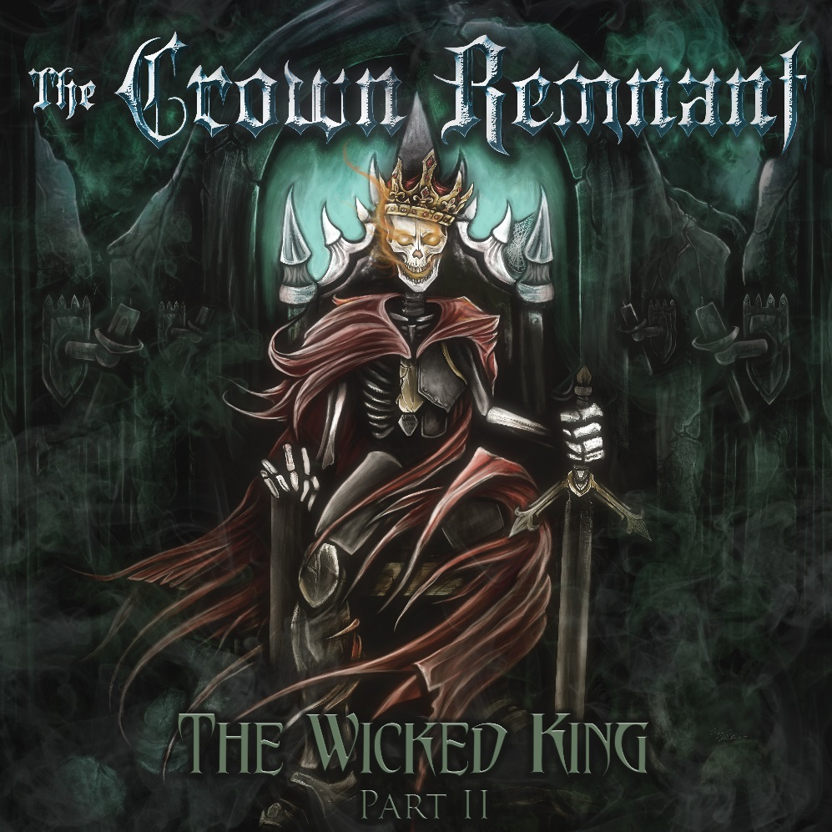
The Wicked King: Part II album art

