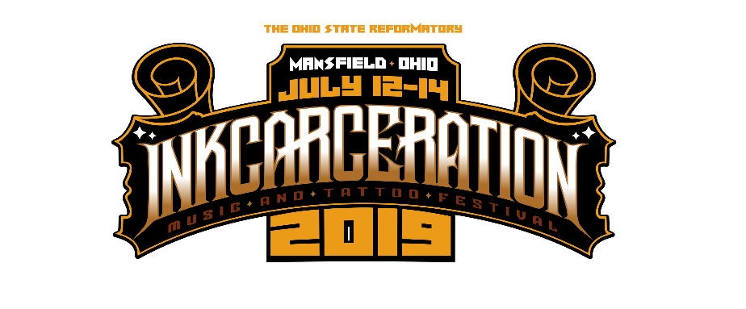

***To apply for INKCARCERATION 2019 press credentials, please fill out the official press request form here.

For Immediate Release
January 15, 2019

INKCARCERATION Music and Tattoo Festival Announces Massive 3-Day Line Up

Featuring Shinedown, Godsmack, Five Finger Death Punch, +Live+, Taking Back Sunday, Seether, Skillet and Many More

The Second Annual INKCARCERATION: Taking Place July 12-14, 2019 at the Historic Ohio State Reformatory | GET TICKETS HERE!

INKCARCERATION 2019 to Also Feature:
70+ Tattoo Artists
Food Trucks & Beverages
Tent & RV Camping
“Escape from Blood Prison” Haunted House Attraction
+ More!

Watch a New INKCARCERATION Teaser Here

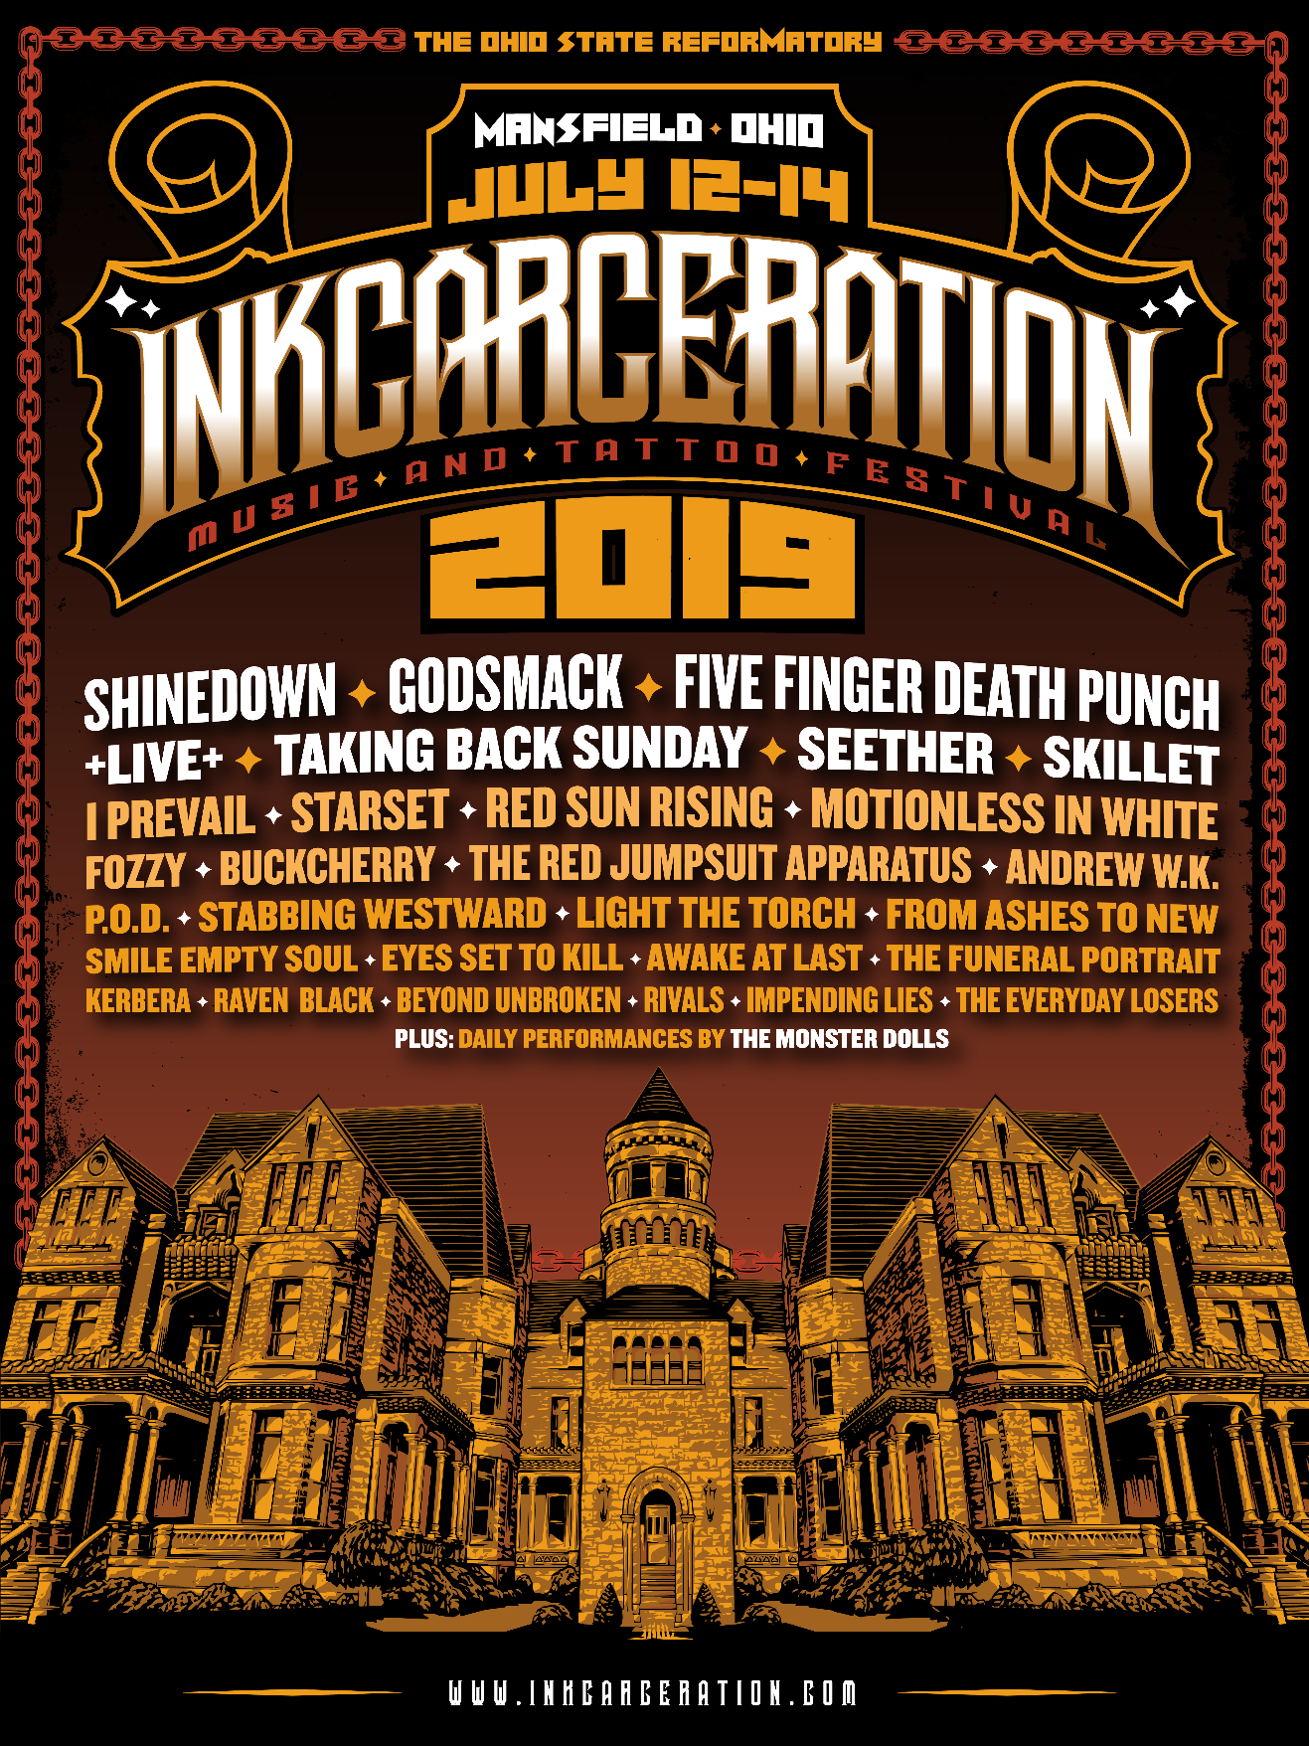

The wait is over! The INKCARCERATION Music and Tattoo Festival has announced the massive line-up scheduled to perform at its second annual event, set to feature colossal rock headliners Shinedown, Godsmack and Five Finger Death Punch! Quickly becoming one of the nation’s premier rock festivals, INKCARCERATION – taking place this year on July 12, 13 and 14 at the historic Ohio State Reformatory, a.k.a. Shawshank Prison, in Mansfield, OH – will feature over 30 bands on two outdoor stages, 70 tattoo artists, reformatory tours, gourmet food trucks, the best drinks and for the first time, the haunted house attraction, Escape from Blood Prison!

This year’s electrifying line-up also includes +Live+, Taking Back Sunday, Seether, Skillet, I Prevail, Starset, Red Sun Rising, Motionless in White, Fozzy, Buckcherry, The Red Jumpsuit Apparatus, Andrew W.K., P.O.D., Stabbing Westward, Light the Torch, From Ashes to New, Smile Empty Soul, Eyes Set To Kill, Awake at Last, The Funeral Portait, Kerbera, Raven Black, Beyond Unbroken, Rivals, Impending Lies and The Everyday Losers, plus special performances by The Monster Dolls.

Field, Camping and VIP tickets are on sale NOW via https://inkcarceration.frontgatetickets.com/!

Once again, INKCARCERATION Music and Tattoo Festival will take place at one of the most unique festival settings in the country – the Ohio State Reformatory. Considered one of the most haunted buildings in the country and the setting of the 1994 cinematic classic/IMDB’s highest rated movie of all time, The Shawshank Redemption (celebrating its 25th anniversary his year), the Reformatory is centrally located about an hour away from Cleveland, Columbus, and Canton/Akron, Ohio and within a three-hour driving distance of Toledo, Dayton, Cincinnati, Youngstown, Pittsburgh, Pennsylvania, northern West Virginia, Michigan and southern Ontario. This is the perfect destination festival! Additionally, INKCARCERATION features tent and RV camping for a true outdoor festival experience! See below for more details.

Stay tuned for more details coming soon regarding tattoo artists, gourmet food trucks, and more!

INKCARCERATION Music and Tattoo Festival promoters promise an epic year. “Building off such a strong inaugural year, we are so stoked to give our fans even more in year two. With Billboard chart-topping bands such as Shinedown, Godsmack and Five Finger Death Punch leading the way, tattoo artists from around the globe, and the historic backdrop of the haunted Shawshank Prison, INKCARCERATION 2019 will be the don't miss rock event of the summer in the Midwest!”

It’s Halloween in July at INKCARCERATION 2019!

Mentioned above, Escape from Blood Prison is the annual Halloween haunted house attraction hosted at the historic Ohio State Reformatory in Mansfield, OH. It typically runs from the end of September through early November every year, but INKCARCERATION will make this spooky attraction available for festival goers to experience all weekend long in 2019! Once Blood Prison takes over the reformatory, the enormous facility is filled with bloodthirsty inmates waiting for victims to enter and try and make it through the facility alive!

“It’s an honor to be able to open the doors of Blood Prison a couple months early and give the guests of INKCARCERATION a few scares in July! The warden, his family and the Blood Prison inmates are all excited to meet the fans at INKCARCERATION,” says Vic Amesquita, manager of Blood Prison.

INKCARCERATION 2019 Ticketing Details:

All available via https://inkcarceration.frontgatetickets.com/!

Weekend Field Passes:
- 3-day General Admission
- Field Passes to the concert for the entire weekend
- Self guided reformatory tours

Starting at: $139

Weekend VIP:
- 3 day VIP wristband
- Field Passes to the concert for the entire weekend
- Self guided reformatory tours
- Air-conditioned VIP lounge w/seating & tables
- Free catering (dinner) Friday, (Lunch & Dinner) Saturday & Sunday
- Private bar
- Dedicated bathrooms
- Raised viewing platform
- Dedicated entrance to the event

Starting at: $299

Weekend Camping Packages:
Tent Camping
- General Weekend Tent Camping includes 1,000 sq. ft. space for your car and up to 3 tents.
- 2 cars and 2 tents can also fit. 1000 sq ft is yours to work with.

RV Camping
- General Weekend RV camping includes hookups for electric & water.

Both camping packages include:*
- Access to showers and bathrooms
- Shuttle service to and from the festival (shuttles run every half hour)
- Small fires are permitted, see camping info for more details
*Admission must be purchased separately

Weekend Tent camping: $175
Weekend RV camping: $299

--

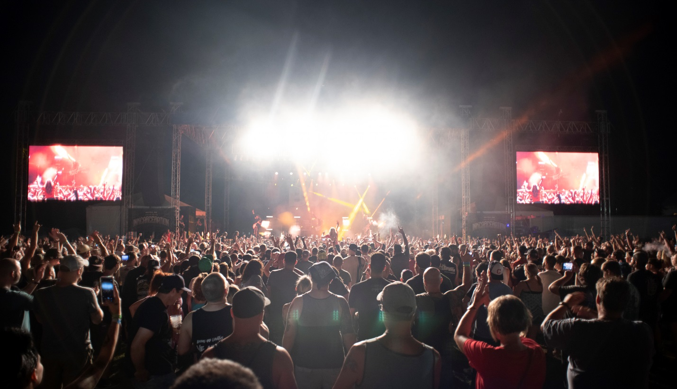
Photo taken at INKCARCERATION 2018

In its first year, INKCARCERATION brought enormous entertainment to over 18,000 fans, and this year, the festival aims even higher. Stay tuned for more news coming soon about INKCARCERATION 2019!

INKCARCERATION Music and Tattoo Festival online:
Website - www.inkcarceration.com
Tickets (Field, Camping & VIP) - https://inkcarceration.frontgatetickets.com/
Facebook - www.facebook.com/Inkcarcerationfestival
Twitter - www.twitter.com/InkcarFestival
Instagram - www.instagram.com/inkcarcerationfestival

The Historic Ohio State Reformatory online:
www.mrps.org
www.mrps.org/learn/film-and-television
www.shawshanktrail.com/photos

INKCARCERATION Music and Tattoo Festival is produced by Inkcarceration LTD.

