For Immediate Release
February 22, 2019

COMBICHRIST Reveals New Album Release Date & Art + Adds International Tour Dates

New Full-Length Album, One Fire, out June 7, 2019 via Out Of Line Music

Pre-Orders Coming Soon!

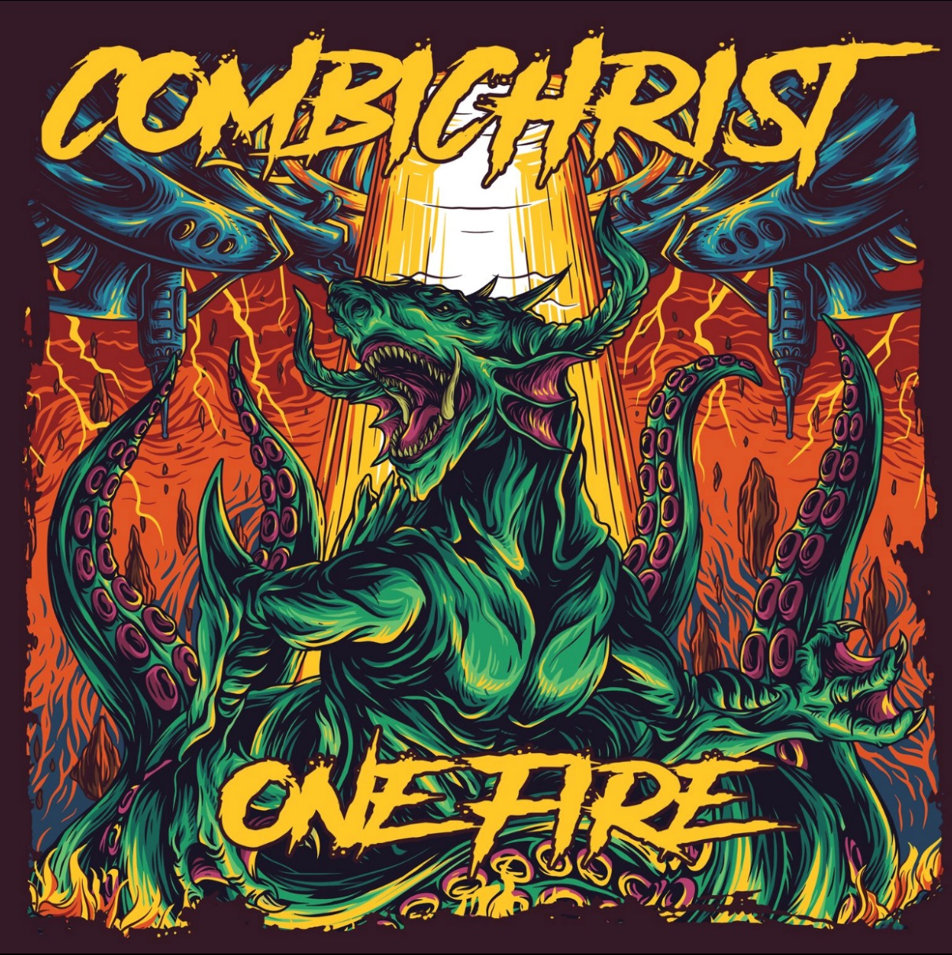

Electro-industrial metal leaders COMBICHRIST are thrilled to announce more details regarding their upcoming ninth full-length album, One Fire, scheduled for release on June 7, 2019 via Out Of Line Music. In addition to revealing the album’s release date, the band has leaked their new album art, illustrated by Deka Sepdian.

COMBICHRIST mastermind Andy LePlegua says about working with Deka Sepdian, “I worked with Deka for my clothing line, “Deathrod”, in the past, and he always does amazing work. I basically told him to make something chaotic that could just as well represent end of days as much as the chaos inside our heads. He did a killer job! Can’t wait to see this on a vinyl sleeve.”

One Fire pre-orders and music are coming very soon!

In the meantime, COMBICHRIST have added even more dates to their “One Fire World Tour”, now visiting the UK and Europe! The North American portion of the tour begins April 8 in San Diego, CA, and will tour for two months, concluding on June 2 in Indianapolis, IN. Then, not even a month later, COMBICHRIST will continue their international onslaught in the UK and Europe, starting in Dessel, BE on June 21. They will tour for nearly another two months, wrapping up on August 14 in Zebbug, MT.

See below for all tour dates. Tickets are available via individual venues. North American meet and greet upgrades are available now via http://bit.ly/combichristvip.

COMBICHRIST “One Fire” Tour Dates w/ Silver Snakes:
NORTH AMERICA:
4/8 - San Diego, CA @ Brick By Brick
4/9 - Tempe, AZ @ Club Red
4/12 - Oklahoma City, OK @ 89th Street Collective
4/13 - Dallas, TX @ GMBG
4/14 - Austin, TX @ Come And Take It Live
4/15 - Houston, TX @ Scout Bar
4/16 - New Orleans, LA @ The Goat
4/19 - Tampa, FL @ Brass Mug
4/20 - Atlanta, GA @ Masquerade
4/21 - Charleston, SC @ Music Farm
4/22 - Baltimore, MD @ Baltimore Soundstage
4/23 - Teaneck, NJ @ Debonair Music Hall
4/24 - New York, NY @ Gramercy
4/26 - Philadelphia, PA @ Voltage Lounge
4/27 - Hampton Beach, NH @ Wally's
4/28 - Providence, RI @ Fete Ballroom
4/30 - Lancaster, PA @ Chameleon Club
5/1 - Easton, PA @ One Centre Square
5/2 - Pittsburgh, PA @ Crafthouse
5/3 - Lakewood, OH @ The Winchester
5/5 - Chicago, IL @ Bottom Lounge
5/7 - Denver, CO @ Marquis Theater
5/9 - Las Vegas, NV @ Backstage Bar
5/10 - Los Angeles, CA @ The Regent
5/11 - San Francisco, CA @ Slim's
5/12 - Sacramento, CA @ Holy Diver
5/14 - Portland, OR @ Hawthorne Theater
5/15 - Seattle, WA @ El Corazon
5/16 - Vancouver, BC @ The Rickshaw Theater
5/17 - Edmonton, AB @ Starlite
5/19 - Regina, SK @ The Exchange
5/20 - Winnipeg, MB @ Pyramids
5/23 - London, ON @ Rum Runners
5/24 - Toronto, ON @ Lee's Palace
5/25 - Montreal, QC @ Café Campus
5/26 - Quebec City, QC @ L'Anti Bar & Spectacles
5/28 - Ottawa, ON @ The Brass Monkey
5/29 - Buffalo, NY @ Ironworks
5/31 - Flint, MI @ Machine Shop
6/1 - Grand Rapids, MI @ The Stache at The Intersection
6/2 - Indianapolis, IN @ The Citadel

UK/EUROPE:
6/21 - Dessel, BE @ Graspop Metal Meeting
6/22 - Clisson, FR @ Hellfest
6/24 - Bristol, UK @ The Fleece
6/25 - Dublin, IE @ Voodoo Lounge
6/26 - Belfast, UK @ The Palm House
6/27 - Glasgow, UK @ Audio
6/28 - Manchester, UK @ Academy 3
6/29 - London, UK @ Electric Brixton
6/30 - Birmingham, UK @ The Mill
7/2 - Amstelveen, NL @ P60
7/3 - Ballenstedt, DE @ Rock Harz
7/4 - Saarbrücken, DE @ Garage
7/5 - Lyon, FR @ Ninkasi Kao
7/6 - Barcelona, ES @ Rockfest
7/7 - Madrid, ES @ Caracol
7/9 - Montepellier, FR @ Secret Place
7/10 - Zurich, CH @ Xtra
7/11 - Milano, IT @ Legend Club
7/12 - Ljubljana, SI @ Kino Siska
7/13 - Zagreb, CR @ Mocvara
7/14 - Vienna, AT @ Scene
7/17 - Sofia, BU @ Mixtape 5
7/18 - Brasov, RU @ Kruhnen Musik Halle
7/19 - Budapest, HU @ Dürer Kert
7/21 - Bratislava, SK @ Randal Club
7/23 - Posnan, PL @ Klub U Bazyla
7/24 - Warschau, PL @ Proxima
7/25 - Riga, LV @ Melna Piektdiena
7/26 - Tallinn, EE @ Tapper
7/27 - Helsinki, FI @ Virgin Oil
7/28 - Tampere, FI @ Klubi
7/30 - Stockholm, SE @ Fryshuset Klubben
7/31 - Oslo, NO @ John Dee
8/1 - Göteborg, SE @ Sticky Fingers
8/3 - Hamburg, DE @ Grünspan
8/4 - Oberhausen, DE @ Kulttempel
8/6 - Stuttgart, DE @ Wizemann
8/7 - Munich, DE @ Backstage
8/8 - Frankfurt, DE @ Batschkapp
8/9 - Nürnberg, DE @ Hirsch
8/10 - Jaromer, CZ @ Brutal Assault Festival
8/11 - Hildesheim-Drispenstedt, DE @ MeraLuna Festival
8/14 – Zebbug, MT @ The Garage

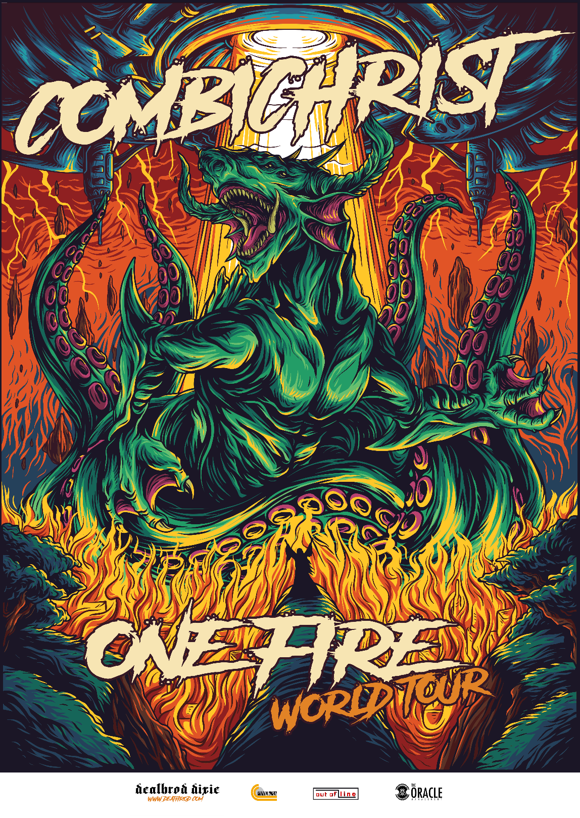

About COMBICHRIST:
Formed in 2003, COMBICHRIST took founder Andy LaPlegua's hardcore past and electronica present and merged them into a singular, mechanical music monster. Since releasing the first COMBICHRIST album The Joy of Gunz, LaPlegua and COMBICHRIST have unleashed six subsequent full-lengths, including 2014's We Love You, and numerous EPs while also cracking Billboard's Top 10 Dance Singles chart. Their latest released studio effort, This is Where Death Begins, was produced by LaPlegua and Oumi Kapila (Filter), and mastered by the legendary Vlado Meller (Red Hot Chili Peppers, Slipknot). An apocalyptic behemoth of guitars, electronica, infernal drums and dark elemental force, it is easily COMBICHRIST's most accomplished effort to date and landed the band a top 30 chart position in Germany. COMBICHRIST plans to expand on this success while returning to their industrial roots with 2019’s One Fire.

COMBICHRIST is:
Andy LaPlegua (vocals)
Eric 13 (Guitar)
Nick Rossi (Drums)
Will Spod (Drums)

COMBICHRIST online:
www.combichrist.com
www.facebook.com/combichrist
Twitter: @combichristarmy
Instagram: combichrist
www.indiemerchstore.com/b/combichrist

