For Immediate Release
February 21, 2019

SEPTEMBER MOURNING Launches U.S. Tour with Smile Empty Soul Next Week

Beginning February 28 in St. Louis, MO at Fubar

Announcing New Signing with The Oracle Management

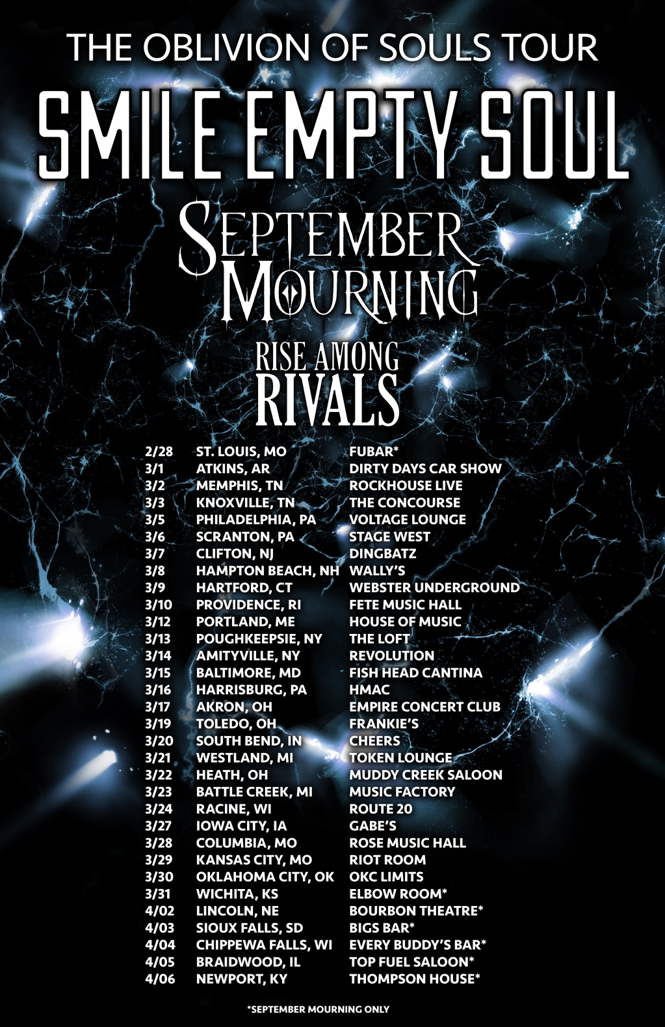

SEPTEMBER MOURNING have been turning heads in the dark art and metal scenes for years, bringing a fusion of dark culture and fantasy based in the world of comic books to life on stage. Created by SEPTEMBER MOURNING frontwoman Emily Lazar and comic book legend Marc Silvestri, the comics “A Murder of Reapers” and “The Hand of Fate” (collectively “Volume I”, published by Top Cow/Image Comics) tell the tale of September, a human/reaper hybrid with no memory of her past. Empowered with supernatural gifts, she is driven to protect humanity from Fate and his Reapers.

This mysterious story – brought to life by SEPTEMBER MOURNING’s potent mixture of dark pop, electronica and modern metal – can be experienced in auditory form via their latest Billboard-charting (#19, Heatseekers) Sumerian Records release, Volume II, out now (Amazon | iTunes | Spotify).

Witness SEPTEMBER MOURNING on the road this winter during their upcoming tour with headliners Smile Empty Soul and fellow support artist Rise Among Rivals! The tour begins next week on February 28 in St. Louis, MO, and will visit over a month’s-worth of major U.S. cities, coming to an end on April 6 in Newport, KY.

See below for a full listing of tour dates (please note that specific dates notated with an asterisk feature SEPTEMBER MOURNING only), and pick up tickets via www.septembermourning.com.

SEPTEMBER MOURNING U.S. tour dates with headliners Smile Empty Soul:

*= SEPTEMBER MOURNING Only

2/28 – St. Louis, MO @ Fubar*
3/1 – Atkins, AR @ Dirt Days at Sweeden Island Park
3/2- Memphis, TN @ RockHouse Live
3/3 – Knoxville, TN @ The Concourse
3/5 – Philadelphia, Pa @ Voltage Lounge
3/6 – Scranton, PA @ Stage West
3/7 – Clifton, NJ @ Dingbatz
3/8 – Hampton Beach, NH @ Wally’s
3/9 – Hartford, CT @ The Webster Underground
3/10 – Providence, RI @ 5th Annual Providence Tattoo and Music Festival at Fete Music Hall
3/12 – Portland, ME @ Portland House of Music and Events
3/13 – Poughkeepsie, NY @ The Loft at The Chance
3/14 – Amityville, NY @ Revolution Music Hall
3/15 – Baltimore, MD @ Fish Head Cantina
3/16 - Harrisburg, PA @ Harrisburg Midtown Arts Center
3/17 – Akron, OH @ The Empire Concert Club and Bar
3/19 – Toledo, OH @ Frankie’s Inner City
3/20 – South Bend, IN @ Cheers Pub
3/21 – Westland, MI @ The Token Lounge
3/22 – Heath, OH @ Muddy Creek Saloon
3/23 – Battle Creek, MI @ The Music Factory
3/24 – Sturtevant, WI @ Route 20
3/27 - Iowa City, IA @ Gabe’s Iowa City
3/28 – Columbia, MO @ Rose Music Hall
3/29 – Kansas City, MO @ The Riot Room
3/30 – Oklahoma City, OK @ Oklahoma City Limits
3/31 – Wichita, KS @ The Elbow Room*
4/2 – Lincoln, NE @ The Bourbon Theatre*
4/3 – Sioux Falls, IA @ Bigs Bar*
4/4 – Chippewa Falls, WI @ Every Buddy’s Bar & Grill*
4/5 – Braidwood, IL @ Top Fuel Saloon*
4/6 – Newport, KY @ Thompson House*

SEPTEMBER MOURNING says about the tour: “We are beyond excited to join Smile Empty Soul and Rise Among Rivals for “The Oblivion of Souls Tour”. This is our first Soul Collection of the new year and we look forward to seeing both new and old souls on the road. Expect an intense showcase of all things dark rock as we gather souls across the US this spring.”

SEPTEMBER MOURNING are no strangers to the stage, having built up their touring resume by performing at massive events such as Download (UK), Rock on the Range (Columbus, OH), Aftershock (Sacramento, CA), Comicpalooza (Houston, TX), AC Boardwalk Con (Atlantic City, NJ), Anime Midwest (Chicago, IL), Mechacon (New Orleans, LA) and many more.

SEPTEMBER MOURNING are also pleased to announce their recent signing with The Oracle Management. Founded by Dez (DevilDriver, Coal Chamber) and Anahstasia Fafara, The Oracle Management is powered by passion, honesty, integrity and a militant devotion to the creative arts.

SEPTEMBER MOURNING says about signing with The Oracle Management, “We have been preparing to bring the next chapter of our trans-media story to life and cannot express how excited we are to bring The Oracle Management on board to help facilitate this. With such a solid roster of established and emerging artists, alongside an insatiable drive and dedication to each individual acts' success, The Oracle promises to be just what we need to achieve our future goals.”

The Oracle Management Vice President and COO Dez Fafara adds, “The Oracle Management is proud to sign SEPTEMBER MOURNING to our management roster. This band is fire, so get ready! It will be our pleasure to guide them to a very bright future. Here we grow!”

In late 2018, SEPTEMBER MOURNING released the singles “Empire” and “Glass Animals” and the third chapter of their story, “Trinity”. More music will be released in 2019 and “The Complete Collection”, a full graphic novel containing all four chapters of the story, will hit comic stores in early 2019.

SEPTEMBER MOURNING is:
Emily Lazar (September) - Vocals
Rich Juzwick (Riven) - Guitar
Patrick Romanelli (Wraith) - Guitar
Kyle Mayer (Stitch) - Drums

SEPTEMBER MOURNING online:
www.septembermourning.com
www.facebook.com/septembermourning
www.instagram.com/septembermourning
www.twitter.com/SeptmbrMourning
www.youtube.com/theseptembermourning
www.snapchat.com/add/septmourning

The Oracle Management online:
www.theoraclemanagement.com

September of SEPTEMBER MOURNING by Curtis Noble

