For Immediate Release
March 8, 2019

HEAVY AS TEXAS, Featuring Members of Exhorder, to Release New Album in April

“To Keep A Promise” Single/Music Video Out Now | Watch Here via Guitar World

Pre-Order New Self-Titled Album via iTunes & Official Site

Out April 19, 2019 via Crunchy Western Records

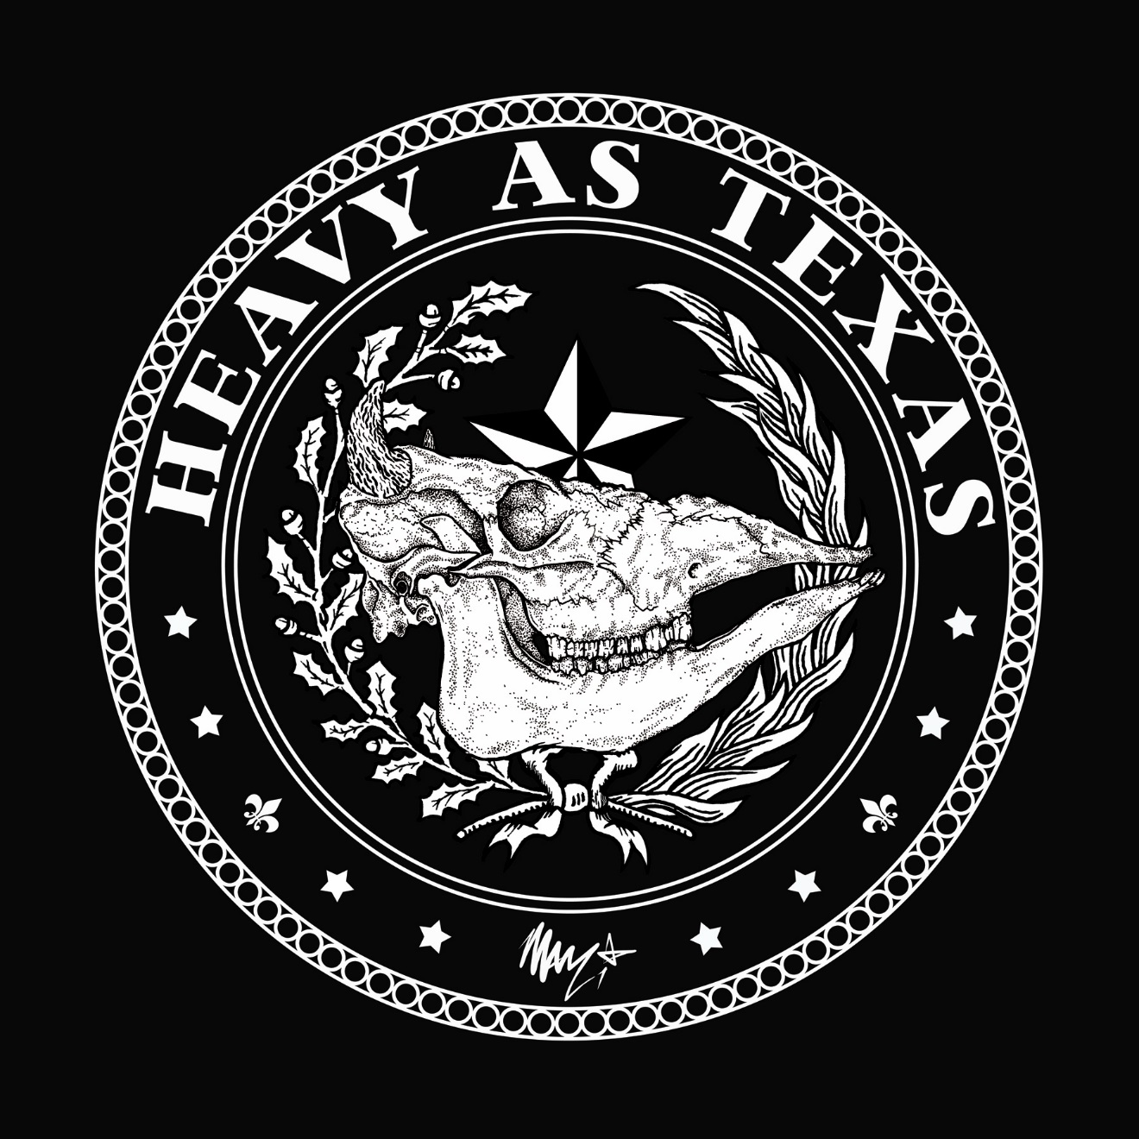

Acclaimed guitarist Marzi Montazeri and vocalist Kyle Thomas – otherwise recognized as members of Louisiana-based metal pioneers Exhorder (named by Spin as one of the 30 Greatest Thrash Bands of All Time) – are thrilled to announce their brand new, whiskey-soaked, aggressive metal project, HEAVY AS TEXAS.

HEAVY AS TEXAS plans to release their brand new self-titled album on April 19, 2019 via Crunchy Western Records. Pre-orders are available now via iTunes and the band’s official website.

Get a taste of a brand new HEAVY AS TEXAS track, entitled “To Keep a Promise”, now via a brand new music video directed by Mark Borchardt. Watch here via Guitar World: https://www.guitarworld.com/news/heavy-as-texas-premiere-to-keep-a-promise-music-video

For the album, HEAVY AS TEXAS tapped renowned drummer Anup Sastry (Marty Friedman, Jeff Loomis, Skyharbor) and notable engineer and multi-instrumentalist Chris Collier (Korn, Prong, Winds of Plague) on bass. Currently, the Houston, TX-based band’s line-up is rounded out by full time members Lenwood Sonnier on bass, and James Goetz on drums.

The new HEAVY AS TEXAS album was produced by guitarist Marzi Montazeri, with mix and mastering duties handled by Chris Collier.

Marzi Montazeri says, “I started this project simply because I wanted to perform new music but wasn’t able to sing and play complex rhythms at the same time. So I thought, I’ll stick to my strengths – the guitar and writing songs! I brought in a vocalist that would fit it perfectly – the one and only Kyle Thomas! As soon as Kyle joined everything musically fell into place.”

After the album drops, HEAVY AS TEXAS plans to begin writing their next effort and to hit the road in support of both. Montazeri adds, “I want to play our music for everyone all over this planet. We have stayed true to our art through complete artistic integrity and we display that live, so it is our duty to get it out to the people and celebrate our own brand of music!”

Heavy metal fans may also recognize guitarist Marzi Montazeri for his contributions to various projects featuring Philip Anselmo throughout the years, as well as his performances with the annual Randy Rhoads Remembered events at NAMM. Vocalist Kyle Thomas is also recognized for his time with Alabama Thunderpussy.

Stay tuned, hang on tight and prepare for the wild ride that is HEAVY AS TEXAS!

HEAVY AS TEXAS Self-Titled track listing:
1 - To Keep a Promise
2 - It’s On
3 - Death of a Prodigy
4 - Blind
5 - Reality Check
6 - King of Fools
7 - From This Day On
8 - Love Gets Us All

HEAVY AS TEXAS online:
Website: www.heavyastexas.com
Facebook: www.facebook.com/heavyastexas
Instagram: www.instagram.com/heavyastexas

Guitarist Marzi Montazeri online:
www.marzimontazeri.com
www.facebook.com/marziarmy
www.instagram.com/marziarmy
www.twitter.com/marziarmy
www.youtube.com/user/marziarmy

Marzi Montazeri is endorsed by Washburn Guitars, Fortin Amplification, Seymour Duncan, Jim Dunlop Products, Spectraflex, Pigtronix, Eventide and Godlyke Inc.

Crunchy Western Records online:
Website: www.crunchywesternrecords.com
Facebook: www.facebook.com/crunchywesternrecords
Instagram: www.instagram.com/crunchywesternrecords

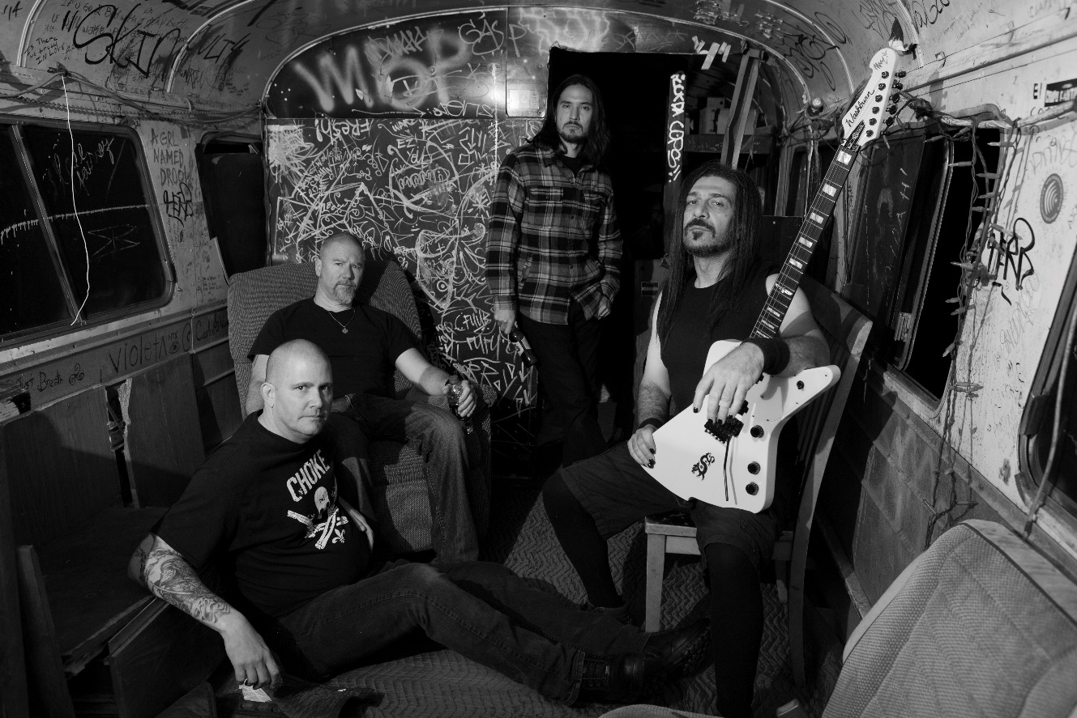
HEAVY AS TEXAS Press Photo by Bryan Anderson

