For Immediate Release
June 21, 2019

NY-Based Heavy Metal Band DAMN YOUR EYES Announces New Album, “Kill the Outside”, out August 2, 2019
Watch New Music Video for “Ascension” Now via Decibel Magazine | YouTube

Download “Ascension” Track Here | Full Album Pre-Orders Coming Next Week

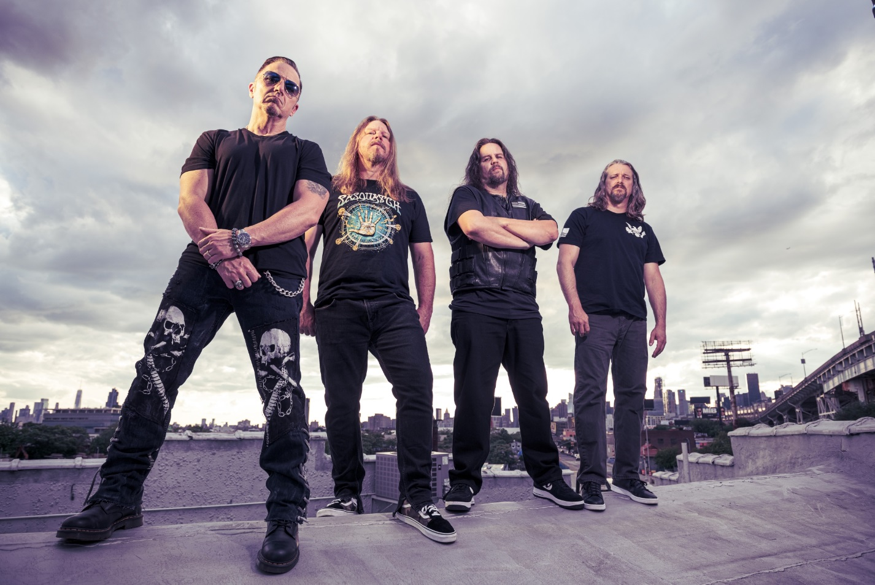
DAMN YOUR EYES Press Photo by Dante Torrieri

New York-based heavy metal band DAMN YOUR EYES may seem new to the scene, but they are anything but green. The band – formed by former members of We Are The Enemy and Bonesmith, plus current members of Black Water Rising – came together in 2015 and immediately hit the ground running. As respected musicians in their local scene with extensive recording experience, the band quickly recorded an EP, released it to local acclaim, and rapidly returned to the studio to record their upcoming international full-length debut, Kill The Outside.

Kill The Outside will hit digital retailers everywhere in full on August 2, 2019, with pre-orders available beginning next week. Kill The Outside will be available in physical CD and vinyl formats upon release date.

DAMN YOUR EYES isn’t about clickbait or gimmicky metal. The band performs pure American heavy music – blending influences of 90’s heavy metal with grunge, stoner metal and sludge to create a potent mixture of candid aggression. Decibel Magazine says it best: “…DAMN YOUR EYES’ style is straight ahead American metal, with nods to everyone from Down to Alice in Chains and Phil Demmel-era (read: good) Machine Head.”

Today, DAMN YOUR EYES have revealed their brand new, headbang-inducing lead single from Kill The Outside, entitled “Ascension”, by way of a brand new music video, directed by Tom Flynn. Watch here via Decibel Magazine, or via YouTube.

“Ascension” is available to download as a standalone single now via Apple Music, and will be available via Google Play, Amazon and Spotify soon.

Regarding “Ascension”, guitarist Artie Alexander tells Decibel Magazine: “I wrote this song while in a revolutionary state of mind. It’s more or less about how I’m fed up with the nonsense going on in our government, and I also wanted it to parallel the feelings of the colonies – in a subtle way – that were tired of the nonsense they had to endure under British rule. Overtaxing, overspending, buying elections setting the conversation in their favor, etc. Patriots rise up against misrule. It’s about not eating the garbage the government is feeding us and doing something about it. Taking the power back to the people.”

Kill The Outside showcases a mixture of styles, making for a truly dynamic and emotive collection of tracks. In addition to the metal radio-ready “Ascension”, mellow head-bobbers like “Burn” echo grunge and stoner metal influences, while standout track “Low Road” kicks off with a Type O Negative-esque intro riff before quickly transitioning to full-on antagonistic southern groove metal. Slow and low, grooving “Dirty Viper” tells the intense and personal story of a friend who committed suicide by heroin overdose. Tracks like “Punk Fuck” kick it up a notch, while another standout track, the heartfelt “Slower”, brings the tempo down while telling the opposite story of “Dirty Viper” – an uplifting tale of wonderful results after making the decision to change oneself.

Artie Alexander adds: “In the bed of all of these songs lies personal experiences. Experiences that every person on this planet can identify with, having either lived through them themselves or watched someone they love go through them. The album is about being human and the images seen through our eyes. Moments of anger, frustration, sorrow, loss, redemption, hope, recovery, revenge, survival and healing.”

Kill The Outside track listing:
1) Ascension
2) Burn
3) Dirty Viper
4) Lions from Lambs
5) Low Road
6) Punk Fuck
7) Slower
8) These Are the Things
9) Through it All
10) Tree Line

Kill The Outside was recorded at Front Row Recording and produced by John Iadevaio. The album was mastered by Dan Malsch at Soundmine Recording.

DAMN YOUR EYES is sought after by Long Island and New York City area promoters and venues because of their energetic live performances! Catch DAMN YOUR EYES performing at two shows coming up – July 20 in Amityville, NY at Revolution, and August 27 in Elmhurst, NY at Blackthorn 51 with Crowbar.

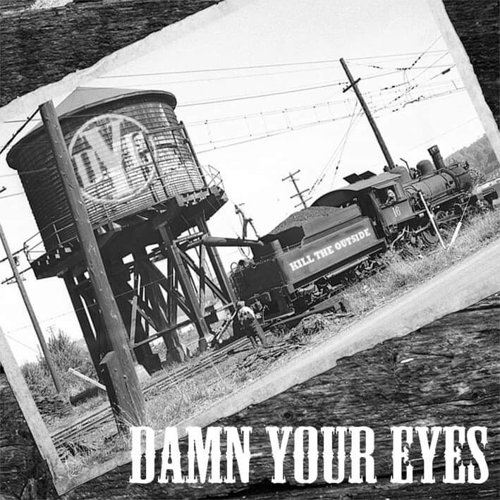
Kill The Outside album art
DAMN YOUR EYES is:
Kenny Vincent Jr. – Lead Vocals
Artie Alexander – Guitar and Vocals
Oddie McLaughlin – Bass
Rick Taiano – Drums

DAMN YOUR EYES online:
www.damnyoureyesband.com
www.facebook.com/steelegrovestudio
Instagram: @dyebandofficial

