For Immediate Release
July 26, 2019

Emerging Modern Metal Outfit ABSENCE OF DESPAIR to Release New Album, “Desolate”, on September 13, 2019

Watch New Music Video for “Bite My Tongue” Now via Metal Injection

Pre-Order Here

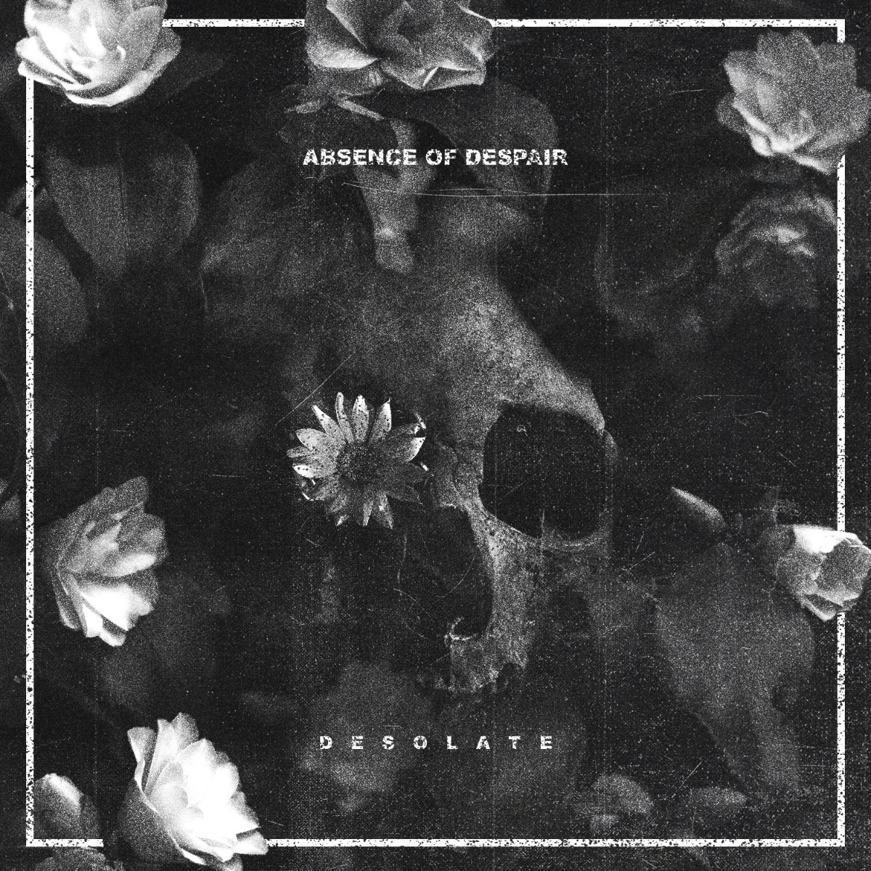

Providence, Rhode Island-based modern metalcore upstarts ABSENCE OF DESPAIR have made waves in the scene since their formation in 2008, but are set for national acclaim with their brand new album, Desolate, scheduled for release on September 13, 2019. The album features 12 brand new, heavy-hitting anthems that showcase this hard working up-and-coming band’s undeniable raw talent. Ripping, intense metal grooves blended with addictive hooks poise ABSENCE OF DESPAIR’s Desolate as an undeniable metalcore favorite of 2019.

Desolate pre-orders are available here via the band’s website, and will be available via all digital retailers very soon.

Today, ABSENCE OF DESPAIR are thrilled to reveal the first single cut from their upcoming album, entitled “Bite My Tongue”. Fans can witness the brand new, high octane music video for the headbang-inducing track now, exclusively via Metal Injection: https://metalinjection.net/video/throw-down-with-absence-of-despairs-new-song-bite-my-tongue

The “Bite My Tongue” video was shot by Matty LaBonte of Crown Media Collective. Bassist Rob Bryant says: “The main concept of the video is to not be taken over by anxiety, but to overcome, and breakthrough it. Crown Media Collective did a fantastic job on the video. They were able to purge the anxiety concept well with the static televisions placed around us.”

Desolate immediately bursts into a brutal assault of fast-paced grooves on the album’s opener, “ESC”, and continues to traverse a melodic-yet-darkened metalcore landscape on tracks like “Bite My Tongue” and “Godkiller”. Anthemic tracks such as “Fearless” and “This Reckoning” solidify the band’s keen ability to write unforgettable hooks without sacrificing sinister riffage, while “Lost & Hopeless” provides an example of ABSENCE OF DESPAIR’s more extreme side. Beyond these tracks, there’s even more to love on Desolate.

Vocalist Joe Reynolds says: “Desolate is focused on gaining the strength to look at obstacles in your life and overcome them. Each song represents a different side or emotion of a person and tells the story of what’s going through their head. At the end of the day, we want the listener to find meaning in themselves and the world around them.”

Desolate was recorded, mixed and mastered by Josh Schroeder (For The Fallen Dreams, King 810, The Color Morale) at Random Awesome Studios in Midland, Michigan.

Bassist Rob Bryant says: “Josh Schroeder really brought possibilities to light for us musically, helped shape the songs the way we needed them to be, and brought us out of our comfort zone. He pushed us, and helped us push ourselves into creating what we feel is our most dynamic and heavy hitting project yet.”

Desolate track listing:
1) ESC
2) Bite My Tongue
3) Wild
4) Godkiller
5) Fearless
6) Lost & Hopeless
7) This Reckoning
8) Die Primitive
9) Shadowbreaker
10) I Am Catastrophe
11) The Skin We Live In
12) Pathwalker

ABSENCE OF DESPAIR will perform at the Providence, Rhode Island date of the Summer Slaughter tour, taking place on August 2 at Fete Music Hall. For more information, visit this location. The band is currently booking fall tour dates in support of Desolate.

ABSENCE OF DESPAIR endorses Fishman, GHS Strings, Empire Ears, Coldcock Whiskey, InTune Guitar Picks and Sennheiser.

Stay tuned for more tracks and videos coming from ABSENCE OF DESPAIR soon!

ABSENCE OF DESPAIR is:
Joe Reynolds: Vocals
Tyler Caruso: Guitar/Vocals
Dillon DeSimone: Guitar/Vocals
Rob Bryant: Bass
Mike Perrotta: Drums

ABSENCE OF DESPAIR online:
www.absenceofdespair.com
www.facebook.com/absenceofdespair
https://twitter.com/aodmetal
www.instagram.com/absenceofdespair
www.youtube.com/aodmetal

ABSENCE OF DESPAIR Press Photo by Eric Hooker (Hook U Photography)

