For Immediate Release
July 22, 2019

Instrumental Progressive Quartet ANAMORPH to Release New Album, “Lucid”, on September 6, 2019

Watch New Music Video for “Breakthrough!” Now via Kerrang!

Pre-Order Lucid Now: Physical via Website | Digital via Bandcamp & iTunes
Stream Tracks via Spotify

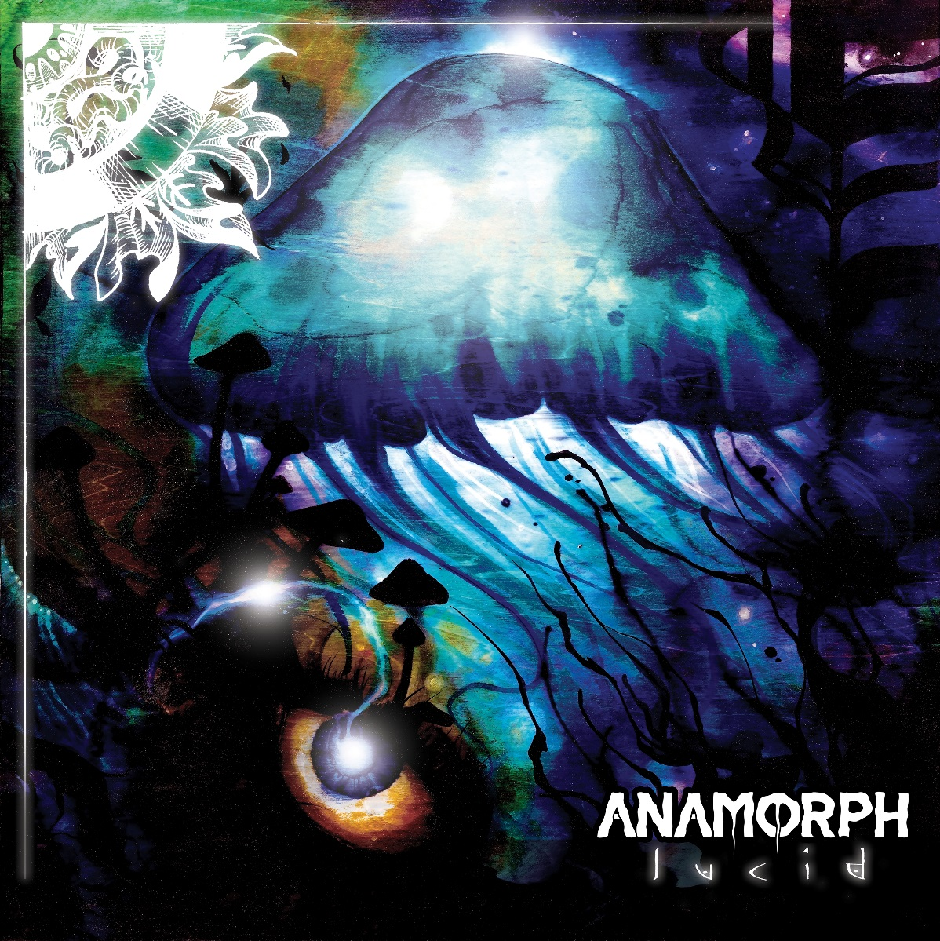
Album Art by Leif Olson

Fast-rising North Carolinian instrumental progressive metal band ANAMORPH are thrilled to announce the upcoming release of their ambitious, otherworldly full-length album, Lucid, scheduled for independent release on September 6, 2019. The Raleigh-based quartet – featuring Sean Parkinson and Cole Lohmann on guitars, James Agusta on drums and Griffin Daniels on bass – deftly weave notes of prog-rock, prog-metal, tech death, math rock, post rock and other influences together, making the 57-minute Lucid an intriguing listen for any fan of thought-provoking metal.

Lucid, which was recorded by renowned producer Jamie King (Between the Buried and Me, Scale the Summit, The Contortionist), is available for pre-order now via the band’s website, Bandcamp and iTunes, and the album will be available to stream upon release via Spotify.

Get your first taste of Lucid now via ANAMORPH’s new music video for the beautifully intricate single “Breakthrough!”, shot by Erez Bader of Silent Flight Productions (Between the Buried and Me, The Contortionist, The Dear Hunter, Veil of Maya) and available to view now via Kerrang! Watch here:
https://www.kerrang.com/the-news/anamorph-get-dreamy-and-elaborate-in-their-new-video/

Drummer James Agusta says about the video: “Working on the “Breakthrough!” video with Erez and Nathan was a blast. We all had to do some pretty weird and goofy stuff to get some of the most memorable shots. From Nathan climbing a tree to get a killer drum angle, Sean playing guitar in the back of a moving pickup truck to nail down some dreamy guitar shots, or all of us having to do some very over-the-top facial expressions and body language for the video’s climax, the entire shoot was a riot. Erez worked his magic and brought out the best in all of us, really getting us in the right mindset to execute the video.”

While online, check out a behind-the-scenes video of ANAMORPH in the studio with Jamie King here: https://youtu.be/RZkJ9EISuoQ

Having taken creative leaps musically and professionally with Lucid, ANAMORPH’s live and recorded output is a hidden gem that has greatly exceeded their exposure to the public eye at-large thus far.

ANAMORPH likens themselves as “a band about the world” – writing music that is deeply reflective, with themes and motifs that span the scope of the human condition – wide ranges of emotions, states of mind, thought processes, and perspectives. ANAMORPH emulates the world at large, drawing attention to triumphs and shortcomings, beauty and destruction, the struggles of growth, and the uncertainty that encompasses us all as we drive forward into the future.

Agusta adds: “These themes can all be found on the album, which plays and develops as a progression of thought. Musical and thematic motifs can be found throughout the album, which create ties and links between the overarching theme of the record.”

ANAMORPH wastes no time kicking off the album with “Reverie” and “Myopia”, two different entrancing examples of heavy prog-metal/rock mixed with experimental ethereals. Tracks like “Hubris” show off the band’s jazz metal inspiration, while songs like “Fading Azure” and the outright ripping “Feasting a Ravaged Earth” delve into total tech death. Listeners can expect this and more on ANAMORPH’s truly astonishing new offering.

Lucid track listing:
1. Reverie
2. Myopia
3. Hubris
4. Fading Azure
5. Twilight's Somber Gaze
6. Feasting a Ravaged Earth
7. Breakthrough!
8. Endogenous Change
9. Sublimate
10. Overcome
11. Civilized Sociopath
12. Catharsis
13. In Time

ANAMORPH have honed their performance chops by supporting artists such as Felix Martin, Consider The Source, Sarah Longfield, Toothgrinder and more. The band is scheduled to hit the road on a tour of the U.S. east coast this September, performing with various artists along the way such as Stellar Circuits and others. See below for a full list of confirmed dates.

Upcoming confirmed ANAMORPH tour dates:
September 5 - Durham, NC @ The Pinhook
September 6 - Augusta, GA @ The Epicenter
September 10 - Toms River, NJ @ The Clubhouse
September 11 - Boston, MA @ O’Brien’s Pub
September 12 - Wallingford, CT @ Cherry St. Station
September 14 - Dayton, OH @ Blind Bob’s
September 15 - Charlotte, NC @ The Milestone

Stay tuned for more new tracks and videos coming soon via ANAMORPH!

ANAMORPH online:
www.facebook.com/anamorphband
www.instagram.com/anamorphband
www.youtube.com/user/anamorphofficial
www.twitter.com/anamorphband

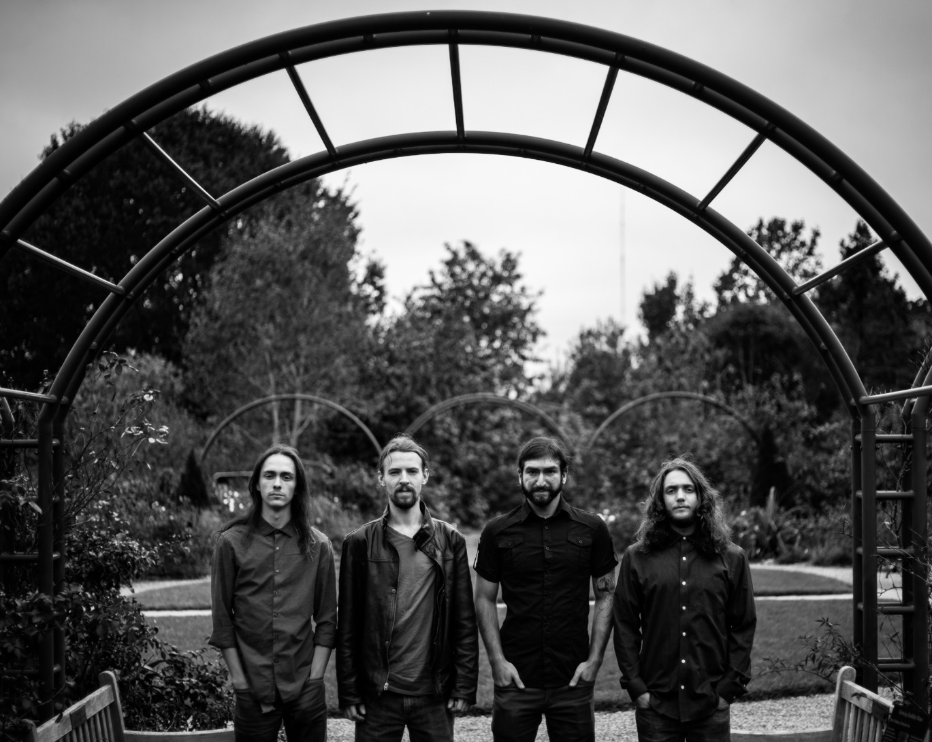
ANAMORPH Press Photo by Brian Krahe

