**For Immediate Release**

**August 13, 2019**

**Music Industry Legend Jon Zazula, a.k.a. Jonny Z, to Release Tell-All Book, “Heavy Tales: The Metal. The Music. The Madness. As Lived by Jon Zazula”**

**Lived and Told by Megaforce Records Co-Founder Jon Zazula**

**Brought to Life by Harold Claros-Maldonado**

**Foreword by Testament Vocalist Chuck Billy**

***Heavy Tales: The Metal. The Music. The Madness. As Lived by Jon Zazula* Available for Pre-Order in Hardcover and Paperback** [**Here**](https://www.jonzazula.com/)

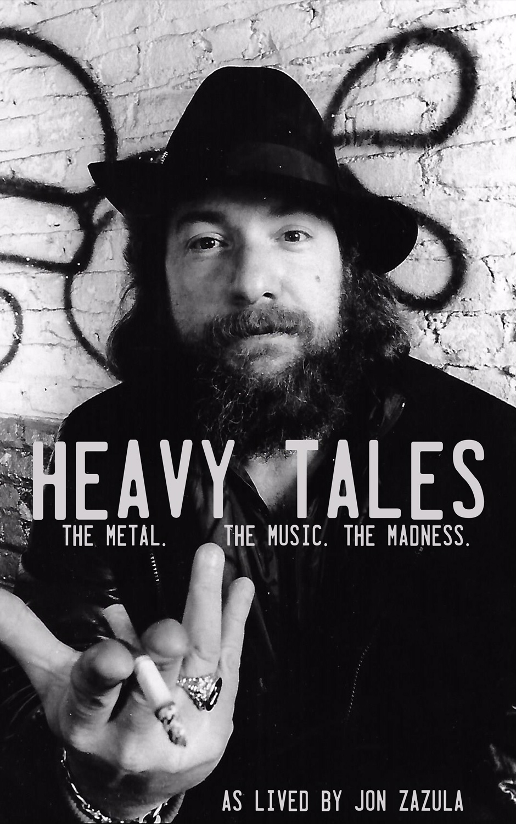

Jonathan Zazula, known the world over as Jonny Z, has lived an intense life. Born in 1952, he began his extraordinary journey as a renegade youth who went from living on the streets of the Bronx in New York City, to later working on Wall Street, and eventually (and unexpectedly) transitioning into the music business and discovering **Metallica** and others. Today, Jonny Z remains one of the most respected names in heavy metal and the music industry as a whole.

Jonny Z tells all about his incredible life in a brand new book that he describes as, *“not a typical rock n’ roll book, but rather, a blue collar success story”* – entitled ***Heavy Tales: The Metal. The Music. The Madness. As Lived by Jon Zazula***, scheduled for release on Tuesday, October 29, 2019. ***Heavy Tales*** is the detailed, never before told story of how Jonny Z founded legendary New Jersey-based label **Megaforce Records** with his wife, Marsha, and built a dynasty unmatched by others – forever changing the scope of heavy metal.

Pre-orders for standard and signed hardcover and paperback copies of ***Heavy Tales*** are now available via [www.jonzazula.com](http://www.jonzazula.com), as well as digital retailers such as [Amazon](https://www.amazon.com/Heavy-Tales-Metal-Music-Madness/dp/1733056726), Audible, [Barnes & Noble](https://www.barnesandnoble.com/w/heavy-tales-jon-zazula/1132756247?ean=9781733056755) and Ingram Content Group.

The ebook version of ***Heavy Tales*** will be available for pre-order soon, and will be released on Black Friday, November 29, 2019.

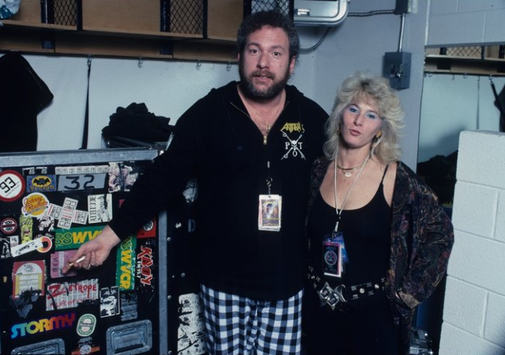

**Jonny Z and Marsha Zazula in the Golden Era of Megaforce**

Jonny Z says about deciding to release a book about his life, *“I wanted to tell the story of my life before someone else did. This is a story that has a motto behind it – “nothing to it but to do it”. There were a lot of odds factoring in for Marsha and myself, and we did it. No matter what anyone says to Marsha and I, we did it, and I just wanted to get that story down – that it took two people. I wanted our love story in there. I was also never very forward and transparent about my manic depression and bi-polar condition, and I just wanted to tell the story of how a man can get through that, poverty, incarceration and humiliation and rise to succeed with everything against him.”*

After experiencing the horrors of Wall Street, in order to put food on the table for his children, Jonny Z began selling records at a flea market store he dubbed Rock N’ Roll Heaven in 1981, which blossomed into a major record store in the United States and influenced the heavy metal movement as we know it today. Seminal Megaforce Records publicist and Adrenaline PR CEO Maria Ferrero was his first customer before the store was even open.

Zazula adds, *“I sold metal records because metal is foreground music, not background music. It inspires you to listen and pay attention to it. The fans of heavy metal music all came into the store with their painted jackets and denim vests and patches, which was very reminiscent to me of the late 60s and early 70s music scene that I was such a part of.”*

In the winter of 1982, Jonny Z received an unexpected demo tape from underground, unsigned band **Metallica**. Eager and determined to have the music heard by the entire world, Jonny and Marsha, founded **Megaforce Records** in 1983, and soon after, released **Metallica**’s debut album, *Kill ‘Em All*. Through this release, Megaforce cemented its position as the de-facto music label in America for heavy metal - but that’s just the start. The bands they would go on to work with released some of the most prolific and important albums in heavy metal history, giving it its Golden Era.

***Heavy Tales*** details the stories of how Jonny Z worked miracles by managing and releasing albums by **Metallica**, **Anthrax**, **Testament**, **Mercyful Fate**, **Raven**, **Overkill**, **Exciter**, **Stormtroopers of Death**, **Method of Destruction**, **Ace Frehley**, **King’s X**, **Ministry**, **Mindfunk**, **Nudeswirl**, **Warren Haynes**, **Disco Biscuits** and others, and how one night in 1984, he jokingly created rap metal before anyone else conceived the idea.

With a foreword written by **Testament** vocalist Chuck Billy, plus over 100 rare photographs unearthed from the MegaVault and photographer friends worldwide, ***Heavy Tales*** is the definitive American story of a family man with a dream, determined to prove to the world that heavy metal belonged on the stage, in your car, on the radio, inand in your living room.

Chuck Billy mentions in the foreword, *“After reading this book and learning about Jonny Z and how he helped to shape the future of heavy metal, I think you will agree that being a bat shit crazy genius is what it took to create the biggest independent record label in the world.”*

Together, Jonny and Marsha built a musical dynasty out of modest beginnings unmatched by any other underground heavy metal label, a partnership that has stood the test of time, deaths, egos, and grunge.

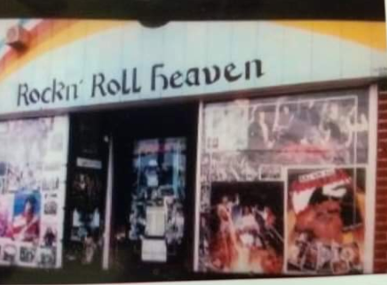

**Outside Rock N’ Roll Heaven record store in Clark, NJ**

**Photo: Brian Keith Nyers**

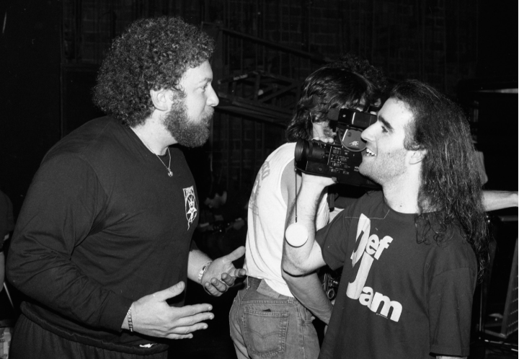

**Jonny Z and Scott Ian of Anthrax**

**Photo: Mark Weiss**

The stories told in ***Heavy Tales*** were captured and compiled by Harold Claros-Maldonado, a lifelong fan of heavy metal who originally contacted the Zazulas to write a report on early **Metallica**. After several discussions, Zazula felt Claros-Maldonado would be the ideal partner to help him tell his story in a book.

Harold Claros-Maldonado says, *“Jon Zazula is without question the Godfather of thrash metal. Having the opportunity to work together, I learned about the miracles he worked in order to release some of the most potent heavy metal albums of all time. With this book, I know many fans of Megaforce Records releases will have a greater sense of how a working-class man built an empire out of nothing to give us all the soundtrack to our lives.”*

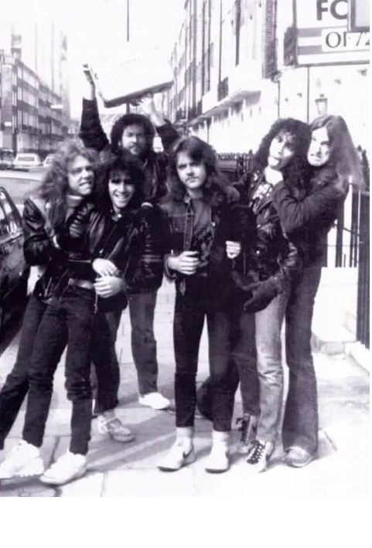

**L to R: James Hetfield, Scott Ian, Jonny Z, Lars Ulrich, Kirk Hammett, Cliff Burton**

**Photo: Metal Mike Rijswijk**

Jonny says, *“At one point we were one of the biggest indie record labels in America. With all of the mistakes and all of the successes, we managed to thrive. Readers may learn what to do and what not to do as fledgling industry hopefuls getting started in the business. The book is a hard, brutal unraveling of the truth, and tells it all. I’m putting this book out around Halloween, because there’s nothing scarier than the truth.”*

Release parties are currently being planned for the fall – stay tuned for more details!

For more information on ***Heavy Tales: The Metal. The Music. The Madness. As Lived by Jon Zazula***, please visit [www.jonzazula.com](http://www.jonzazula.com), <www.facebook.com/heavytales> and <www.instagram.com/thejonzazula>, and stay tuned for more information coming soon.

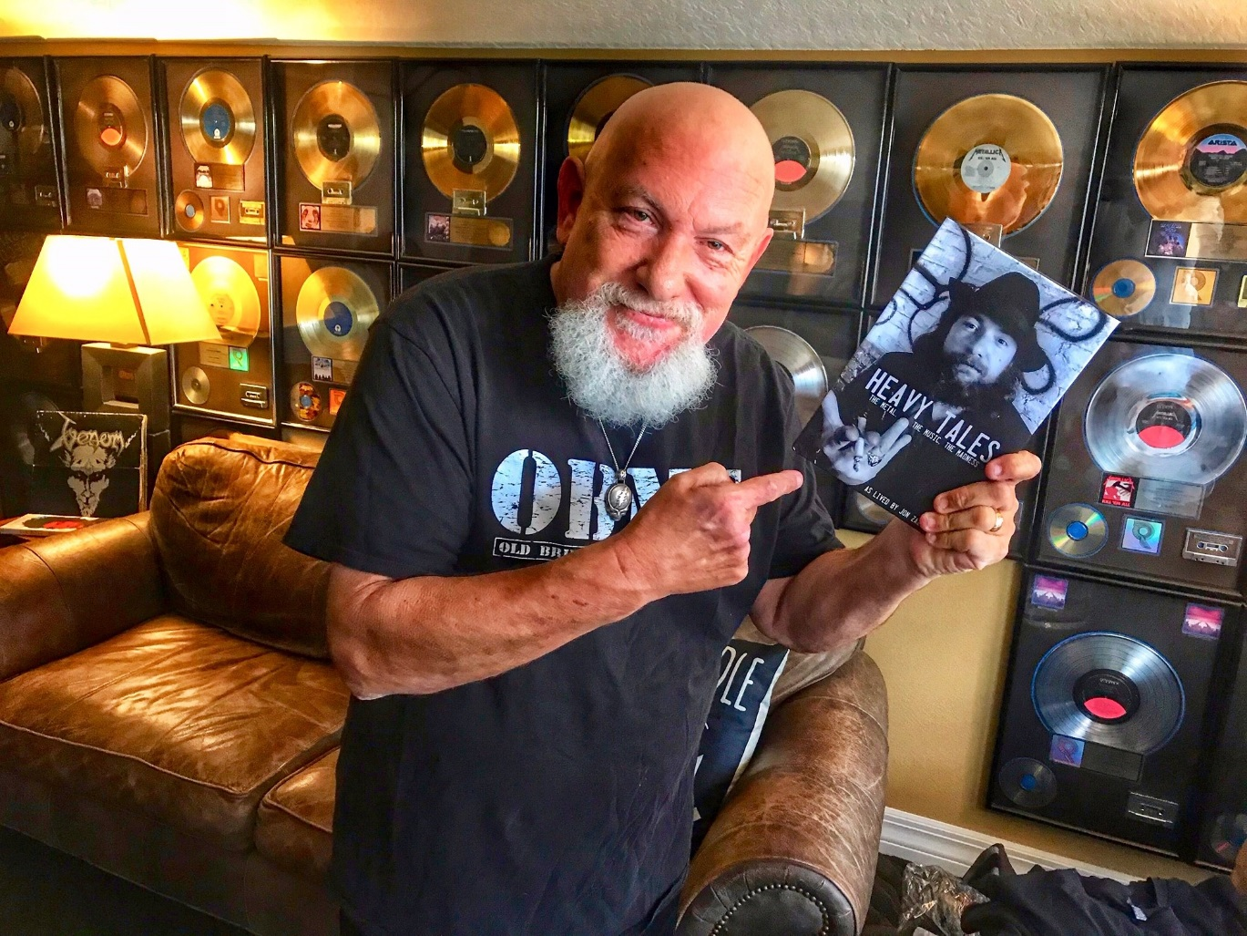

**Photo: Gary Schwartz**