For Immediate Release
September 16, 2019

DEATH TRIBE Debuts New Video from “Beyond Pain and Pleasure: A Desert Experiment”

Watch “Neurotic Breakdown” via Metal Insider

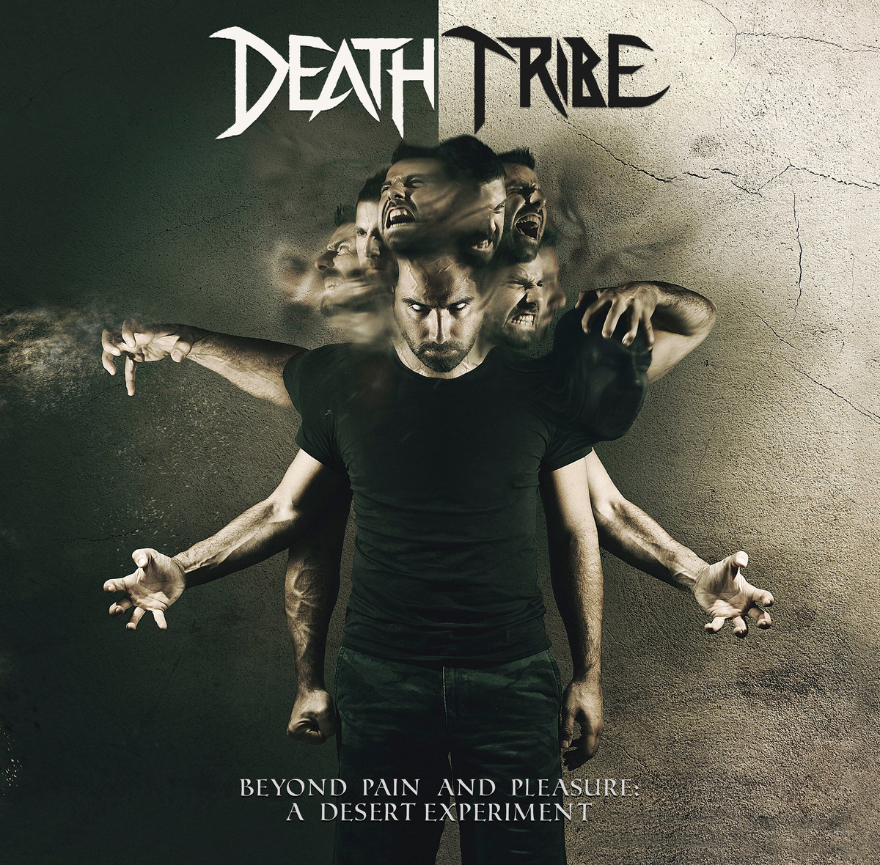

Encompassing everything from black metal to straight-forward heavy metal, DEATH TRIBE’s debut, Beyond Pain and Pleasure: A Desert Experiment, captures the pain of living amid war-torn Beruit. Today, Metal Insider premieres a video for the track “Neurotic Breakdown” from the album.

Watch “Neurotic Breakdown” here: https://www.metalinsider.net/premieres/video-premiere-death-tribe-neurotic-breakdown.

Says DEATH TRIBE’s Anthony Kaoteon, “This track is complex, technical and intense, as it represents the stage in life when one realizes they were forced into this pit and left to deal with its atrocities. We don’t choose where we are born. Black, white, yellow, Arab or Jew, some of us are born in war torn countries, others in below-poverty areas. Even those born with a silver spoon in their mouth are still battling their own demons because everything is about perspective. However, most people don’t realize that, and the only way to escape reality is through substances that create an even more complex schizoid world that is out of control. We blame others, if not ourselves, and hate everyone and everything around us instead of accepting that we can influence change through our choices, accept ourselves and the differences of others. Hate feeds on hate. Start by accepting your reality and grow to accept others.”

Scarred by death, corruption and a multitude of atrocities supported by radical ideologies, Anthony Kaoteon has always been driven by challenges to hustle out of a cursed life and establish himself without prejudice or belonging. He decided not to accept the status quo and shaped his own fate.

The diversity of Beyond Pain and Pleasure: A Desert Experiment is truly a result of time and place.
Composed over the course of several years and several periods of war – Kaoteon pulled the album together after leaving Lebanon for the more peaceful deserts of Dubai.

Beyond Pain and Pleasure: A Desert Experiment track listing:
1-Hollow
2-Beyond Pain and Pleasure
3-Implode Explode
4-Neurotic Breakdown
5-Psychopathetic
6-Death Blues
7-Narcissist Bastard Nation
8-Nuclear Hate
9-Face the Facts

Beyond Pain and Pleasure: A Desert Experiment features Anthony Kaoteon on vocals and guitar, Linus Klausenitzer (Obscura, Alkaloid, Kaoteon) on bass and Mattias Landes (Dark Fortress, ReVamp) on drums. The album also features guest vocalists Walid Wolflust (Kaoteon), Serge the Slave (Aramaic), Adnan Mryhij (Svengali), Youmni Abou el Zahab (Ascendant), JM Elias (Damage Rite, Svengali).

DEATH TRIBE online:
www.deathtribeofficial.bandcamp.com
www.facebook.com/DeathTribe.Official
www.instagram.com/deathtribe.official
https://store.cdbaby.com/cd/deathtribe

