For Immediate Release
January 15, 2020

ALL HAIL THE YETI to Join Life of Agony and Doyle on Beast Coast Monsters Tour 2020

Beast Coast Monsters Tour 2020 Kicks off Friday, March 13 in Philadelphia

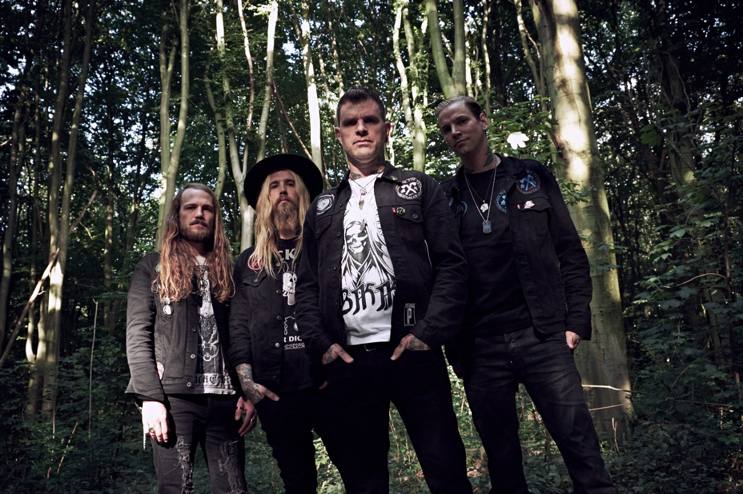
Photo: Tessa Wiegerinck

ALL HAIL THE YETI will join fellow musical heavyweights Life of Agony and Doyle on this spring’s Beast Coast Monsters Tour 2020, kicking off on Friday, March 13 in Philadelphia.

“We are beyond excited to join the beast coast monsters tour,” says vocalist Connor Garritty. “To be included with two absolute legends in the heavy metal music world is an honor beyond measure. Life of Agony and Doyle - what an amazing tour! Both bands have had a huge influence on who we are as musicians. We can’t wait to spread our gospel across the United States. We hope to see all the familiar faces and are very stoked to make some new friends along the way! HAIL!!!”

The whiskey-soaked hardcore metal hybrid recently began work on a new EP with producer Steve Evetts (Suicide Silence, DevilDriver) at the Omen Room in Orange County, CA. The EP will be the first to features new guitarist Dave Vanderlinde.

To tide fans over, ALL HAIL THE YETI released a lyric video last month for the track “Felo De Se” from their last album, Highway Crosses. Watch the video at https://youtu.be/LjQNwIv7ti8.

As the moniker cryptically suggests, the music of ALL HAIL THE YETI evokes a hair-raising mixture of superstitious ritual and trippy backwoods folklore. It’s all drenched in the countercultural, mind-smashing, gut-punching bile of likeminded spiritual shamans like Acid Bath and Eyehategod, with the down-tuned sludge of stoner rock, and an electric injection from four-on-the-floor classic rock pioneers.

Heavy music adherents weaned on anything from Metallica and Pantera to metalcore, Southern groove, black metal or stoner grind will find a home among the ALL HAIL THE YETI faithful, as evidenced by stellar slabs Highway Crosses (2018), Screams from a Black Wilderness (2016) and their self-titled debut.

ALL HAIL THE YETI Beast Coast Monsters Tour with Life of Agony, Doyle:
3/13- Philadelphia, PA - The Foundry
3/15 - Greenville, SC - The Firmament
3/17 - Orlando, FL - Soundbar
3/18 - Miami, FL - Churchills
3/19 - Tampa, FL - Orpheum
3/21 - Athens, GA - 40 Watt
3/22 - Nashville, TN - The Basement East
3/24 - Louisville, KY - Diamond Concert Hall
3/25 - Indianapolis, IN - Hi-Fi
3/27 - Chicago, IL - Reggie’s
3/28 - Grand Rapids, MI - The Stache/Intersection
3/29 - Flint, MI - The Machine Shop
3/31 - Cleveland, OH - The Winchester
4/1 - Pittsburgh, PA - The Crafthouse
4/3 - Lancaster, PA - The Chameleon
4/4 - Asbury Park, NJ - The Stone Pony
4/5 - Brooklyn, NY - Warsaw

ALL HAIL THE YETI is:
Connor Garritty - vocals
Nicholas Diltz - bass and vocals
Ryan “Junior” Kittlitz - drums
Dave Vanderlinde - guitar

ALL HAIL THE YETI online:
www.facebook.com/officialallhailtheyeti
https://twitter.com/allhailtheyeti

