For Immediate Release
January 24, 2020

Death-Grind Mavens GRAVESLAVE Reveal First Video from Upcoming “Devotion” EP

Watch Riotous Video for “God of Slaughter” Today via Metal Insider

“Devotion” Available March 6

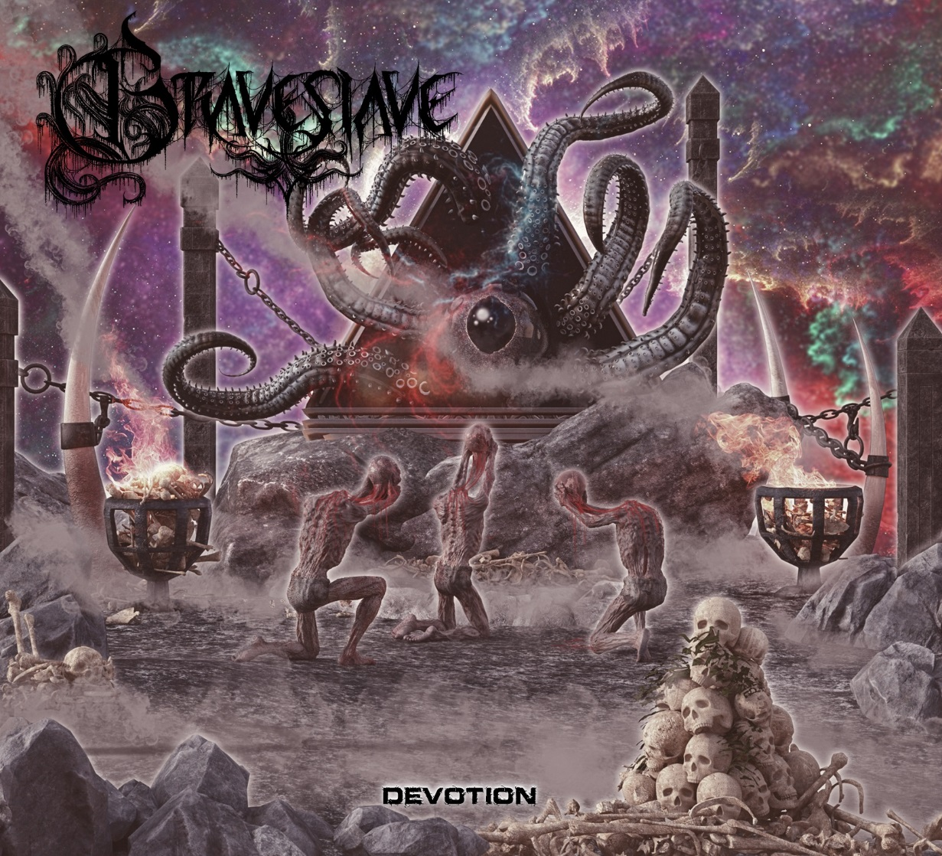.

Minneapolis death-grind stalwarts GRAVESLAVE have revealed a riotous new video for “God of Slaughter,” the first single from their upcoming Devotion EP, available March 6 via Trvasfuk Music.

Contrary to the song’s title, the video for “God of Slaughter” is narcissistically fun. Watch the video today, exclusively via Metal Insider at https://www.metalinsider.net/video/video-premiere-graveslave-god-of-slaughter.

“We like doing goofy videos,” says guitarist/songwriter Roman Non. “For this one, we kinda went with an ‘It’s Always Sunny in Philadelphia’ theme, where we're all acting like assholes and ruining everyone's good time. It was a blast to shoot.”

Devotion, the first of two “sister” EPs, features five tracks of razor-sharp riffs and blindingly fast drum work, blending elements of death metal, thrash and grind. Each of the EP’s tracks were inspired by the cult card game Magic: The Gathering.

Says Non, “The name of the record is a reference to all the sacrifice and perseverance that comes with the life of a musician, and how much dedication and belief in yourself it takes to see this dream take off. But the title is also a ‘Magic’ cards reference.”

Devotion is available for pre-order at https://graveslavemn.bandcamp.com/album/devotion.

Founded in 2014, Graveslave has been on the grind since inception. The group was formed by Non, drummer Ben Fagerness (Gloryhole Guillotine) and bassist Josh Burke, whom all share a mutual love for gutturals and blast beats. From humble beginnings at local Twin Cities shows and DIY tours all the way to trekking across Europe in support of Origin, Rings of Saturn, and Hideous Divinity, GRAVESLAVE kept consistently active, also releasing two EPs and a single, until the untimely death of vocalist and key member Don “Doombringer” Durkee in 2019. After a brief hiatus, the group began quietly rebuilding and recuperating. After adding new vocalist Ashton George and guitarist Joel Sigsbee (Oklahoma Caddyshack), GRAVESLAVE began putting finishing touches on Devotion, a record that now bridges two distinct eras of the band.

Devotion tracklisting:
1. God of Slaughter
2. Grotesque Hybrid
3. Surgical Extraction
4. Underworld Connections
5. Fatal Push

GRAVESLAVE is:
Ashton George - Lead Vocals
Roman Non - Guitar, Vocals
Joel Sigsbee - Guitar, Vocals
Josh Burke - Bass
Ben Fagerness - Drums

GRAVESLAVE online:
www.facebook.com/graveslaveMN
www.instagram.com/graveslaveband
https://graveslavemn.bandcamp.com
www.youtube.com/channel/UCtcahDim2U0Zw8XyNVbFTUQ

