For Immediate Release
January 10, 2020

All-Star Quintet IMONOLITH Release New Single; Announce Debut Album And UK/EU Headline Tour

State of Being Released 27th March; Guest Features Include Jens Kidman (Meshuggah)

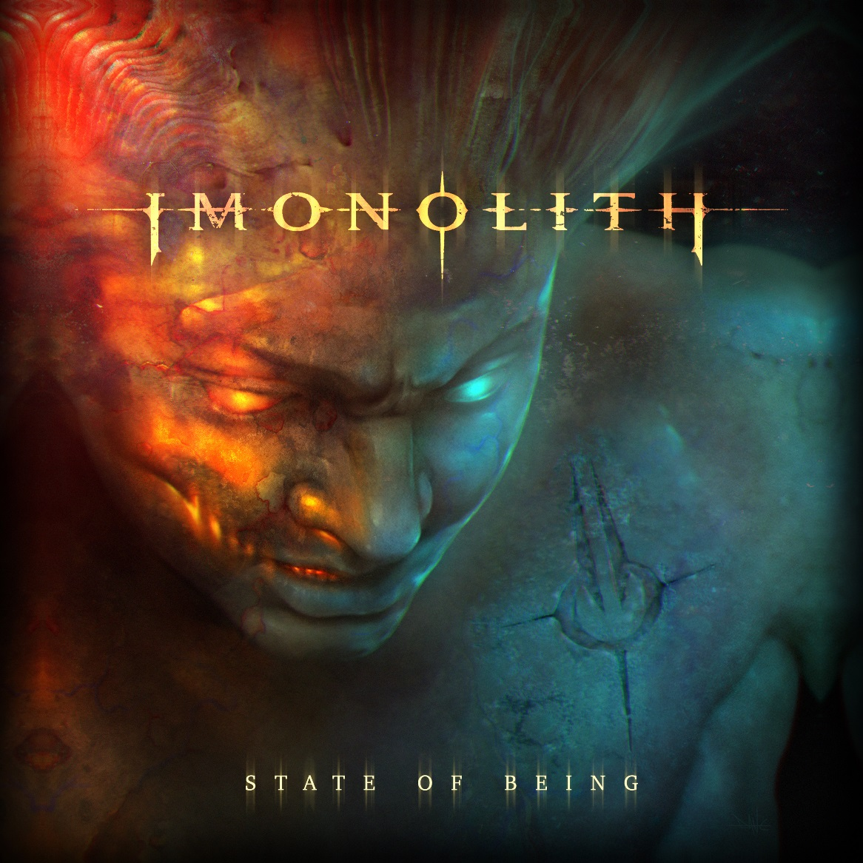
IMONOLITH have announced the release of their highly anticipated debut album State of Being on March 27 via Imonolith Music and are streaming a new single/video, “Instinct.”

Check out “Instinct” here: https://youtu.be/zlmOcXMilHs.

State of Being is now available to pre-order/pre-save here: https://lnk.to/stateofbeing.

Featuring drummer Ryan ‘RVP’ Van Poederooyen (Devin Townsend Project) guitarist Brian ‘Beav’ Wadell (Devin Townsend Project), Jon Howard (Threat Signal), guitarist Kai Huppunen (Methods of Mayhem, Noise Therapy) and Scott Whalen (Econoline Crush), IMONOLITH is a collective of heavy hitting players at the top of their game, and “Instinct” serves as a great taster of what can expected on their debut album.

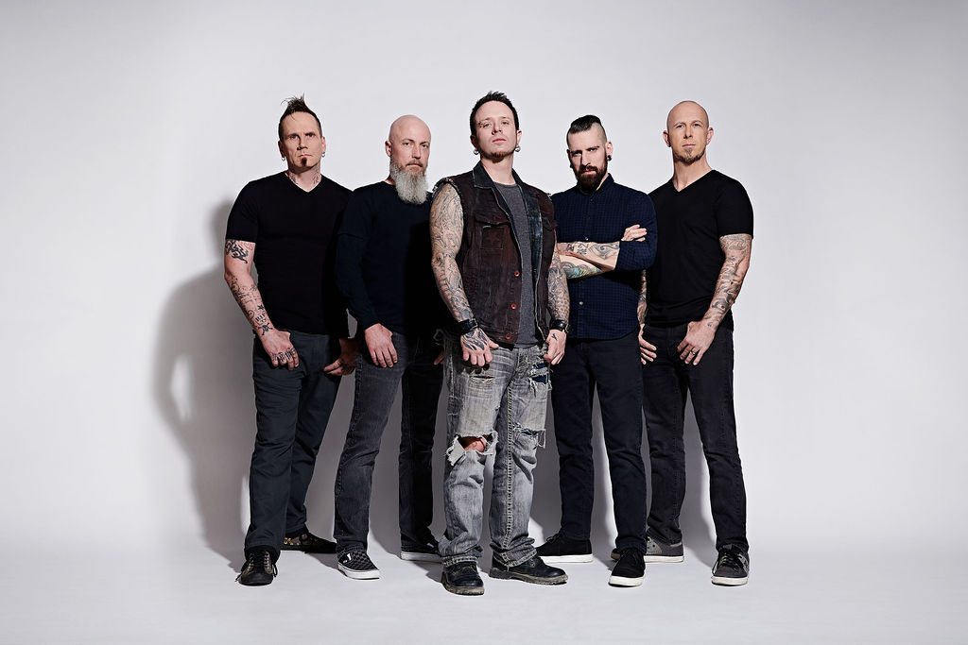

State of Being features 10 hook-laden, riff-heavy tracks including “Hollow,” the debut single that made big waves for IMONOLITH straight out of the gate, racking up 216K Spotify streams in 2019. There are also two very special guest performances from Jens Kidman (Meshuggah) and Swedish vocalist Johannes Eckerström.

Having spent much of 2019 writing, arranging, recording and fine-tuning State of Being, the band worked incredibly hard to achieve their goal - to make an engaging heavy metal album. RVP commented, “We spent a lot of time making this record. We wanted it to be done the way we envisioned it. We didn’t cut any corners, from the song writing right up to the album production and artwork. It’s a debut album that we’re very proud of and excited for the world to hear.”

The high production video to “Instinct” is not only a great example of the band’s quality aesthetic, but it also serves as a look at IMONOLITH’s collective personality. RVP continues, “I think we raised the bar with the ‘Instinct’ video. It’s a different kind of video that’ll catch you off guard in a few ways. It can also be interpreted differently depending on the viewer. We put a lot of thought into it and hired great visionary people to make it a fun watch.’’

IMONOLITH will be touring globally for the next two years and have announced their first ever UK/EU headline dates, commencing on March 27 in Sheffield, UK. Beav commented: “To be able to take a brand-new band overseas and have the opportunity to headline shows is completely mind blowing!! And we plan on making every show count, this is a dream situation for us.”

IMONOLITH tour dates:
Mar 27: Sheffield, UK - Corporation
Mar 29: Manchester, UK - Rebellion
Mar 30: Glasgow, UK - Broadcast
Mar 31: Bristol, UK - Exchange
Apr 1: London, UK - Underworld
Apr 2: Bree, BE - Ragnarok
Apr 4: Copenhagen, DK - High Voltage
Apr 5: Stockholm, SE - Debaser Strand
Apr 8: Mainz, DE - Schon Schon
Apr 9: Turin, IT - Blah-Blah
Apr 10: Como, IT - Centrale Rock Pub
Apr 11: Verona, IT - The Factory
Apr 13: Ljubljana, SL - Orto Bar
Apr 14: Zagreb, HR - Hard Place
Apr 15: Sofia, BG - Live & Loud
Apr 16: Bucharest, RO - Quantic Club
Apr 17: Budapest, HU - ROBOT
Apr 18: Geislingen, DE - MieV
Apr 21: Prague, CZ - Rock Cafe
Apr 25: Dobeln, DE - KL17
More dates to be announced soon

State of Being tracklisting:

1. State of Being (intro)
2. Becoming the Enemy (feat. Johannes Eckerstrom)
3. Instinct
4. Dig
5. The Mourning
6. Forgone
7. Breathe
8. The Reign (feat. Jens Kidman)
9. We Never Forget
10. Hollow
11. Persevere

IMONOLITH online:
http://imonolithband.com
https://www.facebook.com/imonolithband/
https://www.instagram.com/imonolithband/

