**For Immediate Release**

**February 6, 2020**

**LAMB OF GOD Releases First New Music in Five Years, “Checkmate,” from Upcoming Self-Titled Album, Due Out May 8**

**Watch the Video for “Checkmate” Now via** [**lamb-of-god.com**](http://www.lamb-of-god.com)

**Pre-Order *Lamb Of God* at** [**http://lambofgod.lnk.to/LOG**](https://linkprotect.cudasvc.com/url?a=http%3a%2f%2flambofgod.lnk.to%2fLOG&c=E,1,-nOPvORI6INhwXrdk6jtSNydu2wZNxWSMeD4uQp9K9zv6GgzhDiZeKGaeC8eL07wLiEONhVTzI-Oda6_nkY05X0N83DjHGc3ATd2VaQN4cUq&typo=1)

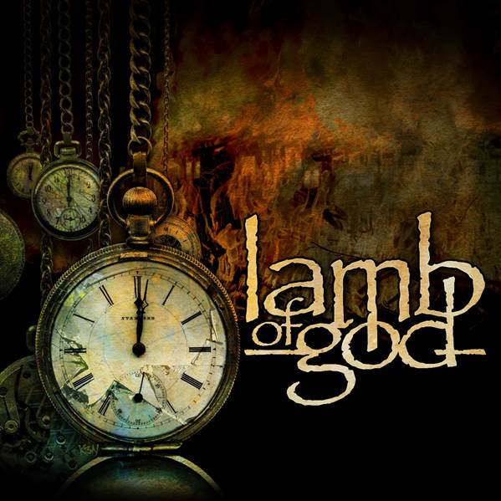

**LAMB OF GOD** has revealed a brand new single and video, “Checkmate,” from the band’s first release in five years and the first to feature new drummer Art Cruz.  The self-titled ***Lamb Of God*** is due out May 8 via Epic Records.

Watch “Checkmate” now at: <http://lamb-of-god.com>.

*“‘Checkmate’ brings together all the components of the* ***LAMB OF GOD*** *sound that we’ve been developing over the last two decades, but with the ambition and ferocity that comes with the start of a new chapter for our band,”* says guitarist Mark Morton. *“Re-energized and reignited, this is* ***LAMB OF GOD*** *2020. We’ve never been more excited.”*

The simple ***Lamb Of God*** title for their first album in five years is a declaration from **LAMB OF GOD**.

It is a testament to the band’s long career - which includes two gold albums, two platinum DVDs and five Grammy nominations - and a bold statement about where the quintet is now.

*“Putting only our name on it is a statement,”* Blythe says. *“This is* ***LAMB OF GOD****. Here and now.”*

A true collaboration between all members of the band, **LAMB OF GOD**’s eighth studio album is an amalgam of each individual’s writing style, perfectly blended to create a singular style. Guitarists Mark Morton and Willie Adler inject the album with a mountain of thrash, groove, shred and stripped-down aggression in equal measure. The fluid bass playing of John Campbell looms large as a rhythmic shadow and drummer Art Cruz, who makes studio debut with **LAMB OF GOD** on this record, commands his position with passion, sweat and expansive dynamics. Vocalist D. Randall Blythe is as angry, insightful, informed, and hyper-literate as ever. Known for his outspoken lyrics, Blythe delivers once again, examining the state of the world through an early punk rock-style lens.

In celebration of the release of “Checkmate” and the announce of the new album, **LAMB OF GOD** will appear at a special show at the House of Vans in Chicago on February 14. The event is free and fans can RSVP beginning at 12 noon CST today at [http://houseofvans.com](https://linkprotect.cudasvc.com/url?a=https%3a%2f%2furldefense.proofpoint.com%2fv2%2furl%3fu%3dhttp-3A__houseofvans.com_%26d%3dDwMF-g%26c%3d7hkCqVsDKDTt8zdLsM8LWA%26r%3dXXPNJLEu7M0SilYQYNY8sdJYXpRZxeQVmfXLH_IGv5g%26m%3dfSO_C8lUAc52FoVpSphQkSMM3ZDYTnirNmNcwFFCCao%26s%3dQVplWBrggpIQgp9cTlGZ0Fr0wgVbeaZkZAZORewBhqk%26e%3d&c=E,1,2d-_Vi01gKwDelfoAXEJsf_9ogCFZg0wiSijbRVQlsgjUaNiwKzIcptVWWymIiNA8aquRJ0aLKoifhrD-35OVtCQx9_L-pqwyjZ0gb2538DIjo-9Cg,,&typo=1).  The event will include a photography exhibit featuring photos from D. Randall Blythe that will be included in the new **LAMB OF GOD** album artwork. **Harm's Way** will open the show.

In the midst of writing the 10 song that appear on ***Lamb Of God***, the group hit pause on the works-in-progress to man the stage as main support **Slayer**’s “The Final Campaign.” After months of playing their best-known songs nightly, **LAMB OF GOD** returned to the new tracks and began to work with longtime producer Josh Wilbur (**Korn, Megadeth, Gojira, Trivium**). Special guests Jamey Jasta (**Hatebreed**) and Chuck Billy (**Testament**) also make appearances on ***Lamb Of God***.

***Lamb Of God*** pre-orders are available at [http://lambofgod.lnk.to/LOG](https://linkprotect.cudasvc.com/url?a=http%3a%2f%2flambofgod.lnk.to%2fLOG&c=E,1,cMWJC9pW2AyozV2YIGMzZVGlY4RG-yBl4ucM5zSReNyy9PFwhk--a8wCgBQVwBuitq8XNesLj-5AQiyEMGfzXoIWgJF2BUsv99F9lsf-gvS2XxkDeZbCVg,,&typo=1).

***Lamb Of God* tracklisting:**

1. Memento Mori

2. Checkmate

3. Gears

4. Reality Bath

5. New Colossal Hate

6. Resurrection Man

7. Poison Dream (feat. Jamey Jasta)

8. Routes (feat. Chuck Billy)

9. Bloodshot Eyes

10. On The Hook

The Richmond, Virginia, quintet propelled heavy metal into the new millennium two decades ago with the prophetically titled *New American Gospel*, followed by 2003’s *As the Palaces Burn*, which made the *Rolling Stone* list of the Top 100 Greatest Metal Albums of All Time. *Ashes of the Wake*, released in 2004, was the first **LAMB OF GOLD** album to be certified gold by the RIAA, with 2006’s *Sacrament*,which also made a Top 10 Billboard 200 chart debut, following it its footsteps. 2009’s *Wrath* began **LAMB OF GOD**’s collaboration with producer Wilber and earned the album the number one spot on *Billboard*’s Hard Rock, Rock, and Tastemaker charts, with a number two position on the *Billboard* 200.

Those number one positions were repeated with 2012’s *Resolution*, which swung effortlessly between thrash, traditional metal, sludgy doom, and flashes of crust punk with swagger and bravado. **LAMB OF GOD**’s last album, *VII: Sturm und Drang* (2015) made its debut on the *Billboard* 200 at number three.

In 2020, **LAMB OF GOD** is re-energized and unrelenting, ready to lay claim to the metal throne.

This is **LAMB OF GOD**. Here and now.

**LAMB OF GOD tour dates:**

2/14- Chicago, IL @ House of Vans **\*Headline show**

**European tour with Kreator and Power Trip:**

3/27 – Stockholm, SE @ Fryshuset Arenan  
3/28 – Copenhagen, DK @ Forum Black Box  
3/30 – Oulu, FI @ Club Teatria  
3/31 – Helsinki, FI @ Ice Hall Black Box  
4/2 – Kraków, PO @ Tauron Arena  
4/3 – Berlin, DE @ Columbiahalle  
4/4 – Oberhausen, DE @ Turbinenhalle  
4/5 – Wiesbaden, DE @ Kulturzentrum Schlachthof  
4/7 – Zurich, CH @ Samsung Hall  
4/8 – Munich, DE @ Zenith  
4/9 – Ludwigsburg, DE @ MHP Arena  
4/11 – Hamburg, DE @ Sporthalle  
4/14 – Barcelona, ES @ Razzmatazz  
4/15 – Madrid, ES @ Sala Riviera  
4/17 – Paris, FR @ L’Olympia Bruno Coquatrix  
4/18 – Saarbrücken, DE @ Saarlandhalle  
4/19 – Brussels, BE @ Ancienne Belgique  
4/21 – Bristol, UK @ O2 Academy Bristol  
4/22 – Manchester, UK @ Manchester Academy  
4/23 – Glasgow, UK @ O2 Academy Glasgow  
4/24 – Birmingham, UK @ O2 Academy Birmingham  
4/25 – London, UK @ O2 Academy Brixton

5/9 – Daytona Beach, FL @ Welcome to Rockville **\*US Festival**

**LAMB OF GOD is:**

D. Randall Blythe – Vocals

Mark Morton – Guitar

Willie Adler – Guitar

John Campbell – Bass

Art Cruz – Drums

**LAMB OF GOD online:**

[www.lamb-of-god.com](http://r20.rs6.net/tn.jsp?f=001gev3skt0v8jrVsOA-T5uxuID5DrsLhYHCuERtk1ceXrSPTCrV0-nS9-Vt1Wjar_gWvJGqA11Khu1mrFmr21lYIuTGZvD4_lBlHEpGLQgqeg30PX48gICXIHZHk8WOmlcJMFhIrYSf69HFdNGY3_uq0EGVJcypfpX8vTrsXP7J4NVbdO30nE0zA==&c=NvPangUUZTTkhmSqHrKGF_SAyj_Mi8wZXMvQOsrYHD9IaK8jBFDpkg==&ch=2Ud2m4FHU3v-3SDCFQEHkW9niaZTeCCSEh9zolH5O3yWXEluYv5y6g==)

[www.facebook.com/lambofgod](http://r20.rs6.net/tn.jsp?f=001gev3skt0v8jrVsOA-T5uxuID5DrsLhYHCuERtk1ceXrSPTCrV0-nS9-Vt1Wjar_gY4ySofe5PwewUuKB4BvZfs2jIPwTpS9kA9QB1TQZKIgzLiVVnstAi3j53NEMkB1HHXAUvcaaAyrvBY4QKZYaa7sIvyuc6fWXT3MARBUr1DZkL8pLu7baAA==&c=NvPangUUZTTkhmSqHrKGF_SAyj_Mi8wZXMvQOsrYHD9IaK8jBFDpkg==&ch=2Ud2m4FHU3v-3SDCFQEHkW9niaZTeCCSEh9zolH5O3yWXEluYv5y6g==)

[https://twitter.com/lambofgod](http://r20.rs6.net/tn.jsp?f=001gev3skt0v8jrVsOA-T5uxuID5DrsLhYHCuERtk1ceXrSPTCrV0-nS9-Vt1Wjar_g12cvlaT0S46pECSH9mz4GbTP5ewtBiZgKAwamWPpKTMAsCrImRuwSWe0ifSN67Dy9ta8OlsA9nT2HGqDOPm82DgLTIR653MjyAnaGMkzu2K3HUoKHs_kvg==&c=NvPangUUZTTkhmSqHrKGF_SAyj_Mi8wZXMvQOsrYHD9IaK8jBFDpkg==&ch=2Ud2m4FHU3v-3SDCFQEHkW9niaZTeCCSEh9zolH5O3yWXEluYv5y6g==)

[http://instagram.com/lambofgod](http://r20.rs6.net/tn.jsp?f=001gev3skt0v8jrVsOA-T5uxuID5DrsLhYHCuERtk1ceXrSPTCrV0-nS9-Vt1Wjar_gIOCIkXkobH0FrPWIA73_eKOD6tAtdAMwi67nEJKDclqO-T3Cubfnt2-PnWNJn5Yfr1aVOXA62uT5TNIZJQzoW5Kf76etRb-e7KhzjsH2aYlRP1L7vBwbJw==&c=NvPangUUZTTkhmSqHrKGF_SAyj_Mi8wZXMvQOsrYHD9IaK8jBFDpkg==&ch=2Ud2m4FHU3v-3SDCFQEHkW9niaZTeCCSEh9zolH5O3yWXEluYv5y6g==)

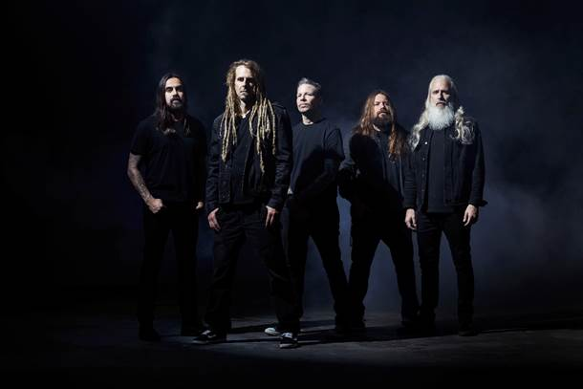

**Photo: Travis Shinn**