For Immediate Release
February 20, 2020

Theatrical Metal Quartet RAVEN BLACK Teases New Video in Advance of Tour with In This Moment, Black Veil Brides and DED

The In-Between Tour Kicks Off March 24 in Orlando

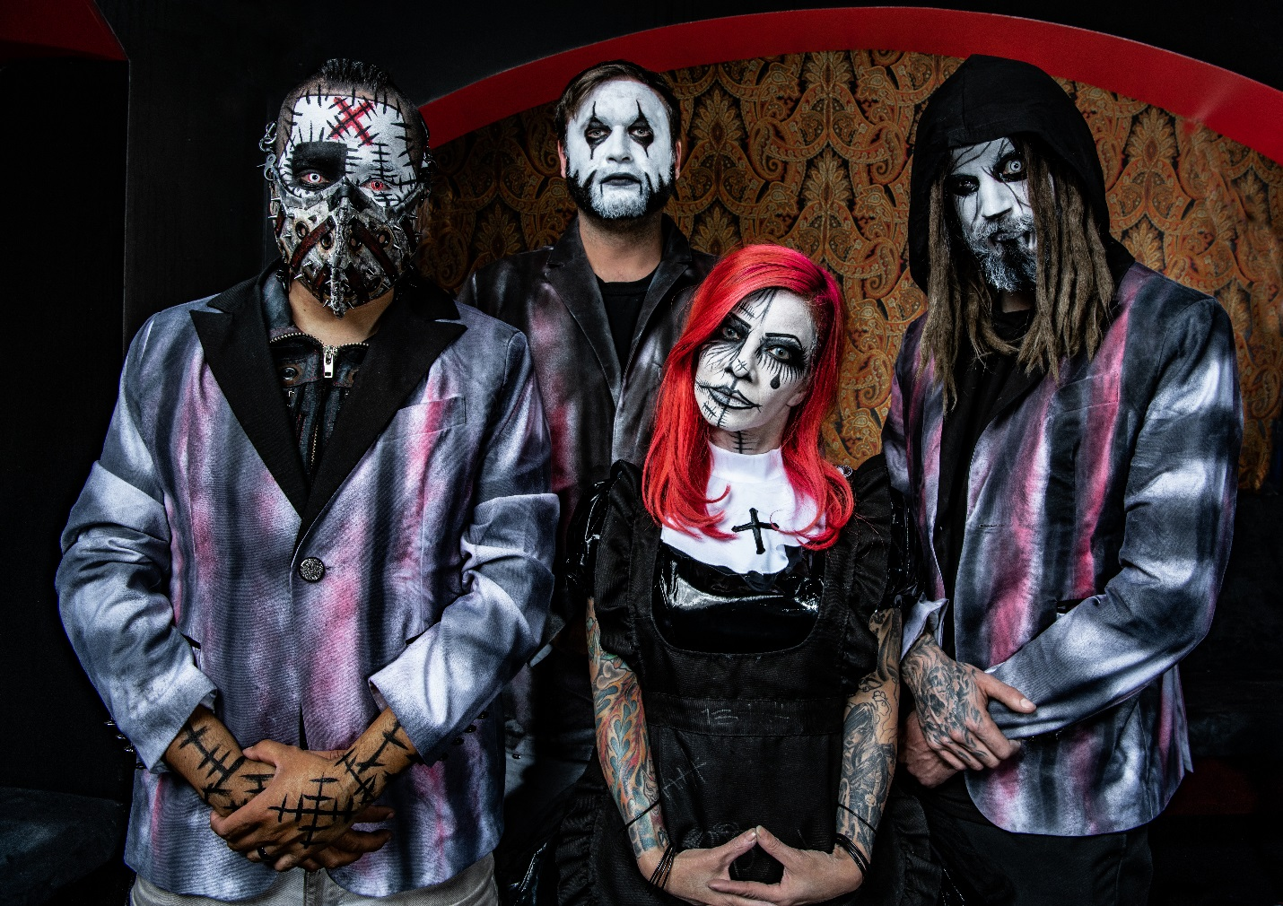

Theatrical metal band RAVEN BLACK will preview their upcoming third album, The Key, on The In-Between Tour this spring with In This Moment, Black Veil Brides and DED.

The nearly-two-month-long tour will begin March 24 in Orlando and will continue through May 16.

“We are incredibly excited to support In This Moment and Black Veil Brides along with DED on this tour, and share our new music with all of you,” says Raven. “We can’t wait to share our new album and feel there would be no better tour to present the Dark Metal Carnival.”

The Key, produced by Ulrich Wild (Static-X, White Zombie, Deftones), is scheduled for release this May via WurmGroup. Pre-orders for the album and an assortment of bundles are available via RAVEN BLACK’s webstore at https://squareup.com/store/ravenblackshop/. A new video for the track “Hear Me Cry” will be available soon. VIP packages for The In-Between Tour are also available at the webstore.

RAVEN BLACK’s Dark Metal Carnival story began when a voodoo doctor, The Doctor, happened upon a lost and scared little girl named Raven. Using his magic, The Doctor attempted turned the girl into a doll. The Doctor’s attempt, however, was interrupted by the terrified girl’s screams, leaving her in a half-human, half-doll state. As Raven lived in the dark world of the Doctor, she secretly learned his magic and conjured up a demon named Muppet, whom she trapped inside of her heart and made her eternal protector. Together, The Doctor and Muppet created another character, Stitches, to help search for souls to join the Dark Metal Carnival in the 13th hour.

Together, the quartet has created a soundtrack to the Dark Metal Carnival, releasing the 2016 EP Seven Sins and the 2018 album 13. The band has toured extensively, perfecting a creepy live show that unifies the visual and aural aspects of RAVEN BLACK.

RAVEN BLACK “The In-Between Tour” w/In This Moment, Black Veil Brides and DED dates:
3/24 - Orlando, FL - House of Blues
3/26 - Atlanta, GA –Tabernacle
3/27 - Birmingham, AL - Sloss Furnaces
3/28 - Cherokee, NC - Harrah's Cherokee Events Center
3/30 - Richmond, VA - The National
3/31 - Silver Spring, MD – Fillmore
4/1 - New York, NY – Terminal 5
4/3 - Stroudsburg, PA - Sherman Theatre
4/4 - Cleveland, OH - The Agora Ballroom
4/5 - Pittsburgh, PA - Stage AE
4/7 - Nashville, TN - Marathon Music Works
4/9 - Columbus, OH - Express Live!
4/10 - Detroit, MI – Fillmore
4/11 - Chicago, IL - Aragon Ballroom
4/13 - Louisville, KY - Palace Theatre
4/14 - Ft. Wayne, IN - The Clyde Theatre
4/15 - Grand Rapids, MI - 20 Monroe Live
4/17 - Minneapolis, MN - Myth Live
4/18 - Milwaukee, WI - Eagles Ballroom
4/19 - Columbia, MO - Blue Note (Outdoor Stage)
4/21 - Kansas City, MO - Arvest Bank Center at The Midland Theatre
4/23- Dallas, TX - Southside Ballroom
4/24 - Oklahoma City, OK – Criterion
4/25 - Lubbock, TX - Lonestar Events Center
4/27 - Phoenix, AZ - Comerica Theatre
4/28 - Anaheim, CA - House of Blues
4/29 - Los Angeles, CA - The Novo
5/1 - Las Vegas, NV - House of Blues
5/2 - Reno, NV - Grand Theatre - Grand Sierra Resort
5/3 - San Francisco, CA - The Warfield
5/5 - Salt Lake City, UT - The Complex
5/6 - Boise, ID - Revolution Center
5/7 - Portland, OR - Roseland Ballroom
5/8 - Kennewick, WA - Toyota Center: Retter & Company Theatre
5/10 - Seattle, WA - Paramount Theatre
5/10 - Vancouver, BC - Queen Elizabeth Theatre
5/13 - Calgary, AL - MacEwan Hall
5/15 - Billings, MT - First Interstate Arena
5/16 - Casper, WY - Casper Events Center

RAVEN BLACK is:
Raven - Vocals
Muppet - Drums/Vocals
The Doctor - Lead Guitar/Vocals
Stitches – Bass

RAVEN BLACK online:
www.ravenblackband.com
www.facebook.com/ravenblackband
Twitter: @ravenblackband
Instagram: ravenblackband

The Oracle Management online:
www.theoraclemanagement.com

