For Immediate Release
January 31, 2020

TESTAMENT Announces New Album Titans Of Creation & Release Music Video For "Night Of The Witch"

Pre-Order Available Here: https://nblast.de/TestamentTOC

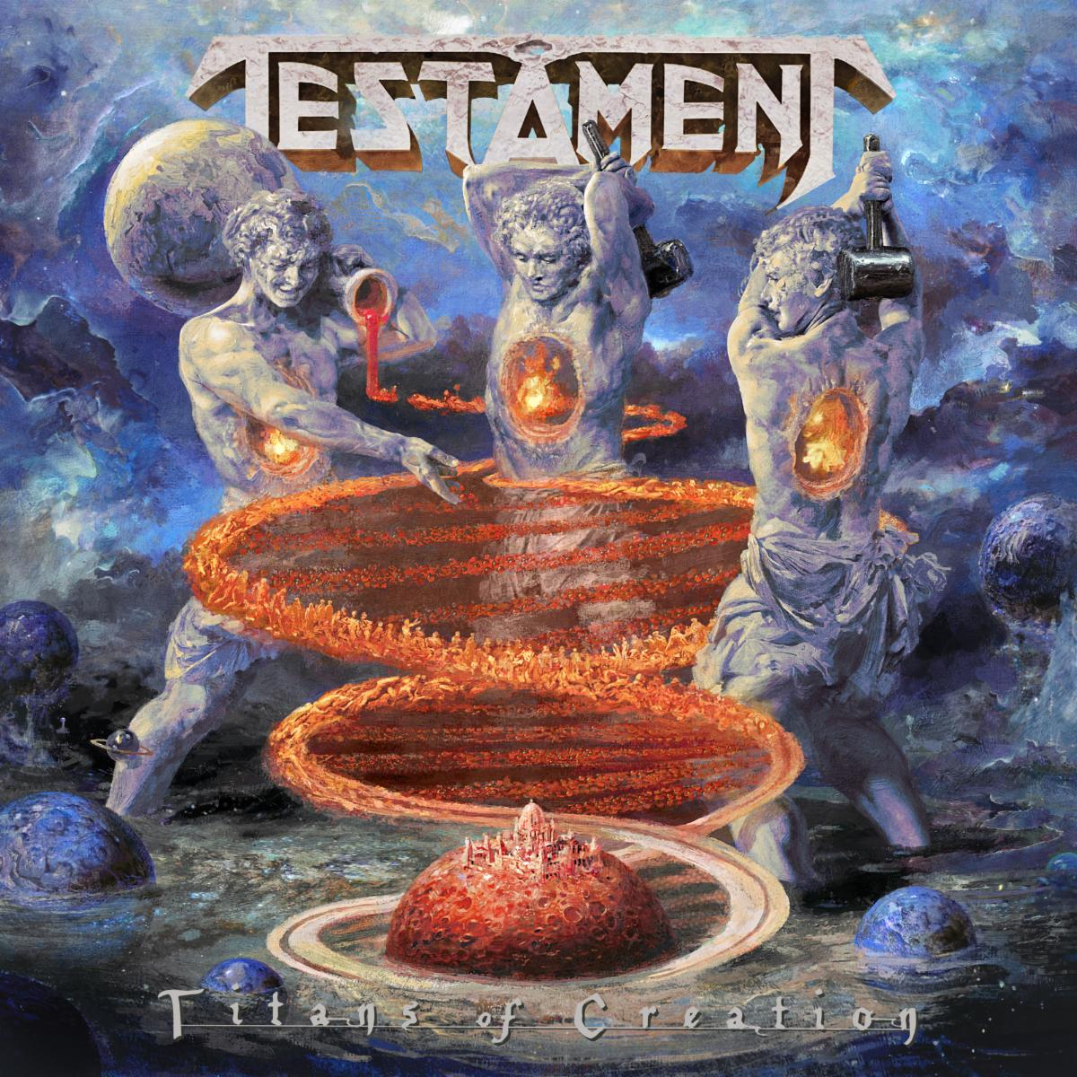

The time has arrived for legendary bay area thrash metal giants TESTAMENT to unleash new thunder to the masses and reveal their thirteenth studio album, Titans Of Creation, which will be released on April 3 via Nuclear Blast.

Today, the band releases the lyric video for the first single, "Night Of The Witch" here: youtu.be/cF2hIrXq2ss

Chuck Billy comments, "It has been months since the final mixing of ‘Titans Of Creation’ and we are eager for fans to hear it. We feel that we put a lot into this record and at the end of the day it is a TESTAMENT record that stands on its own. We are very proud of ‘Titans Of Creation.’”

“'Night Of The Witch’ uses old school lyrics about witches chanting in the moonlight and casting spells. The beauty of this song is that I worked Eric's vocals into the chorus. I wanted to incorporate him as he does Dragonlord and this song was a perfect match. It is a heavy song and a great way to introduce everyone to ‘Titans Of Creation.’”

Titans Of Creation was produced by Chuck Billy and Eric Peterson while Juan Urteaga of Trident Studios handled co-producing, recording and engineering. Andy Sneap was responsible for the mixing and mastering of the album. Eliran Kantor stepped up once again to create a new masterpiece of artwork for the cover of this release.

Titans Of Creation will be available in the following formats:
- CD Digipak
- Light Blue Cassette (Limited to 250)
- DLP + CD Mail-order Box Set (Limited to 1500)
- Includes Earth Element Vinyl
- Vinyl
- Fire Element Edition Vinyl (Limited to 2150)
- Air Element Edition Vinyl
- Water Element Edition Vinyl
- Blue Vinyl (Limited to 500; Retail)
- T-shirt
- TS+ DLP bundle

Pre-order your copy of Titans Of Creation in the format of your choice here: https://nblast.de/TestamentTOC

Pre-save the album on Spotify, Apple Music and Deezer: nblast.de/TESTAMENTpreSave

Below is the track listing:
- Children Of The Next Level
- WWIII
- Dream Deceiver
- Night Of The Witch
- City Of Angels
- Ishtar's Gate
- Symptoms
- False Prophet
- The Healers
- Code Of Hammurabi
- Curse Of Osiris
- Catacombs

Just as the elements of this planet thrive within all living creatures, each musician in TESTAMENT represents a necessary component of this latest musical creation. Still filled with a massive and unstoppable energy since their last release, TESTAMENT has taken their style to the next level and present an album that is loyal to the roots of traditional thrash metal while still including the alluring, brilliant and progressive ingredients they are known for.

TESTAMENT is:
Chuck Billy | Lead Vocals
Eric Peterson | Rhythm/Lead guitar & Vocals
Alex Skolnick | Lead Guitar
Steve Di Giorgio | Bass guitar
Gene Hoglan | Drums

TESTAMENT online:
www.testamentlegions.com/
www.facebook.com/testamentlegions/
www.instagram.com/testamentofficial/
https://twitter.com/testament
www.youtube.com/user/testamentofficial

