For Immediate Release
February 4, 2020

TESTAMENT Announces North American Tour with The Black Dahlia Murder, Municipal Waste and Meshiaak
Titans Of Creation Will Be Released April 3
Pre-Order Available Here: nuclearblast.com/testament-toc

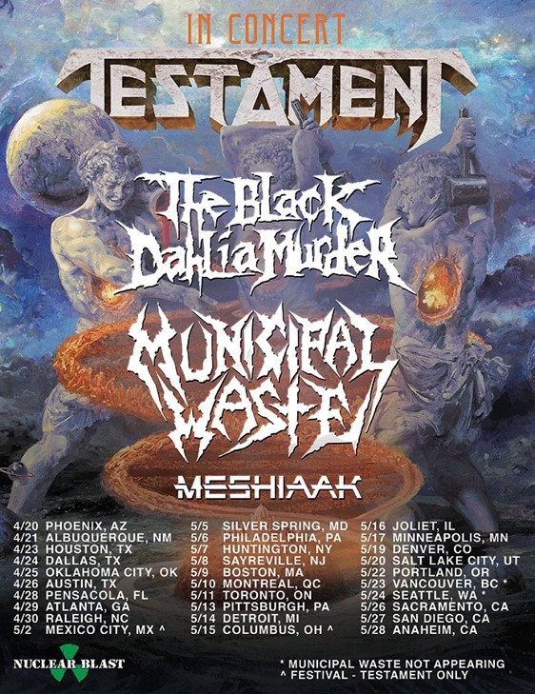

Legendary bay area thrash metal giants TESTAMENT are proud to announce their North American 2020 tour. The 30-date trek will kick-off in Phoenix on April 20 and will make stops in Austin, Mexico and Toronto before concluding in Anaheim on May 28. Joining them on the tour are THE BLACK DAHLIA MURDER, label mates MUNICIPAL WASTE and MESHIAAK.
“I’m super excited about TESTAMENT’s tour with The Black Dahlia Murder and Municipal Waste,” states Alex Skolnick. “As much as we’ve enjoyed touring with bands who emerged before us, from our own time period and slightly later eras, it will be a fresh experience to share the bill with these two, both of whom formed in the new Millennium, each with a unique perspective and a sound unlike anyone else. It’ll be a fun night of music. Don’t miss it!”
Steve Di Giorgio states, “The new album, ‘Titans Of Creation’ comes out on April 3. We are going to be on the road in the USA and Canada in April and May. We hope to see all your thrashers out there. Come out and check out the new record and show! Metal forever!”
Gene Hoglan comments, “Hey everybody! I am here to tell you that the new TESTAMENT album which drops on April 3 called 'Titans Of Creation' has to be one of our best records of all time. Every TESTAMENT fan out there has to pick this one up cause I believe that everybody is going to love this one like crazy. Right on! We'll see you out on the road on all the dates we have lined. See you soon!”
TESTAMENT will be touring in support of their thirteenth album, Titans Of Creation, which was produced by Chuck Billy and Eric Peterson while Juan Urteaga of Trident Studios handled co-producing, recording and engineering. Andy Sneap was responsible for the mixing and mastering of the album. Watch the lyric video for the first single, “Night Of The Witch” here: youtu.be/cF2hIrXq2ss.
The Black Dahlia Murder will be touring in support of their upcoming new album.
Virginia speed metal punks Municipal Waste are touring in support of their latest offering, The Last Rager EP, which was released on October 11 via Nuclear Blast. The band will also leave the tour on May 24th to join the Punk Rock Bowling Festival but will return for the last three California dates. Check out the music video for "Wave Of Death" here: https://www.youtube.com/watch?v=CalJjHGJVrU.
Tickets for the tour go on sale Friday, February 7 at 10 a.m. local time.
Fans have the opportunity to purchase an exclusive TESTAMENT VIP Meet & Greet Package: Below are the details:

- 1 reserved ticket or 1 general admission ticket
- Personal photo opportunity with select members of TESTAMENT
- Meet & greet with select members of TESTAMENT
- Autograph signing with TESTAMENT
  - Limited to 1 item per person
- Signed TESTAMENT 8x10
- TESTAMENT merchandise exclusive to the VIP packages
- Commemorative TESTAMENT VIP laminate

Tickets and VIP Meet & Greet Package are available to be purchased at testamentlegions.com.

Confirmed dates for TESTAMENT's North American 2020 tour with The Black Dahlia Murder, Municipal Waste and Meshiaak;
4/20 - Phoenix, AZ @ The Van Buren
4/21 - Albuquerque, NM @ El Rey
4/23 - Houston, TX @ House of Blues
4/24 - Dallas, TX @ House of Blues
4/25 - Oklahoma City, OK @ Diamond Ballroom
4/26 - Austin, TX @ Emo's
4/28 - Pensacola, FL @ Vinyl Music Hall
4/29 - Atlanta, GA @ The Masquerade
4/30 - Raleigh, NC @ The Ritz
5/2 - Mexico City, MX ^ Festival - TESTAMENT only
5/5 - Silver Springs, MD @ The Fillmore
5/6 - Philadelphia, PA @ TLA
5/7 - Huntington, NY @ The Paramount
5/8 - Sayreville, NJ @ Starland Ballroom
5/9 - Boston, MA @ House Of Blues
5/10 - Montreal, QC @ M'Telus
5/11 - Toronto, ON @ Phoenix Concert Hall
5/13 - Pittsburgh, PA @ Roxian Theatre
5/14 - Detroit, MI @ Saint Andrew's Hall
5/15 - Columbus, OH ^ Festival - TESTAMENT only
5/16 - Joliet, IL @ The Forge
5/17 - Minneapolis, MN @ The Fillmore
5/19 - Denver, CO @ Summit Music Hall
5/20 - Salt Lake City, UT @ The Depot
5/22 - Portland, CA @ Roseland Theater
5/23 - Vancouver, BC * w/o MUNICIPAL WASTE
5/24 - Seattle, WA * w/o MUNICIPAL WASTE
5/24 - Las Vegas, NV @ Punk Rock Bowling + Festival - MUNICIPAL WASTE only
5/26 - Sacramento, CA @ Ace of Spades
5/27 - San Diego, CA @ House of Blues
5/28 - Anaheim, CA @ House of Blues
* - MUNICIPAL WASTE not appearing
^ - Festival - TESTAMENT only
+ - Festival - MUNICIPAL WASTE only
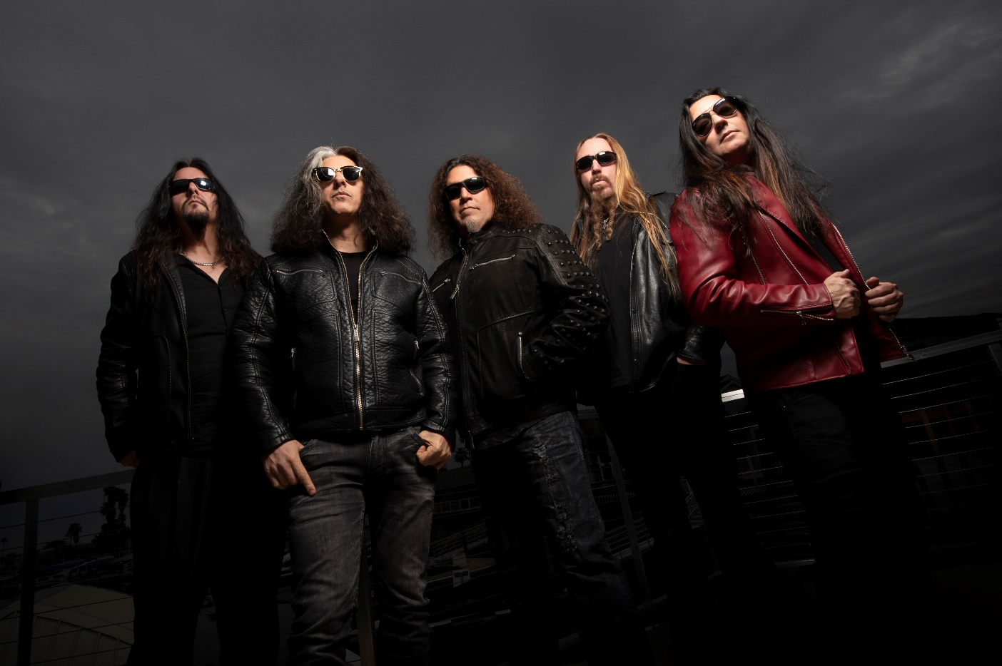

The time has arrived for legendary bay area thrash metal giants TESTAMENT to unleash new thunder to the masses and reveal their thirteenth studio album, Titans Of Creation, which will be released on April 3 via Nuclear Blast.
Last week, the band released the lyric video for the first single, “Night Of The Witch” here: youtu.be/cF2hIrXq2ss.
Chuck Billy comments, "It has been months since the final mixing of 'Titans Of Creation' and we are eager for fans to hear it. We feel that we put a lot into this record and at the end of the day it is a TESTAMENT record that stands on its own. We are very proud of ‘Titans Of Creation.’"
"'Night Of The Witch’ uses old school lyrics about witches chanting in the moonlight and casting spells. The beauty of this song is that I worked in Eric's vocals into the chorus. I wanted to incorporate him as he does Dragonlord and this song was a perfect match. It is a heavy song and a great way to introduce everyone to ‘Titans Of Creation.'"
Titans Of Creation will be available in the following formats:

- CD Digipak
- Light Blue Cassette (Limited to 250)
- DLP + CD Mail-order Box Set (Limited to 1500)
  - Includes Earth Element Vinyl
- Vinyl
  - Fire Element Edition Vinyl (Limited to 2150)
  - Air Element Edition Vinyl
  - Water Element Edition Vinyl
  - Blue Vinyl (Limited to 500; Retail)
- T-shirt
- TS+ DLP bundle
Pre-order your copy of Titans Of Creation in the format of your choice here: http://nuclearblast.com/testament-toc.
Pre-save the album on Spotify, Apple Music and Deezer: nblast.de/TESTAMENTpreSave
Below is the track listing:
- Children Of The Next Level
- WWIII
- Dream Deceiver
- Night Of The Witch
- City Of Angels
- Ishtar's Gate
- Symptoms
- False Prophet
- The Healers
- Code Of Hammurabi
- Curse Of Osiris
- Catacombs

Just as the elements of this planet thrive within all living creatures, each musician in TESTAMENT represents a necessary component of this latest musical creation. Still filled with a massive and unstoppable energy since their last release, TESTAMENT has taken their style to the next level and present an album that is loyal to the roots of traditional thrash metal while still including alluring, brilliant, and progressive ingredients they are known for.
TESTAMENT is:
Chuck Billy | Lead Vocals
Eric Peterson | Rhythm/Lead guitar & Vocals
Alex Skolnick | Lead Guitar
Steve Di Giorgio | Bass guitar
Gene Hoglan | Drums

TESTAMENT online:
www.testamentlegions.com/
www.facebook.com/testamentlegions/
www.instagram.com/testamentofficial/
https://twitter.com/testament
www.youtube.com/user/testamentofficial

