For Immediate Release
September 11, 2020

World-Renowned Photographer Mark “WEISSGUY” Weiss’s The Decade That Rocked is Being Celebrated with an Exhibit at Monmouth Museum

Mark Weiss: The Decade that Rocked! Will Run Through November 1

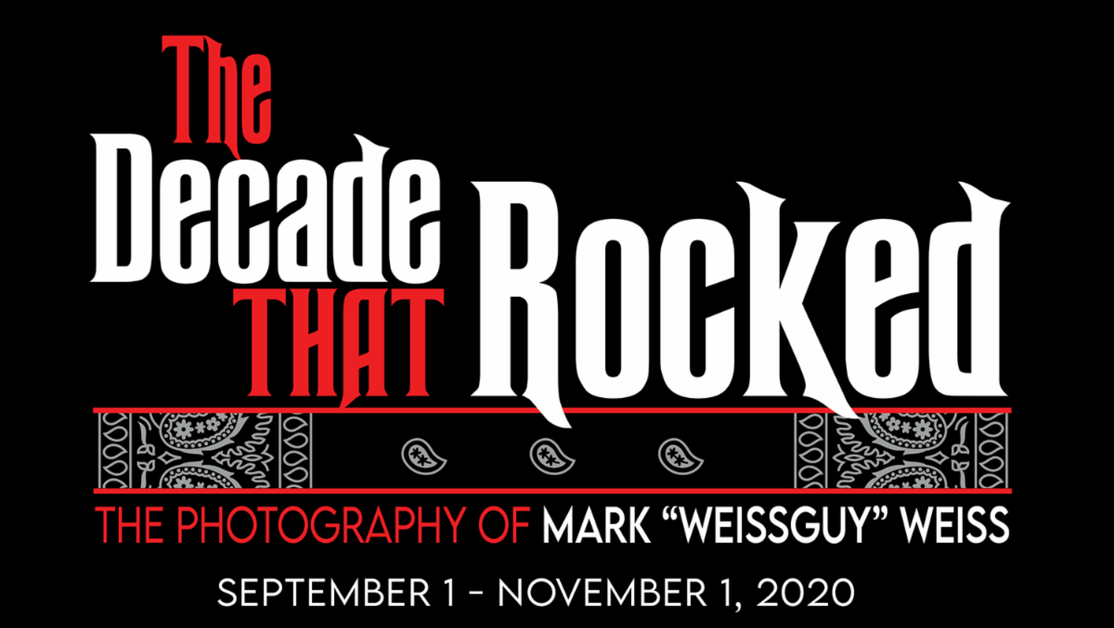

Following the release of world-renowned rock ‘n’ roll photographer Mark Weiss’s The Decade That Rocked book, the Monmouth Museum in Lincroft, NJ, is now featuring a Mark Weiss: The Decade That Rocked! Exhibit.

Mark Weiss: The Decade That Rocked! showcases onstage and backstage moments and never-before-seen images from the period’s most historic concerts, tours and multiplatinum album covers, all captured through Weiss’s lens. The exhibit also features memorabilia from his private collection and will take visitors through Weiss’s journey on his path to becoming one of the most iconic and celebrated photographers in rock ‘n’ roll.

“We are very excited to have Mark Weiss’s work at the Monmouth Museum,” says Monmouth Museum’s Donna Kessinger. “The show is a snapshot of music history.”

A sold-out opening reception will take place this Saturday, September 12. The reception will feature a performance with members of White Tiger, the first metal band Weiss did a photo session with, fronted by Neal Thomas and guitarist Dan Muro, the legendary band that dominated the early ‘80s Jersey club scene. The pair will perform as The Killin’ Floor Project with noted producer, engineer and owner of Long Branch, NJ’s Shorefire Recording Studios Joe DeMaio.

“My goal is to take this exhibit across the country and speak about my life as a rock ‘n’ roll photographer,” Weiss says. “I have worked on this book for the past five years and now it’s time to share my photos and experiences with the world.”

Weiss gives Slippery When Wet cover model Angela Chidnese a preview of the Mark Weiss: The Decade that Rocked! Exhibit

Mark Weiss: The Decade That Rocked! will run through November 1, with Weiss making appearances at the exhibition on select Fridays beginning on September 18. Visit www.monmouthmuseum.org for tickets and for additional information check out www.thedecadethatrocked.com All visitors will receive a choice of a centerfold of Vince Neil or the Slippery When Wet girl with their $10 entrance donation.

Mark “Weissguy” Weiss got his start in photography as a teen in the 1970s in Matawan, NJ. After getting his first camera in trade for mowing a neighbor's lawn for the summer, Weiss began sneaking into concerts, and the rest is quite literally rock ‘n’ roll history. He has traveled the globe photographing legends from Van Halen, Ozzy Osbourne, Aerosmith and Mötley Crüe to Metallica, Guns N’ Roses, Bon Jovi and KISS. Weiss’s iconic images capture the artists onstage, backstage, and behind the scenes. He documented historic events including the US Festival, Live Aid, the Moscow Music Peace Festival, and the PMRC hearings in Washington, DC. His photographs have been published in thousands of magazines worldwide, and he is responsible for two of the era’s defining album covers, Bon Jovi’s Slippery When Wet and Twisted Sister’s Stay Hungry. His inimitable photographs helped craft the visual imagery of rock and metal in the 1980s and beyond.

The Decade That Rocked, released in June, is now in its second print run and boasts over 500 five-star reviews on Amazon. Weiss has appeared on Australia’s Today show and has been featured in The Washington Post, The Daily Beast and Rolling Stone in support of the book.

The companion The Decade That Rocked podcast is now on its third episode. Listen at https://wavve.link/TDTR.

More on Weiss and to purchase The Decade That Rocked, visit www.thedecadethatrocked.com.

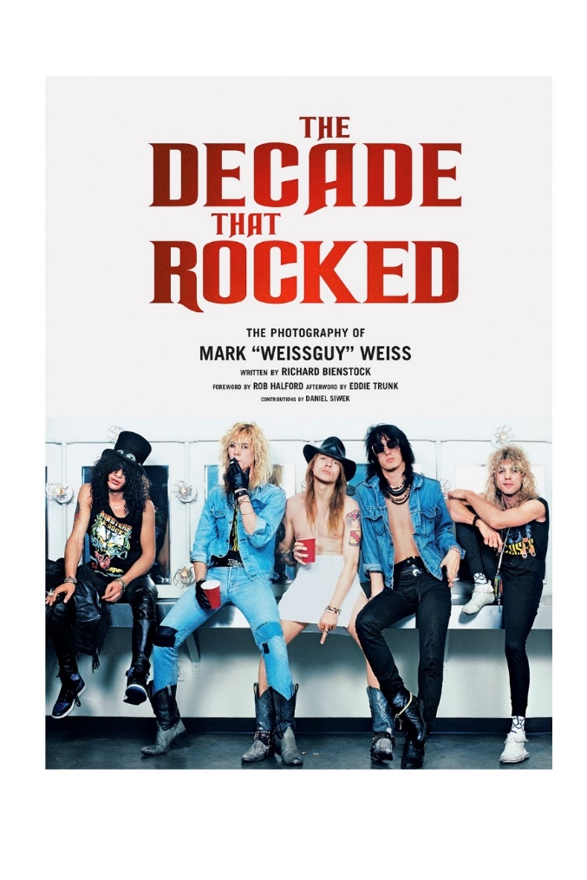

What the media is saying about The Decade That Rocked:

What rock stars are saying about The Decade That Rocked:
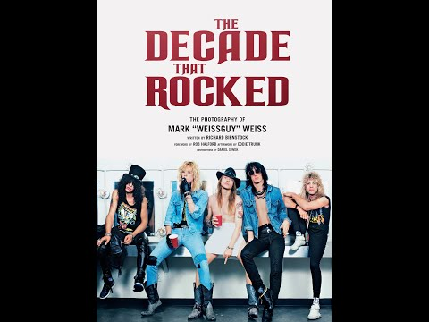

What people are saying about Mark Weiss:
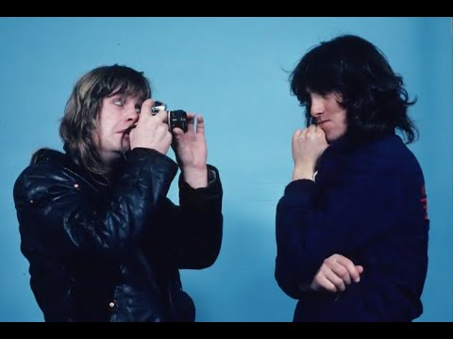

Watch Weiss on VH-1’s The Making of the Album Cover – Slippery When Wet:

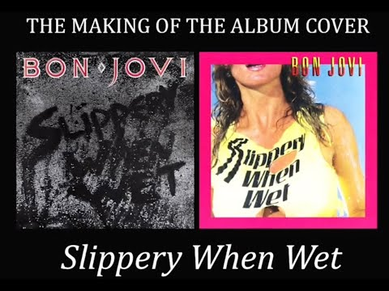

Slippery When Wet – Then & Now:

Weiss is available for interviews and The Decade That Rocked is available for review. Additional images are also available for publication

