For Immediate Release
March 25, 2021

CHTHONIC to Headline Massive MEGAPORT FESTIVAL This Weekend in Taiwan

Watch CHTHONIC at Only Large-Scale Pandemic-Era Rock Festival via Livestream

CHTHONIC Performance Slated for Release as Live Album

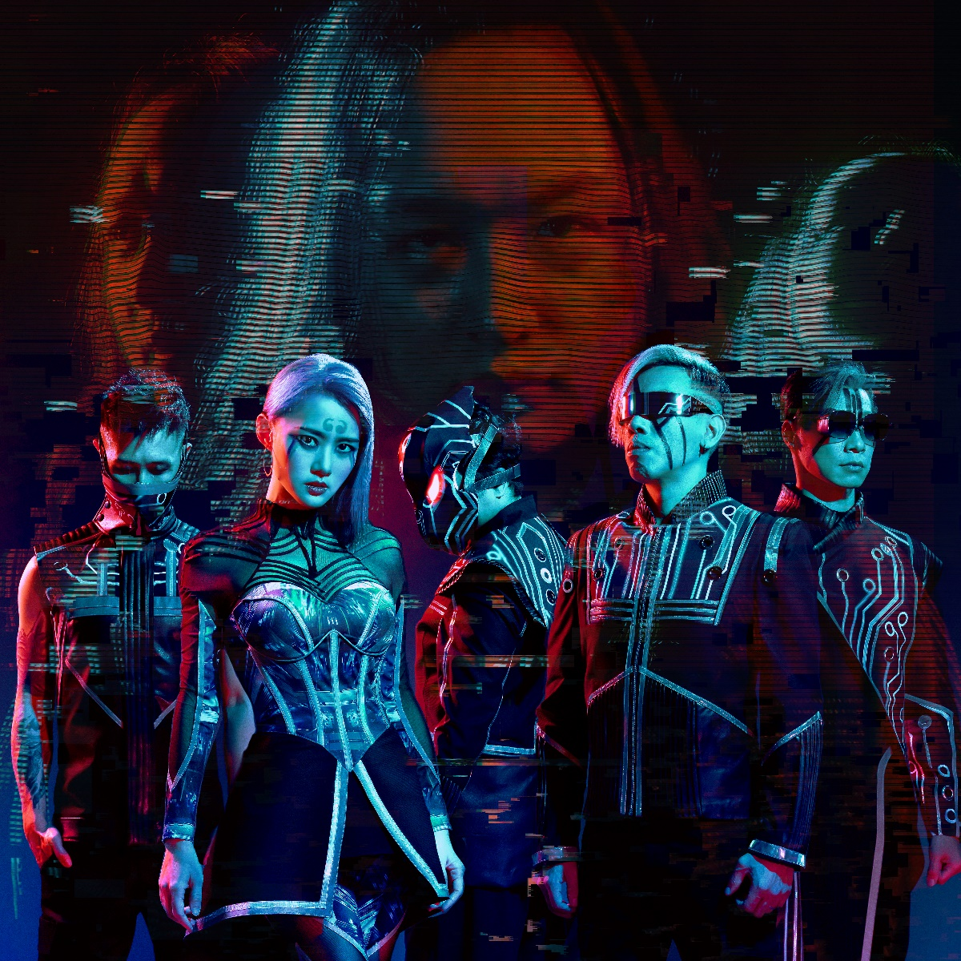

After making history by successfully managing the COVID-19 pandemic, Taiwan will move forward as planned this weekend and host the first large-scale rock festival, MEGAPORT FESTIVAL, since the unprecedented global lockdown.

MEGAPORT FESTIVAL, which will take place March 27-28 in Kaohsiung, Taiwan, will feature more than 100 artists on 10 stages and will be headlined by symphonic extreme metal masters CHTHONIC.
The two main stages will be livestreamed worldwide.

Main stage: https://today.line.me/tw/v2/article/vxzoPE
Second stage: https://today.line.me/tw/v2/article/1WXqLv

Founded in 2006 by CHTHONIC’s Freddy Lim, who left the organizing team after being elected as a member of Taiwanese Parliament in 2016, MEGAPORT FESTIVAL attracts tens of thousands of people every year, featuring a lineup of well-known East Asian bands from Taiwan, Japan and Hong Kong, and occasionally groups from Europe and the United States. Due to the pandemic, this year’s lineup mainly features Taiwanese artists.

To document this historic event, CHTHONIC plans record their performance for an upcoming live album. “We are looking forward to making this performance as perfect and memorable as possible,” says Lim. “Since my focus at the moment remains on politics, I really wanted to participate in the very music festival that I founded. We have been fortunate to have just 1,000 COVID cases in Taiwan’s population of 23 million, with only 77 local cases and 10 COVID-related deaths. Because of Taiwan’s efficiency handling the pandemic, we are able to more move forward with this festival. Everyone is excited to perform live again, and our upcoming live album will reflect that excitement.”

A special limited “anti-epidemic bundle” including a physical CD, CHTHONIC medical-quality mask, a CHTHONIC mask lanyard, large and small CHTHONIC mask containers and a small CHTHONIC spray can for sanitizer will be available. Information on pre-orders is forthcoming.

Watch CHTHONIC’s performance on the main stage via livestream on Saturday, March 27 at 8:40 p.m. EDT/5:40 p.m. PDT.

MEGAPORT FESTIVAL’s venue spans both sides of the Kaohsiung Harbor, with a bridge across the harbor to allow fans access to all stages and the expanded marketplace. Stages are housed in warehouses, on roofs, on a yacht, on the pier side and also on a huge square, with diverse forms and unique styles. The size of the venue makes MEGAPORT FESTIVAL the largest music festival in Taiwan. Among the scheduled performers is Audrey Tang, a longtime CHTHONIC fan who currently holds the seat of Digital Minister in Taiwan's cabinet. After its official announcement, MEGAPORT FESTIVAL’s the 20,000 tickets sold out within five minutes.

Taiwan is one of the few countries that has managed to stably control the COVID-19 pandemic but despite the country’s relatively stable condition, MEGAPORT FESTIVAL is fully prepared for epidemic prevention. Before redeeming the entry bracelet, one must complete an online real-name registration process. Every audience member is required to wear a mask during performances. Moreover, the food stands and dining are separated to avoid group transmission after removing masks. A trailer for this year’s festival is available now via MEGAPORT FESTIVAL’s Facebook page.

Although people in Taiwan are able to maintain most parts of their lives as usual, many events there – as well as around the world - have been restricted or cancelled to avoid the risk of a local epidemic. Because of this, the artists and audience at MEGAPORT FESTIVAL will cherish the opportunity to take part in a festival of this magnitude after an extended period without live music.

MEGAPORT FESTIVAL online:
www.megaportfest.com (Taiwanese Mandarin)
www.facebook.com/megaportfest

CHTHONIC online:
https://chthonic.tw/en/
www.facebook.com/chthonictw
https://twitter.com/chthonictw
https://chthonictw.tumblr.com/
www.youtube.com/channel/UCFn5CIjfAj-KZgJtsXw349g

