For Immediate Release
June 21, 2021

Indian Metal Trio MIDHAVEN Celebrates Summer Solstice with “Primal Song” from Upcoming Of the Lotus & the Thunderbolt Concept Album

Watch “Primal Song” Now via Rolling Stone India

Of the Lotus & the Thunderbolt Slated for Release on July 8

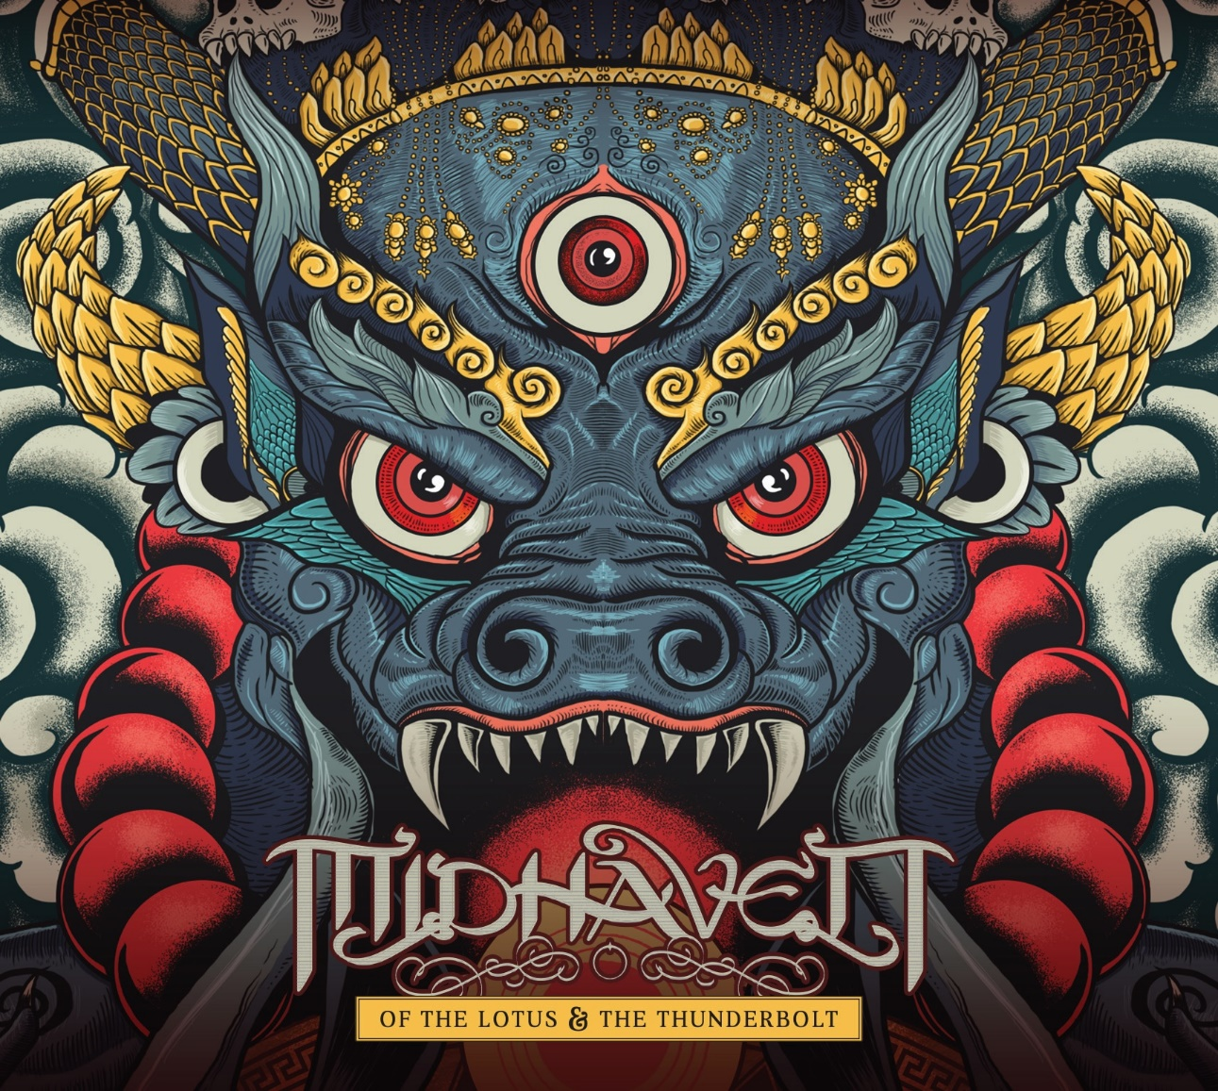

India-based metal trio MIDHAVEN has revealed the first single, “Primal Song,” from the forthcoming Of the Lotus & the Thunderbolt concept album, scheduled for release on July 8.

Watch the video for “Primal Song,” which premiered yesterday via Rolling Stone India to coincide with the Summer Solstice, at https://rollingstoneindia.com/exclusive-premiere-midhaven-primal-song-video/.

The three-piece Mumbai-based band fuses traditional metal with progressive and modern rock to create earth shattering, heavy music with soaring guitars, operatic vocals, guttural growls and war track ready drums, polished off by deeply fascinating lyrical concepts.

“‘Of the Lotus & the Thunderbolt’ is extremely complex and revolves around concepts of time and rebirth,” the band says. “We follow the single but universal soul on its journey to realization, with symbolisms that are deeply rooted in the collective Indian subconscious. They are curated in a manner wherein each song appears as though it’s a chapter in a book, conveying individual meanings that when heard together form a holistic understanding of the universe.”

The melancholic and anguished tracks “Codeman” and “Para Brahman” focus on the existential search for “the reason why,” while the screams and cries of the past echo through “Primal Song” with its rage-induced lyrics and grimy vocals, conjuring images of man’s animalistic need to maraud and destroy. “Zhitro” and “Mahakaal” are the heavyweights of the album, ushering in Indian elements of dark, experimental sounds that are at once groundbreaking and heavy. Riddled with references to the ancient past, “Mahakaal” is the running theme of the album - consuming the world we exist in.- and an homage to Shiva, the Hindu god known as the Destroyer.

Of the Lotus & the Thunderbolt’s artwork, brought to life by prolific indie artist Gaurav Basu (aka Acid Toad), reflects the theme of the album, presenting a gorgeous visual representation of the album’s concept. The record was mixed and mastered by ARIA nominated and internationally renowned Australian producer Forrester Savell (Animals As Leaders, Make Them Suffer, Karnivool), who adds a touch of polish and refinement while not straying far from the raw, analog recording process.

Of the Lotus & the Thunderbolt track listing:
1-Para Brahman
2-Primal Song
3-Codeman
4-The Immanent Effervesence of Sorrow
5-Zhitro
6-Mahakaal
7-Bhairav

Formed in 2012, MIDHAVEN grew quickly with the launch of their first release, the 2013 EP Tales From The Tide. The trio soon became one of the first major signings of an Indian metal band to a worldwide record label, Universal Music Group (UMG), which release MIDHAVEN’s debut full-length, Spellbound, in 2014. Like Of the Lotus & the Thunderbolt, Spellbound was also a concept album and featured re-recorded tracks from Tales From The Tide. MIDHAVEN has been nominated for the VH1 Sound Nation awards in the category of Best Metal Act, performed live on VH1’s Indian Music Diaries, and was nominated for Radio City’s Best Metal Live Act in 2015.

MIDHAVEN is:
Aditya Mohanan – Guitars/Vocals
Aviraj Kumar - Drums
Karan Kaul - Vocals/Guitars
Jason D’Souza – Bass (live)

MIDHAVEN online:
www.facebook.com/midhavenband/
https://www.instagram.com/midhaven.ind/
https://midhaven.bandcamp.com/

