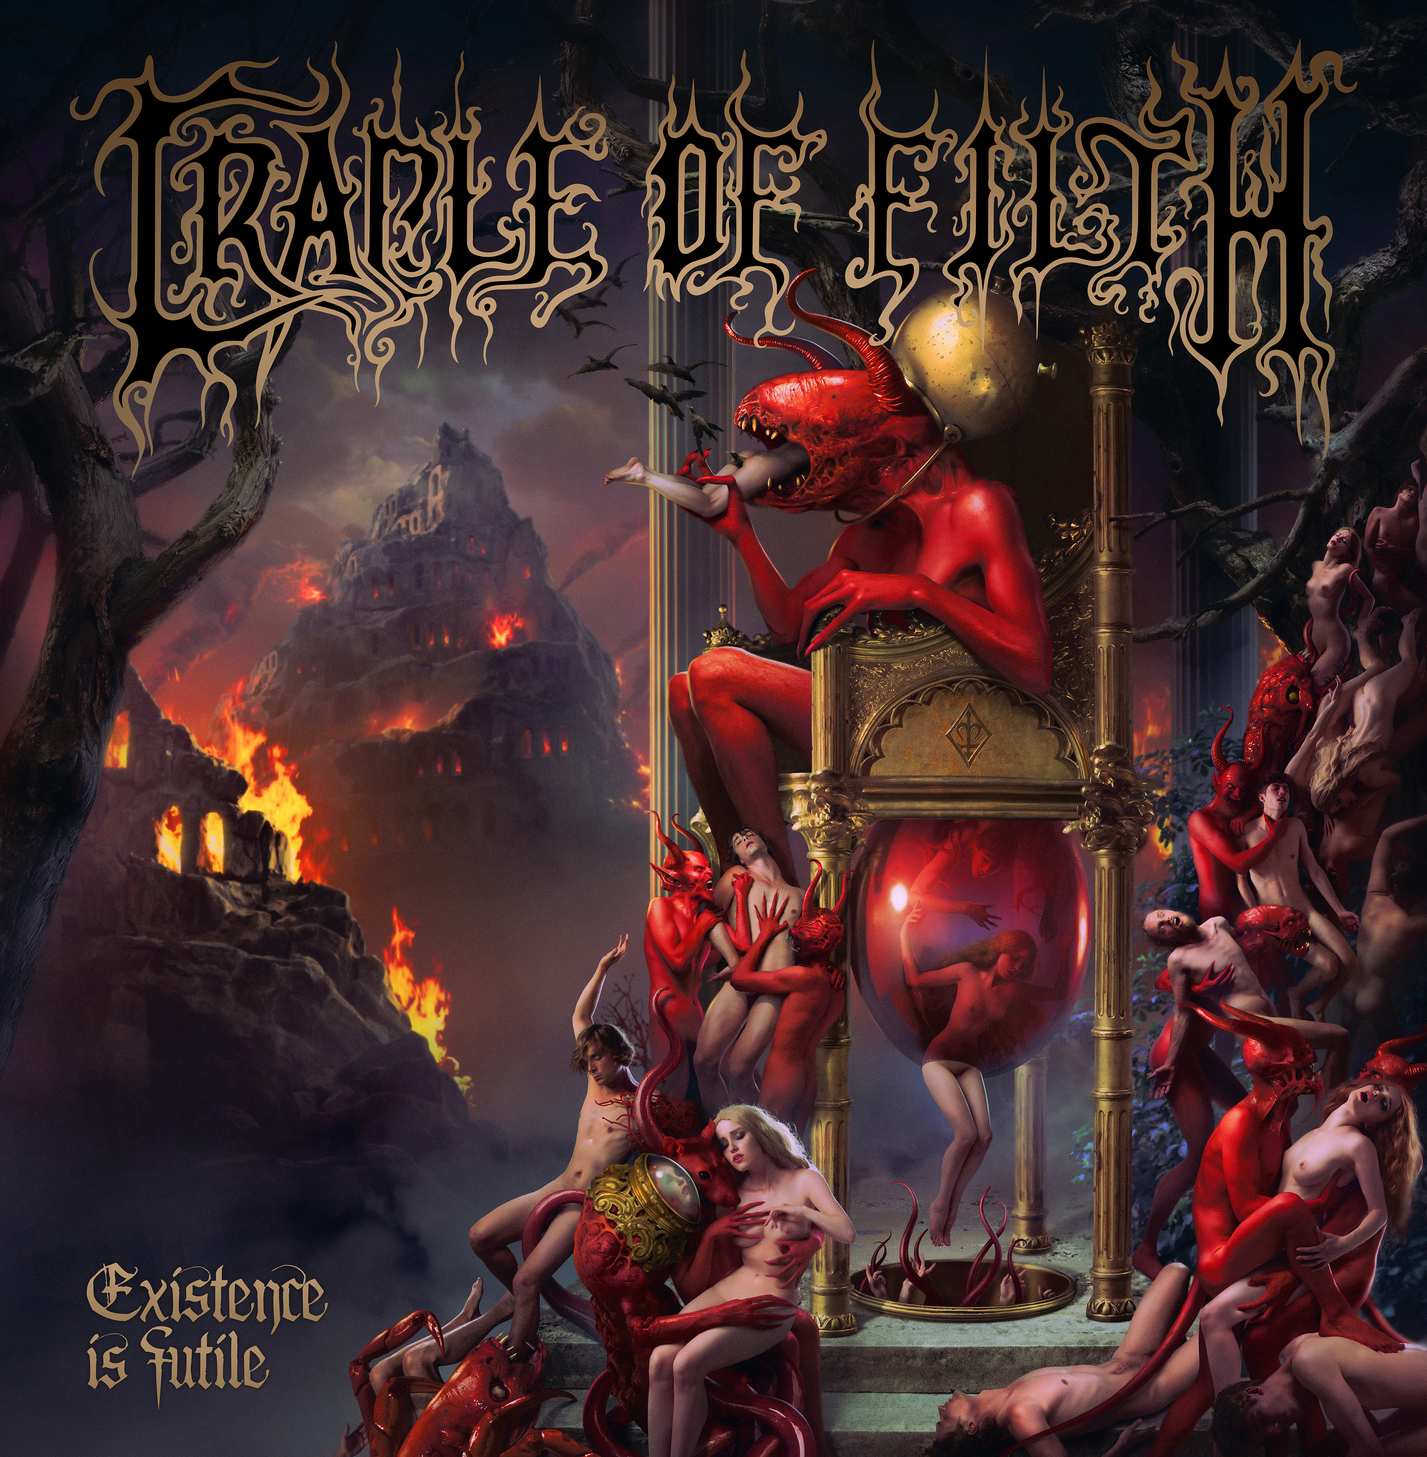

CRADLE OF FILTH
»Existence Is Futile«

out on October 22nd, 2021

Line-Up: | CRADLE OF FILTH online:
Dani Filth | Vocals  Richard Shaw | Guitar  Ashok | Guitar  Daniel Firth | Bass  Martin ‘Marthus’ Skaroupka | Drums  Anabelle | Female vocals, keys, lyre & orchestration | www.cradleoffilth.com  www.facebook.com/cradleoffilth  www.twitter.com/cradleoffilth  www.instagram.com/cradleoffilth

Belched from Hell’s depths into the rustic charms of the Witch County, Suffolk thirty long and disturbing years ago, CRADLE OF FILTH are undisputed giants of the heavy metal realm. Imperious purveyors of a perennially unique strain of dark, dastardly and wilfully extreme metal, with deep roots in the worlds of gothic horror and occult curiosity, the band led by Dani Filth has weathered three decades of tumult and trial, earning a formidable reputation as both a singular creative force and one of the most riotously entertaining live bands the metal world has ever produced.

From primitive early works like 1992 debut »The Principle Of Evil Made Flesh« to more expansive and theatrical classics like »Cruelty And The Beast« and »Midian«, CRADLE OF FILTH defied trends and constructed their own idiosyncratic world of foul grandeur, becoming one of the UK’s most notable metal bands in the process. Since then, they have traversed the world countless times, hoovering up plaudits and praise from an ever-expanding international fan base. Resolutely prolific, the band’s catalogue has grown in depth and stature all the while, irrespective of line-up changes or the whims of the faithful.

In more recent times, CRADLE OF FILTH have hit an unmistakable hot streak of creativity and urgency. As a new line-up coalesced around the creation of 2015’s »Hammer Of The Witches«, fresh impetus propelled the band to new heights, as the revitalised crew became more in demand around the world than ever before. 2017’s »Cryptoriana - The Seductiveness Of Decay« repeated the trick with even more explosive flamboyance. Until a global pandemic brought the music industry to a jarring halt, CRADLE OF FILTH were almost permanently on the road and absolutely fucking flying. As a result, it should surprise no one that the band’s brand new album, »Existence Is Futile«, is yet another monumental and electrifying journey through the dark.

“We’ve enjoyed that sense of momentum since this line-up came together,” states Dani Filth. “It was a team we needed to put together quickly for a tour and because the band worked so much better than before this way, we decided to keep it. More recently 2019 was our busiest year ever, we were literally everywhere.”

Buoyed by these recent triumphs, CRADLE OF FILTH recorded »Existence Is Futile« during 2020, piecing the record together in isolation, at Grindstone Studios in Suffolk with studio guru Scott Atkins (Devilment/Benediction/Vader). Although instantly recognisable as the work of these veteran blackhearts, the thirteenth CRADLE OF FILTH album is a wholly different beast from its immediate predecessors. Pitch-black, perverse and at times absurdly brutal and extreme, it hangs together with mesmerising fluidity. It is also absolutely rammed with giant, rousing melodies and moments of jaw-dropping invention. No one could mistake the venomously catchy likes of ‘How Many Tears To Nurture A Rose?’ or monstrous ballad ‘Discourse Between A Man And His Soul’ for anything other than CRADLE OF FILTH, of course, but »Existence Is Futile« confirms that the band’s exploratory instincts remain as sharp as ever.

“The previous album was very ornate and fiddly and meandered all over the place,” Dani notes. “We attempted to drop the ingredients of all the CRADLE records onto one album. And with that flushed out of our systems, we endeavoured to experiment a little bit this time. Though I do so hate that word, because you know what happens when bands of previous good tenure announce they’re ‘experimenting’! It usually goes totally tits up! [Laughs]. Naturally there’s really stupidly brutal songs on the record but then we go and toss something more balladic into the mix. But despite the extremes prevailing, we still wanted to do something really catchy. So there are, god forbid, sky-punching choruses too!”

Underpinned by its huge and disarmingly organic production, »Existence Is Futile« is plainly the darkest and most unsettling album CRADLE OF FILTH have made in a while. Eschewing the band’s trademark twisted storytelling in favour of horrified glimpses into the mortal void and ruminations on the inevitable destruction of life on Earth, its poignancy and relevance to the cluster of nightmares facing humanity in 2021 is impossible to ignore, even if Dani Filth insists, not unreasonably, that he didn’t anticipate a global pandemic when the news songs were being written.

“The album is about existentialism, existential dread and fear of the unknown. The concept wasn’t created by the pandemic. We’d written it all before that began, but the pandemic is the tip of the cotton-bud as far as the way the world’s going, you know? I guess the title, »Existence Is Futile«, does sound a little morbid. But again, it’s more about recognising that and saying that everything is permitted because nothing really matters, which mimics Aleister Crowley’s maxim. We all know we’re going to die, so we might as well indulge life while we have it. The final track on the album – ‘Us, Dark, Invincible’ – really emphasises that. Also, the artwork for this record was created by the Latvian visionary Arthur Berzinsh, who also dressed the last two albums, and that is exceedingly beautiful yet apocalyptic too.”

With the best possible timing, CRADLE OF FILTH were already due to make a new album during those long, lonely months of lockdown in 2020. Having grabbed the opportunity with both hands, Dani avows that unavoidable isolation from the rest of the world was the best possible incentive to get the job done, while also adding plenty of eerie atmosphere to the whole experience.

“We’d spend all day in the studio and see no one, and then I’d drive back home through a totally deserted town. It just felt like Scott and I were both existing in this self-contained sleep chamber. It was a great feeling but very surreal. We worked the whole summer, when the weather was fabulous. It was just me and Scott for the best part of five months working through the lockdowns! The good thing was, while we were in there, at least three of the songs saw a complete overhaul. I listened to the demos again recently and thought, ‘Damn, why didn’t we put this on the album?’ But we did put it on the album, it just got given a total change of face. So that was a good bi-product of the lockdown situation.”

Sonically speaking, »Existence Is Futile« is easily the most powerful and dramatic record CRADLE OF FILTH have ever made: it’s the sound of band’s enviable onstage chemistry spilling over into the studio, propelling each member of the band to new levels of intensity. Combined with the expected labyrinthine arrangements and moments of spellbinding bombast, »Existence Is Futile« may be the most vivid representation of the CRADLE OF FILTH experience yet.

“Scott was definitely leaning towards making the album sound as live as possible, from the drums up” says Dani. “We also crafted the song arrangements to be fairly concise as well. If there any hint of clutter, we removed it. We aspired to make »Existence Is Futile« sonically massive with maximum clarity, especially when the songs come for you at a million miles an hour. ‘Crawling King Chaos’, ‘Black Smoke Curling From The Lips of War’ and ‘The Dying Of The Embers’ are worthy testament to that result.”

Also, diehard fans will be thrilled to learn that horror icon Doug 'Pinhead' Bradley makes a welcome return to the CRADLE fold, lending his dulcet tones to the epic ‘Suffer Our Dominion’, and to one of the forthcoming new record’s bonus tracks, as Dani explains.

“There are also two bonus tracks in addition to the album, one of which is the culmination to the ‘Her Ghost In The Fog’ trilogy, which began on »Midian«.
For this we had little hesitation in enlisting our friend and actor Doug Bradley to reprise his narrative role. Doug lives in Pittsburgh, which he refers to ‘The Pit’, thus we directed his narrative over Skype from his local studio. He adopts this almost David Attenborough-ish role on ‘Suffer Our Dominion’, which is possibly the most politically astute song we’ve written of late. As a band we usually shy from branching into politics, but it’s something that needed spouting. The fact we’re fucking our ecology up and desperately need to address the situation pronto…”

So, if we’re all going to perish in the fire of our own stupidity, we might as well have a suitably deranged and destructive soundtrack to do it by.
A bewitching, fearless nosedive into the abyss, the band's thirteenth studio album confirms the ferocious efficacy of CRADLE OF FILTH in 2021. Bold, brave, wildly imaginative and heavy as hell, the band’s latest runaway train-ride through the flames is the perfect album for these most imperfect of times. As Dani concludes, “Be like the virus! Mutate and survive!”

