For Immediate Release
July 30, 2021

CRADLE OF FILTH Start Pre-Order for New Album Existence Is Futile + Unveil First Single and Hellish Music Video for “Crawling King Chaos”

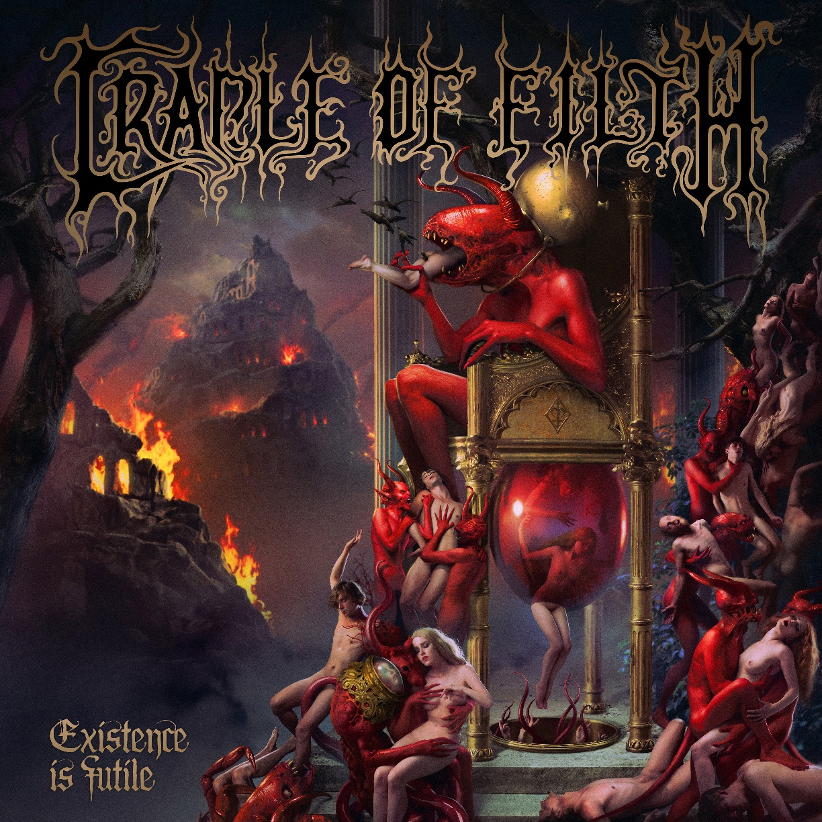

Belched from Hell’s depths into the rustic charms of the Witch County, Suffolk, thirty long and disturbing years ago, CRADLE OF FILTH are undisputed giants of the heavy metal realm. Imperious purveyors of a perennially unique strain of dark, dastardly and willfully extreme metal, with deep roots in the worlds of gothic horror and occult curiosity, the band led by Dani Filth has weathered three decades of tumult and trial, earning a formidable reputation as both a singular creative force and one of the most riotously entertaining live bands the metal world has ever produced.
Now the gates of hell have finally opened up again, to reveal the band's 13th manifesto, recorded during the lockdown periods of 2020 and entitled Existence Is Futile (out October 22nd). Pieced together in isolation, at Grindstone Studios in Suffolk with studio guru Scott Atkins (Devilment/Benediction/Vader), the band's latest chef-d'oeuvre is a pitch-black, perverse and at times absurdly brutal and extreme masterpiece following a truly nihilistic concept:
“The album is about existentialism, existential dread and fear of the unknown,” frontman Dani Filth explains. “The concept wasn’t created by the pandemic. We’d written it long before that began, but the pandemic is the tip of the cotton-bud as far as the way the world is headed, you know? I guess the title, ‘Existence Is Futile,’ does sound a little morbid. But again, it’s more about recognizing that truth and saying that everything is permitted because nothing really matters, which mimics the occultist Aleister Crowley’s maxim. We all know we’re going to die, so we might as well indulge life while we possess it. The final track on the album – 'Us, Dark, Invincible' – really drives that point home. Also, the artwork for this record was created by the Latvian visionary Arthur Berzinsh, who also dressed the last two albums, and that reeks of the exceedingly beautiful yet apocalyptic too.”
Diehard fans will be thrilled to learn that horror icon Doug “Pinhead” Bradley makes a welcome return to the CRADLE fold, lending his dulcet tones to the band's most politically astute song to date, the epic “Suffer Our Dominion” as well as the album bonus track “Sisters Of The Mist,” which is the conclusion to the “Her Ghost In The Fog” trilogy that started over 20 years ago on the infamous and classic Midian.
Yet today, the hellhounds from Suffolk will reveal one of their most brutal tracks on the new album, accompanied by an infernal music video directed by Vicente Cordero.
Poison your eyes and ears with CRADLE OF FILTH's latest Lovecraftian anthem and evoke the “Crawling King Chaos” here: https://youtu.be/Wks1aBh49sQ.
The album pre-order starts on this fateful day of July, so reserve your copy or pre-save the album via this link: https://bfan.link/existence-is-futile.ema.
Existence Is Futile will be available in the following formats:
- CD jewelcase
- CD digipak (incl. 2 bonus tracks)
- Collector's edition boxset including digipak, 2LP in gatefold, necklace with band symbol pendant, 5 buttons, flag with album artwork, lyric sheet from Dani Filth (also available as strictly limited NB mailorder edition featuring an alternative cover artwork)
- 2 LP in gatefold with 2 bonus tracks:
Black
Picture
Glow in the dark
Red + yellow marbled (NB mailorder excl.)
Purple + black marbled (UK exclusive)
Silver + black splatter (US exclusive)
Blue transparent (EMP excl.)
White + black marbled (Revolver excl.)
- Cassette tape (US exclusive)
Existence Is Futile consists of 12 new tracks with a total playing time of 54 minutes:
- The Fate Of The World On Our Shoulders
- Existential Terror
- Necromantic Fantasies
- Crawling King Chaos
- Here Comes A Candle… (Infernal Lullaby)
- Black Smoke Curling From The Lips Of War
- Discourse Between A Man And His Soul
- The Dying Of The Embers
- Ashen Mortality
- How Many Tears To Nurture A Rose?
- Suffer Our Dominion
- Us, Dark, Invincible
- Sisters Of The Mist (Bonus track)
- Unleash The Hellion (Bonus track)
So, if we’re all going to perish in the fire of our own stupidity, we might as well have a suitably deranged and destructive soundtrack to do it by.

CRADLE OF FILTH, 2021 A.D., are:
Dani Filth | Vocals
Richard Shaw | Guitar
Ashok | Guitar
Daniel Firth | Bass
Martin ‘Marthus’ Skaroupka | Drums
Anabelle | Keyboards & backing vocals
Follow or subscribe for further FILTHy propaganda:
www.cradleoffilth.com
www.facebook.com/cradleoffilth
www.twitter.com/cradleoffilth
www.instagram.com/cradleoffilth

