For Immediate Release
July 29, 2021

MR. BIG Celebrates 30th Anniversary of Chart-Topping Album Lean into It with Remastered Expanded Edition + Limited Vinyl Single Box Set

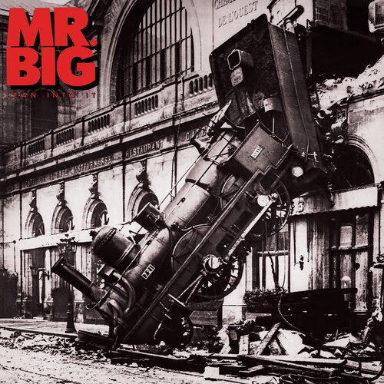

Rock supergoup MR. BIG is celebrating the 30th anniversary of their chart-topping Lean into It album with a remastered and expanded anniversary edition reissue, available digitally, on CD and as a highly collectible limited edition box set made up of five individual colored 7” singles via evoXS.

Physical editions of Lean into It reissue will be available this Friday, July 30. Digital editions are available now.

First released in 1991, Lean into It is the second studio album by the group, consisting of Paul Gilbert, Eric Martin, Billy Sheehan and Pat Torpey. This is the band's breakthrough album, with Lean into It peaking at number 15 on the Billboard 200 charts, while the single “To Be with You” hit and remained number one on the Billboard Hot 100 for three weeks. The follow-up single, “Just Take My Heart,” was a Top 20 hit, peaking at number 16 on the Billboard Hot 100.

The million-selling album also contains the popular tracks “Daddy, Brother, Lover, Little Boy,” “Alive and Kickin” and “Green-Tinted Sixties Mind.” Lean into It shows that MR. BIG could also strip away all the flash and 7-minute solos and simply create well-written songs with rhythm, groove and good melodies, making the band one of the iconic new wave of progressive “musician’s bands” who could play mind-blowing complicated riffs on their instruments at lightning speeds.

evoXS has remastered the album using the hi-resolution digital transfers from the original analogue master tapes for MQA-CD (2 CD), hybrid SACD, 180g Vinyl LP and Hi-Res digital. The hybrid multi-channel SACD plays on both SACD and regular CD players. MQA is an award-winning technology that delivers the sound of the studio. MQA-CD plays on all CD players. When a conventional CD player is connected to an MQA-enabled device, the CD will reveal the original master quality. The SACD has a new multi-track mix in 5.1 surround sound which provides the ultimate sound quality experience. The MQA-CD (2 CD) - disc 1 contains the remastered tracks from the original album and disc 2 contains the previously unreleased Kevin Elson produced tracks, “Stop Messing Around” and “Wild Wild Women,” hard to find bonus tracks and versions minus bass and guitar tracks, specially made for musicians to jam with.

Lean into It MQA-CD track listing:
Disc 1
1-Daddy, Brother, Lover, Little Boy (The Electric Drill Song) (2021 Remastered)
2- Alive and Kickin’ (2021 Remastered)
3- Green-Tinted Sixties Mind (2021 Remastered)
4- CDFF-Lucky This Time (2021 Remastered)
5- Voodoo Kiss (2021 Remastered)
6- Never Say Never (2021 Remastered)
7- Just Take My Heart (2021 Remastered)
8- My Kinda Woman (2021 Remastered)
9- A Little Too Loose (2021 Remastered)
10- Road to Ruin (2021 Remastered)
11- To Be With You (2021 Remastered)

Disc 2
1 – Stop Messing Around
2- Wild Wild Women
3- Just Take My Heart (acoustic)
4- Shadows (2021 Remastered)
5- Strike Like Lighting (2021 Remastered)
6- Love Makes You Strong (2021 Remastered)
7- Alive and Kickin’ (early version)
8- Green-Tinted Sixties Mind (early version)
9- To Be With You (reggae version)
10- Daddy, Brother, Lover, Little Boy (The Electric Drill Song) (minus guitar version)
11- Green-Tinted Sixties Mind (minus guitar version)
12-Love Makes You Strong (minus bass version)
13- Daddy, Brother, Lover, Little Boy (The Electric Drill Song) (minus bass version)

Lean into It SACD track listing:
1- Daddy, Brother, Lover, Little Boy (The Electric Drill Song)
2- Alive and Kickin'
3- Green-Tinted Sixties Mind
4- CDFF-Lucky This Time
5- Voodoo Kiss
6- Never Say Never
7- Just Take My Heart
8- My Kinda Woman
9- A Little Too Loose
10- Road to Ruin
11- To Be With You
12- Love Makes You Strong (Original Japan Bonus Track)

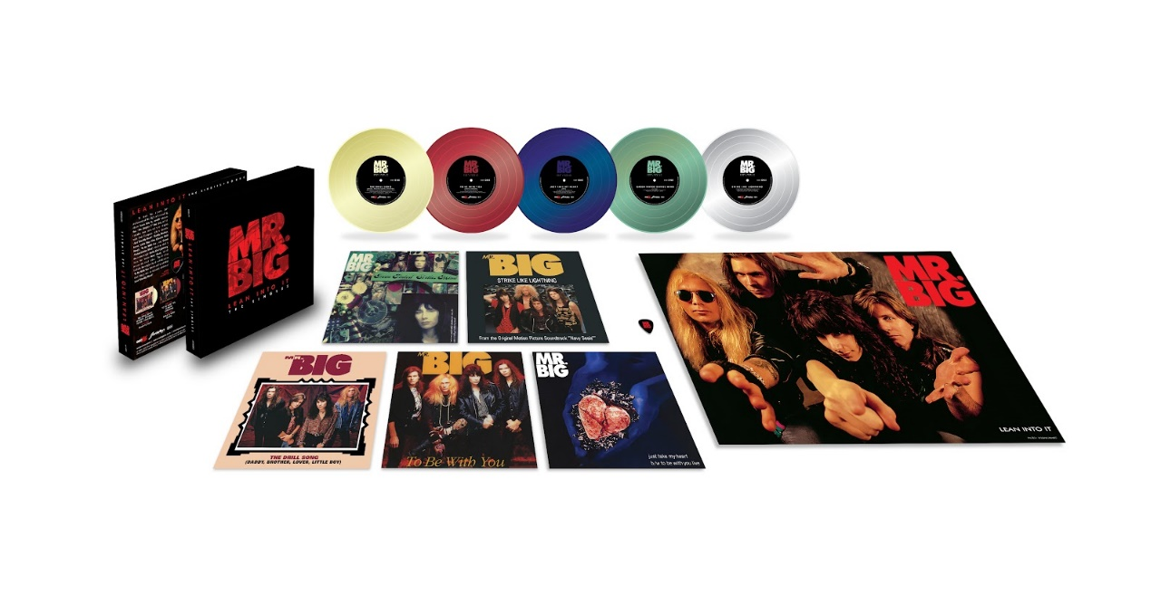

The Lean into It - The Singles 7” box set contains four 7” colored vinyl singles with their European picture sleeves: “Just Take My Heart (edit),” “Daddy, Brother, Lover, Little Boy (The Electric Drill Song),” “To Be With You” and “Green Tinted Sixties Mind,” plus the bonus single “Strike Like Lightning” from the movie Navy Seals, which has never been released on 7” vinyl. The B-sides include the original hard to find tracks “To Be With You (live at NHK Hall Tokyo 1991)” and “Just Take My Heart (acoustic).”

The box set, which also includes a guitar pick and poster, is limited to 2,000 numbered copies.

Lean into It - The Singles track listing:
Single 1
Side A Daddy, Brother, Lover, Little Boy (The Electric Drill Song)
Side B Road to Ruin

Single 2
Side A To Be With You (Single Version)
Side B Baba O' Riley (Live at NHK Hall, Tokyo, Japan, September 26, 1991)

Single 3
Side A Just Take My Heart (edit)
Side B To Be With You (Live at NHK Hall, Tokyo, Japan, September 26, 1991)

Single 4
Side A Green-Tinted Sixties Mind
Side B Just Take My Heart (Acoustic)

Single 5
Side A Strike Like Lightning
Side B Shadows

MR. BIG online:
www.mrbigsite.com
www.facebook.com/mrbigmusic
https://twitter.com/mrbigmusic

evoXS online:
https://evoxs.net
www.facebook.com/Evoxsnet
https://twitter.com/evoxsnet

