For Immediate Release
October 1, 2021

Anthrax Bassist Frank Bello Teams Up with Joel McIver and Rare Bird to Release Memoir + Announces Signed Hardcover Preorders

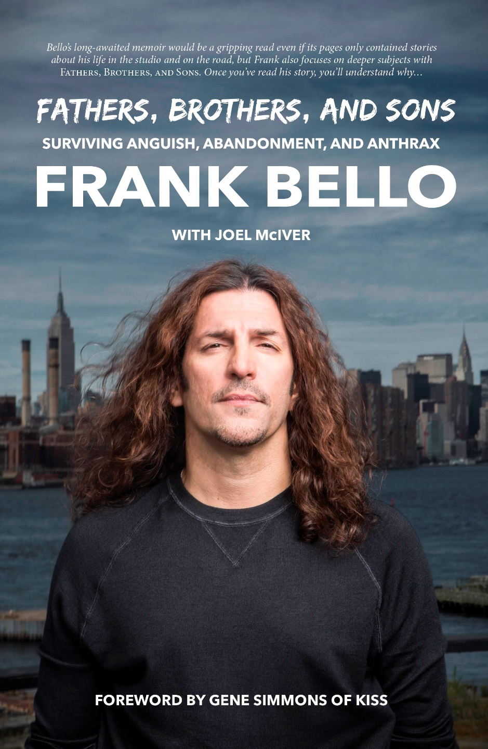

Rare Bird is excited to announce the release of Frank Bello’s Fathers, Brothers, and Sons: Surviving Anguish, Abandonment, and Anthrax, coauthored with Joel McIver, including a foreword by Gene Simmons of KISS.

Frank Bello, bassist with the legendary New York thrash metal band Anthrax since 1984 – one of the “big four” of thrash metal - has sold over 10 million albums, travelled the globe more times than he cares to count and enthralled audiences from the world’s biggest stages. He and his bandmates have even been awarded keys to the Bronx in recognition of their status. His long-awaited memoir would be a gripping read even if its pages only contained stories about his life as a recording and touring musician. While those stories are indeed included—and will blow your mind—Bello also focuses on deeper subjects in Fathers, Brothers, and Sons. Once you’ve heard his life story, you’ll understand why.

Born into a family of five, Frank grew up in difficult circumstances. His father abandoned his wife and children, and Frank’s mother moved heaven and earth to keep them fed and educated. Left with no male role model, Frank found inspiration in heavy metal bass players, following their example and forging a career with Anthrax from his early teens—first as a roadie, and then as the group’s bass player. International stardom came Frank’s way by the mid-to-late 1980s, when he was still in his early twenties, but tragedy struck in 1996 when his brother Anthony was murdered in New York. Although the case went to trial, the suspected killer was released without charge after a witness, intimidated by violent elements, withdrew his testimony.

Two decades later, Frank is a father himself to a young son. Like many men who grew up without the guidance of a dad, he asks himself important questions about the meaning of fatherhood and how to do the job well. This is the wisdom which Fathers, Brothers, and Sons offers readers. Despite the emotive nature of these topics, Fathers, Brothers, and Sons is a funny, entertaining read. A man with a keen sense of humor and the perspective to know how surreal his story has been, Frank doesn’t preach or seek sympathy in his book. Instead, he simply passes on the wisdom gained from a lifetime of turbulence, paying tribute to his loved ones in a way that will resonate with us all.

Frank Bello is an American musician, most notable as bassist for the legendary thrash metal band Anthrax. On hiatus from Anthrax, he briefly performed with Helmet, but he has appeared on every Anthrax release since 1985. He lives in New York.

Joel McIver is the bestselling author of Justice for All: The Truth About Metallica, which has been translated into nine languages, and several other books. He has written for Rolling Stone, The Guardian, Metal Hammer, Classic Rock, and he is the occasional guest on BBC. Classic Rock magazine has called him “by some distance Britain's most prolific hard rock/metal author.”

Fathers, Brothers, and Sons is scheduled for worldwide release in hardcover, e-book, and audiobook on November 2, 2021, will retail for US $28, and a percentage of sales will be donated to charities assisting abandoned families.

Signed hardcover pre-orders now at rarebirdlit.com

Follow Rare Bird, Frank Bello, and Joel McIver at:
Instagram: instagram.com/rarebirdlit | Official Website: rarebirdlit.com
Instagram: instagram.com/thefrankbello | Official Website: thefrankbello.com
Facebook: facebook.com/joelmciver

