For Immediate Release
September 27, 2021

Twisted Sister Founder, Guitarist and Manager Jay Jay French Recounts Band’s Remarkable 50-Year History with New Memoir, Twisted Business: Lessons from My Life in Rock ‘N’ Roll

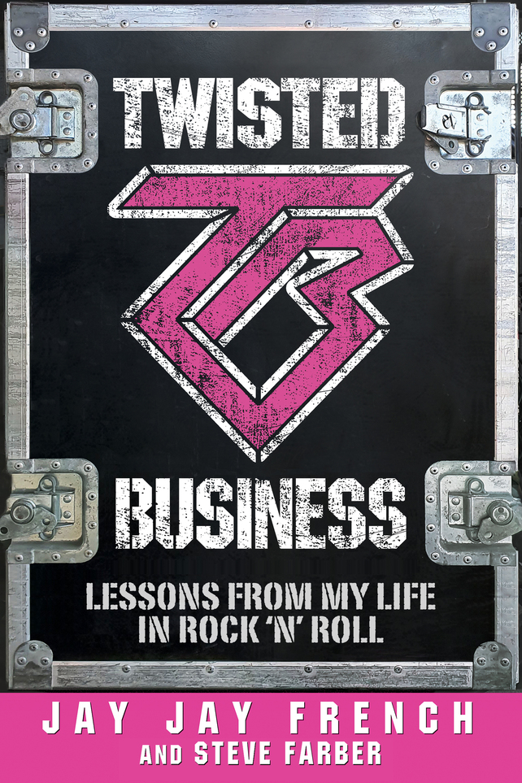

Jay Jay French, founder, guitarist and manager of the world-famous heavy metal institution Twisted Sister, has delivered a “Bizoir” - part memoir (and essential reading for any metal fan) and part business primer – in Twisted Business: Lessons from My Life in Rock ‘N’ Roll, an unexpected, whirlwind, hilarious, transformative story of French’s adventure-filled life.

Co-written with Steve Farber, bestselling author and one of the world’s top leadership and management experts, Twisted Business follows French’s life from growing up as John Segall on the Upper West Side of Manhattan in the ‘60s - using and selling drugs in Central Park West - to quitting cold-turkey after a near-fatal overdose, to creating and cultivating Twisted Sister, turning it into one of the most successful brands in the world.

“I brought my life story into this mix as both entertainment and cautionary tale,” French says. “Along with my co-author Steve Farber, we seamlessly weave the story of Twisted Sister’s remarkable 50-year history (with many legendary never before told stories) into business lessons that are applicable to every profession and even to life in general. For the first time, the story of the rise, fall and triumphant return of Twisted Sister is spelled out in amazing and often surprising detail.”

French offers honest, funny, heartfelt, entertaining in-the-rock-band-trenches stories, as well as unique, hard-earned tips and advice to anyone hoping to create their own brand, re-invent themselves, grow a business or simply love what they do.

“It's a blueprint on how to survive and succeed against some of the toughest odds in the business,” he says. “The T. W. I. S. T. E. D. method of reinvention (as outlined in the book) will help you turn roadblocks into pathways, chaos into stability and ultimately help you realize a greater quality of life both personally and professionally.”

French started the internationally renowned Twisted Sister nearly 50 years ago and has amassed 37 gold and platinum albums as a musician, manager, producer and executive producer while having performed over 9,000 shows in 40 countries and selling 20 million records around the world. A charter member of the Long Island Music Hall of Fame and the costar of the critically acclaimed documentary We Are Twisted F*cking Sister, he is considered a leading expert on vintage guitars and high-end music equipment.

Though legions of fans know French as the yellow and black-clad guitarist for Twisted Sister, he also shines as a business leader who developed Twisted Sister into a global brand with multiple revenue streams and built it into one of the most licensed heavy metal bands in history. Host of the popular podcast The Jay Jay French Connection: Beyond the Music, French is also a columnist as well as a Keynote Motivational Speaker delivering presentations to global Fortune 500 companies as well as to nonprofits.

Twisted Business: Lessons from My Life in Rock ‘N’ Roll by Jay Jay French and Steve Farber is available now via RosettaBooks.

Jay Jay French will sign copies of Twisted Business: Lessons from My Life in Rock ‘N’ Roll this Saturday, October 2 at Barnes & Noble in Paramus, NJ.

Jay Jay French online:
www.jayjayfrench.com
www.instagram.com/jayjayfrench
https://twitter.com/jayjayfrench
www.facebook.com/people/Jay-Jay-French/100063491111465/
www.podcastone.com/pd/The-French-Connection-The-Music-Business-and-Beyond

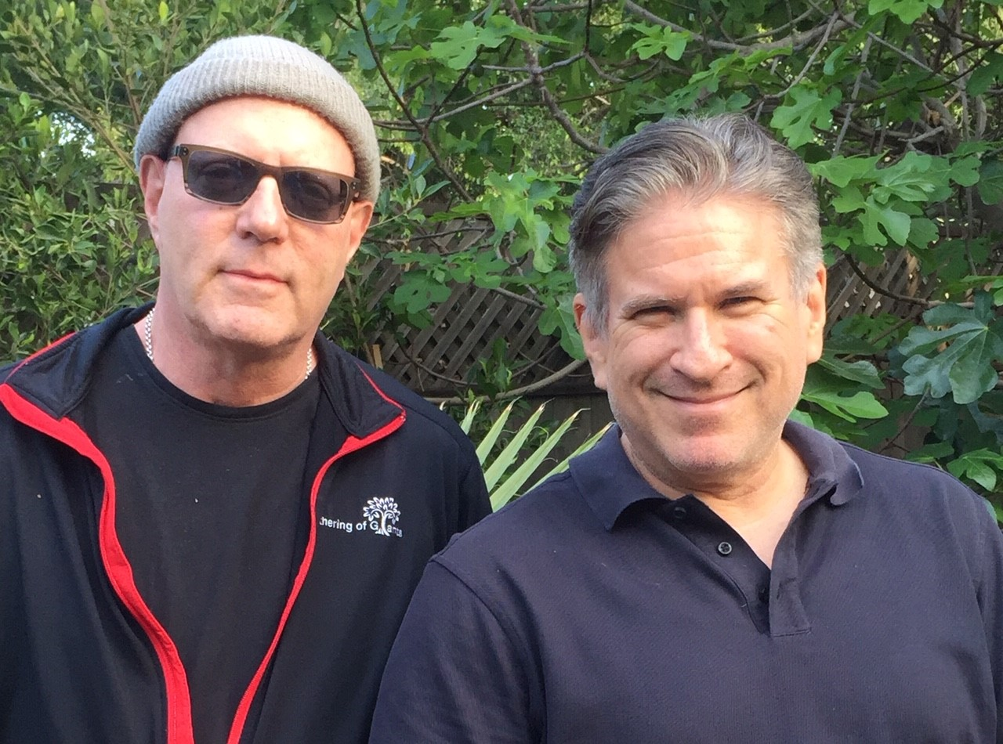
Jay Jay French and Steve Farber

